
ASRockRack Technical Document (July/2022)

Q: How to modify Network setting via ASRR MGMT Tool?

Preparation | :
- An IPMI-capable device (Client) to remotely manage and establish connection to the very system (Host Server).
- Connect RJ45 Lan cable into CM board IPMI port.
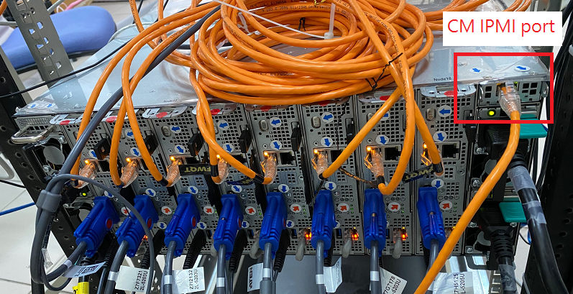
- Each node and CM board default static IP table.
Node number | Interface Name | address source | IPV4 Address
CM | br0 (CM LAN) | Static | 192.168.199.50
Node1 | eth0 (IPMI LAN to CM) | Static | 192.168.199.51
Node1 | eth1 (Shared LAN) | DHCP | -
Node2 | eth0 (IPMI LAN to CM) | Static | 192.168.199.52
Node2 | eth1 (Shared LAN) | DHCP | -
Node3 | eth0 (IPMI LAN to CM) | Static | 192.168.199.53
Node3 | eth1 (Shared LAN) | DHCP | -
Node4 | eth0 (IPMI LAN to CM) | Static | 192.168.199.54
Node4 | eth1 (Shared LAN) | DHCP | -
Node5 | eth0 (IPMI LAN to CM) | Static | 192.168.199.55
Node5 | eth1 (Shared LAN) | DHCP | -
Node6 | eth0 (IPMI LAN to CM) | Static | 192.168.199.56
Node6 | eth1 (Shared LAN) | DHCP | -
Node7 | eth0 (IPMI LAN to CM) | Static | 192.168.199.57
Node7 | eth1 (Shared LAN) | DHCP | -
Node8 | eth0 (IPMI LAN to CM) | Static | 192.168.199.58
Node8 | eth1 (Shared LAN) | DHCP | -
Node9 | eth0 (IPMI LAN to CM) | Static | 192.168.199.59
Node9 | eth1 (Shared LAN) | DHCP | -
Node10 | eth0 (IPMI LAN to CM) | Static | 192.168.199.60
Node10 | eth1 (Shared LAN) | DHCP | -
Node11 | eth0 (IPMI LAN to CM) | Static | 192.168.199.61
Node11 | eth1 (Shared LAN) | DHCP | -
Node12 | eth0 (IPMI LAN to CM) | Static | 192.168.199.62
Node12 | eth1 (Shared LAN) | DHCP | -
Node13 | eth0 (IPMI LAN to CM) | Static | 192.168.199.63
Node13 | eth1 (Shared LAN) | DHCP | -
Node14 | eth0 (IPMI LAN to CM) | Static | 192.168.199.64
Node14 | eth1 (Shared LAN) | DHCP | -
Node15 | eth0 (IPMI LAN to CM) | Static | 192.168.199.65
Node15 | eth1 (Shared LAN) | DHCP | -
Node16 | eth0 (IPMI LAN to CM) | Static | 192.168.199.66
Node16 | eth1 (Shared LAN) | DHCP | -
Node17 | eth0 (IPMI LAN to CM) | Static | 192.168.199.67
Node17 | eth1 (Shared LAN) | DHCP | -
Node18 | eth0 (IPMI LAN to CM) | Static | 192.168.199.68
Node18 | eth1 (Shared LAN) | DHCP | -

Steps:
- Change BIOS settings via ASRockRack Server Manager GUI mode:
- Scan IP Range from 192.168.199.51~192.168.199.68, and login.
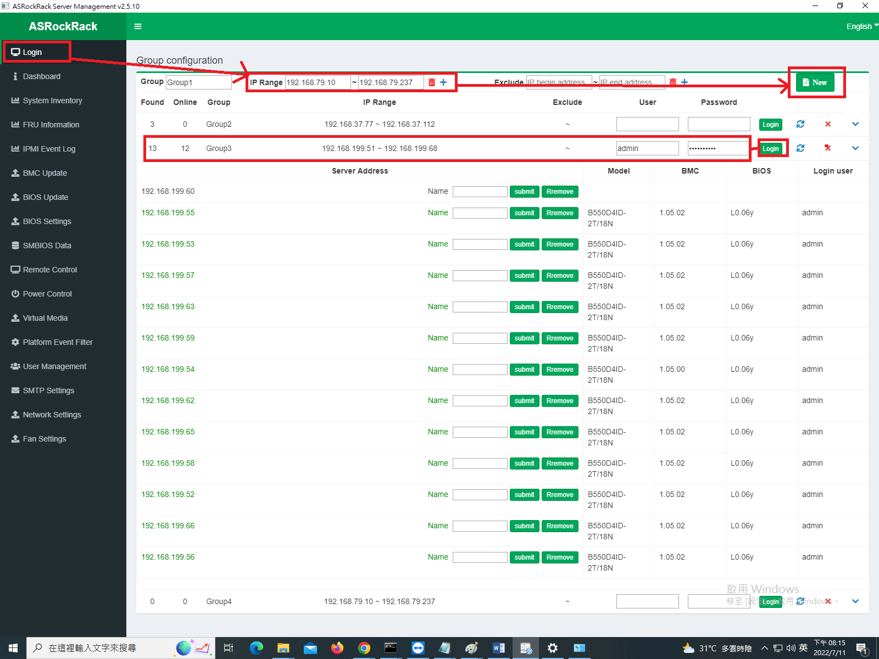
- Select [Network settings], and choose the server list you want to change-> Set Lan info
Ex: 192.168.199.54(node4) change IPv4 IP to 192.168.200.54
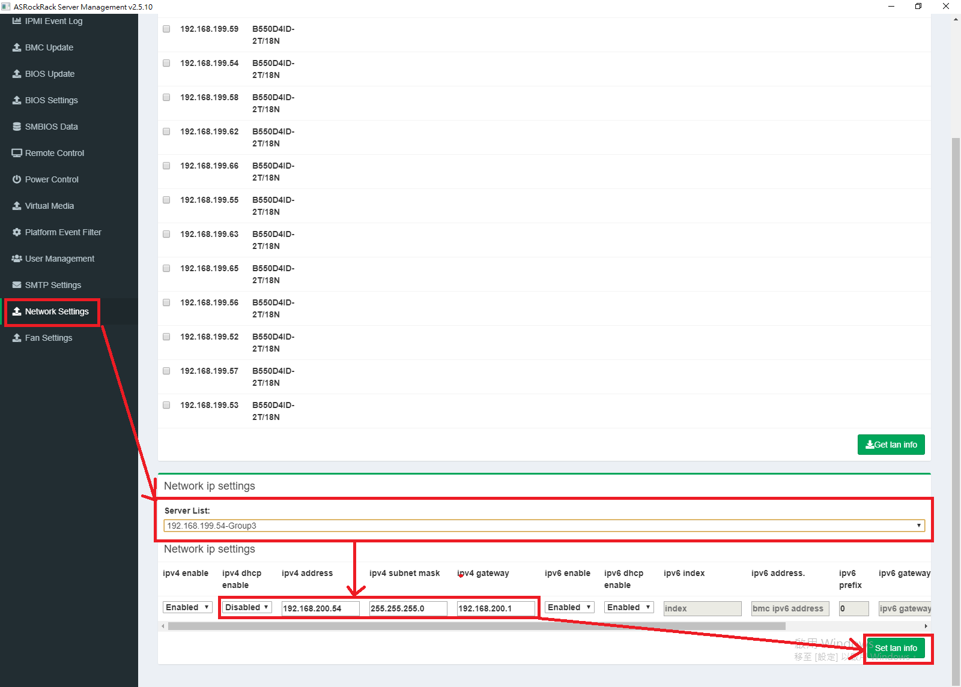
- Done.

