- Flash BIOS FW in DOS
Preparation | :
- A boot USB drive
(P.S. you can build a boot USB drive by rufus)
- Update BIOS batch folder

Step:

- Copy BIOS ROM to “AFUDOS2.39_ASR01” folder.
- Use a boot USB drive booting to DOS.
- Execute command “AFUDOS <ROM_NAME.rom> /p /b /n /asr” to flash BIOS firmware.
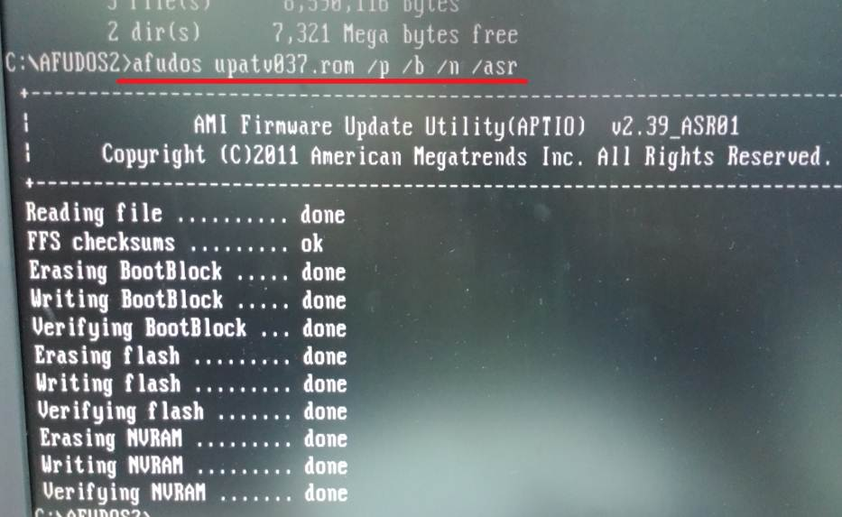

- Check BIOS version in BIOS.
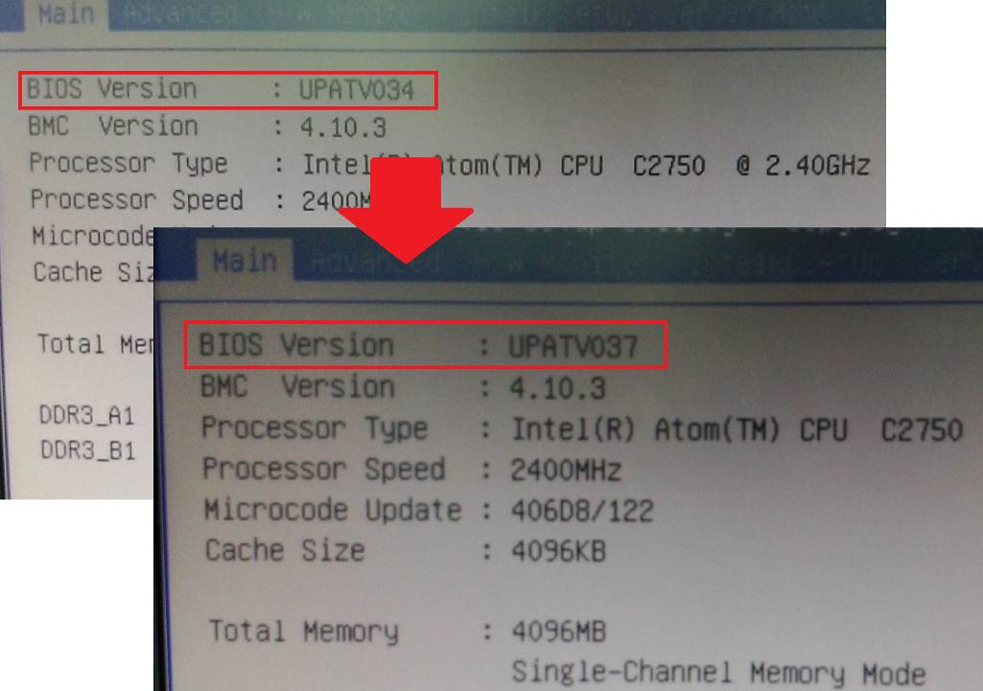
=====================================================
Flash BIOS firmware completed!

