
ASRockRack Technical Document (June/2023)

LAN Firmware Update for Broadcom Models
Steps:
- Put the folder “BCM FW Update Tool” in a USB drive. Insert it to the system to update firmware for, then boot to UEFI: Built-in EFI Shell.
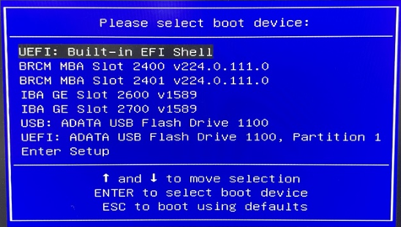

- Enter “FS0:” to access the USB, then “cd” into the Update Tool folder.
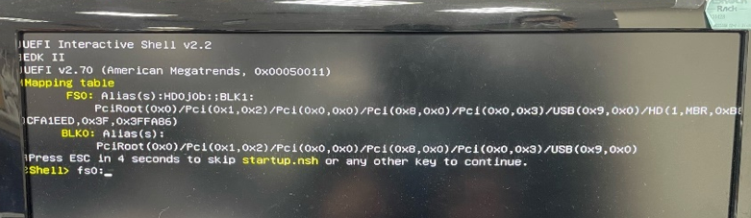

- You may run bnxtmt.efi to check on current FW version, or simply run 01blank.nsh to erase current firmware.
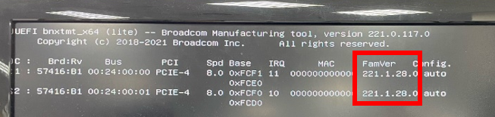

- Run 02fw_225.nsh to program new firmware.

- Run 04mac.nsh to re-write MAC address. Take below photo for instance: LAN3 and 4 are the Broadcom LANs, so we enter A8A159F9E79C & A8A159F9E79D for this board
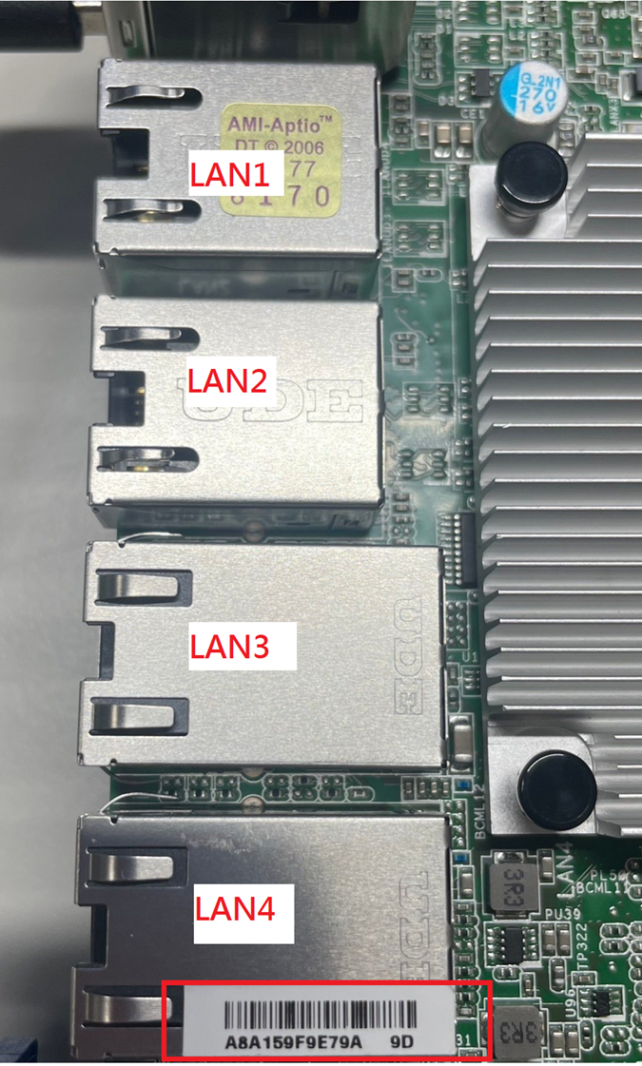

- Perform an AC power cycle and then boot to the USB drive again, then run bnxtmt.efi -none ->Check ver/mac to check if the MAC address is successfully re-written.

-Done-

