

ASRockRack Technical Document (Jan/2019)
Q: How to flash BMC FW in DOS?
Preparation | :
- A bootable USB drive
(P.S. you can build a boot USB drive by rufus https://rufus.akeo.ie/ )
- Update BMC Batch files folder
Step:
- Copy your BMC image to “Socflash” folder
- Use a bootable USB drive boot to DOS.
- Execute command “Socflash.exe {update image name} {backup image name}” to flash BMC firmware.
Ex: Socflash.exe EPC612D8L1.10 backup.ima

Flash process will take about 5 minutes, please wait.

- Check BMC version in BIOS.
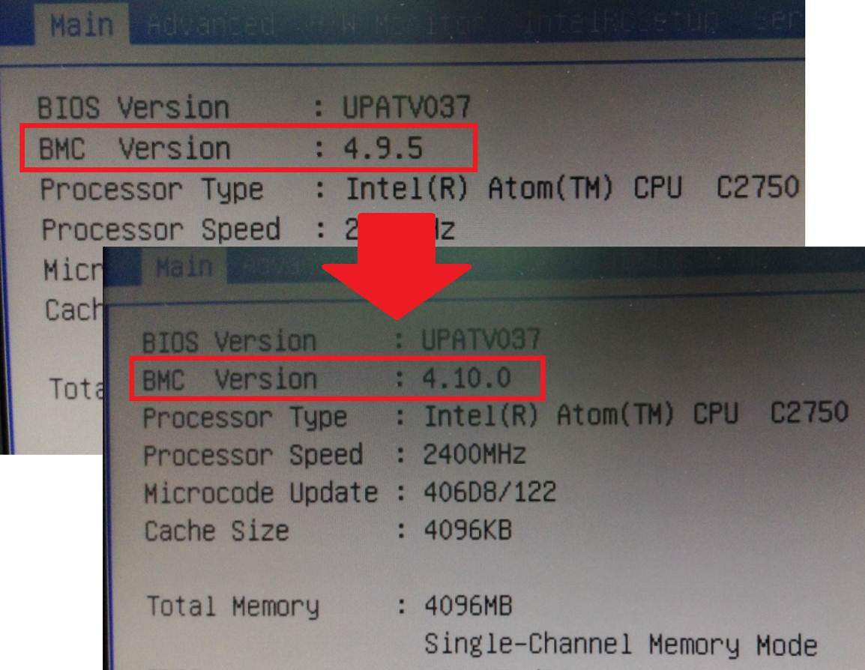
========================================================
Flash BMC firmware completed!

*If MAC address of IPMI and NCSI became 00-00-00-00-00-00, please use BMC Mac backup Tool in BIOS-> Server Mgmt-> Restore BMC MAC from backup to restore MAC address.
