Step 1
Go to iReasoning download MIB Browser and install it.
http://www.ireasoning.com/download.shtml
You can use MIB Browser Personal Edition.
The version can get SNMP trap.
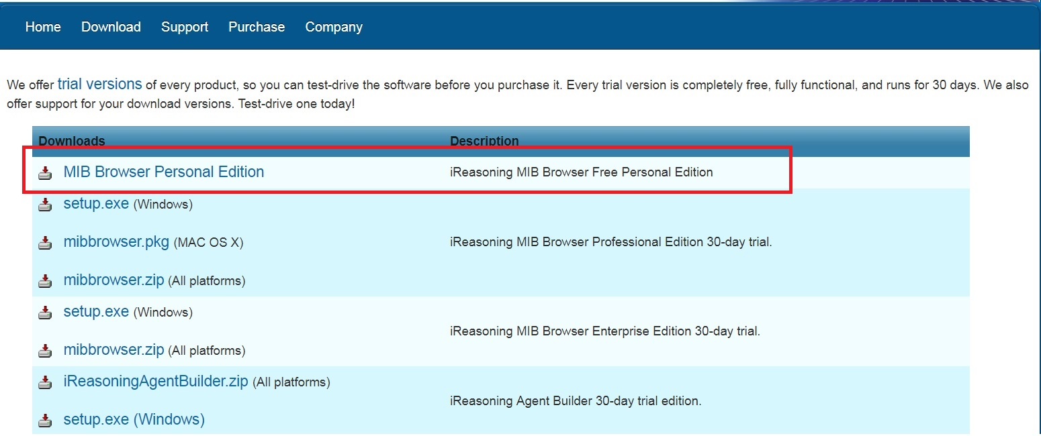
Step 2
Load MIBs.(File->Load MIBs)
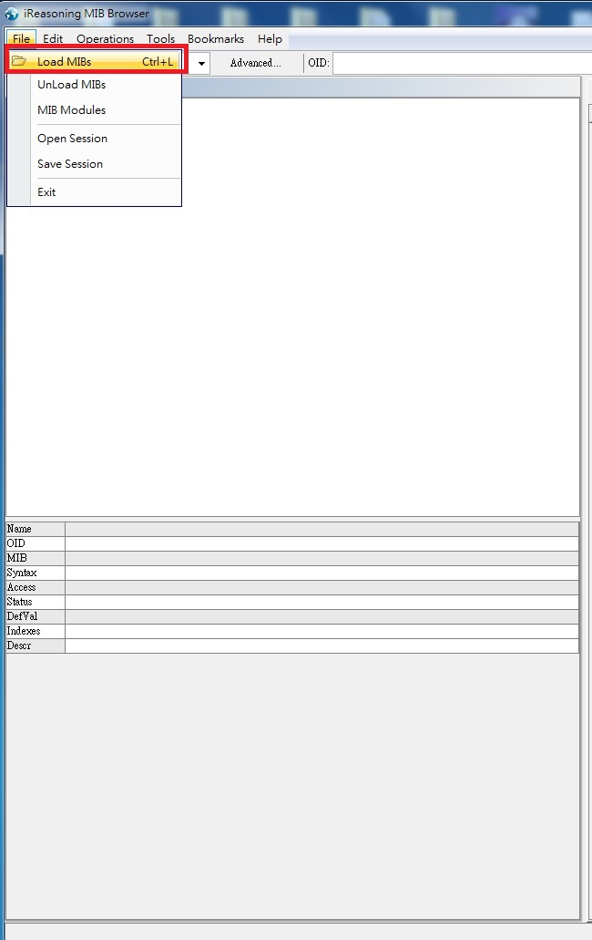
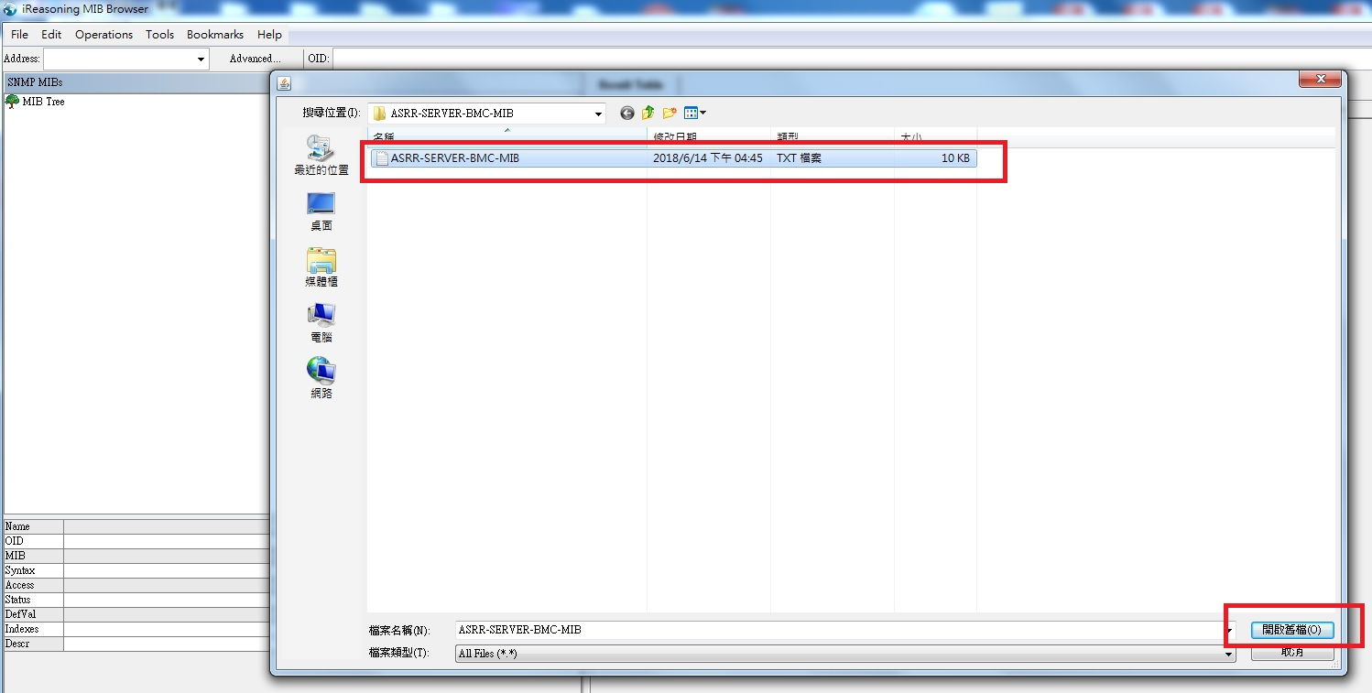
After load file, MIB Browser can get display file’s data.
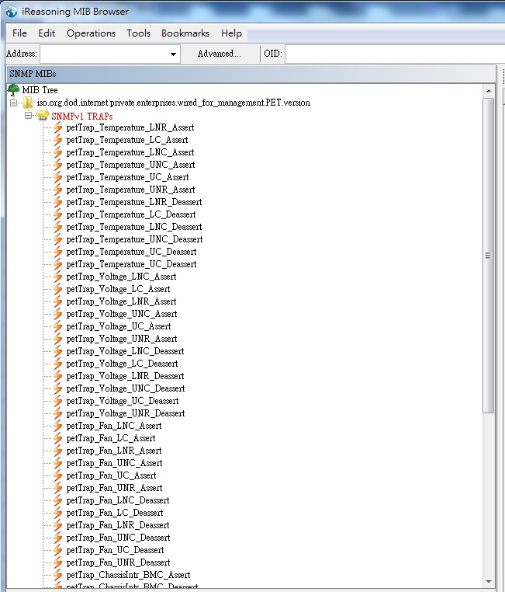
Step3
Open Trap Receiver (Tools -> Trap Receiver)
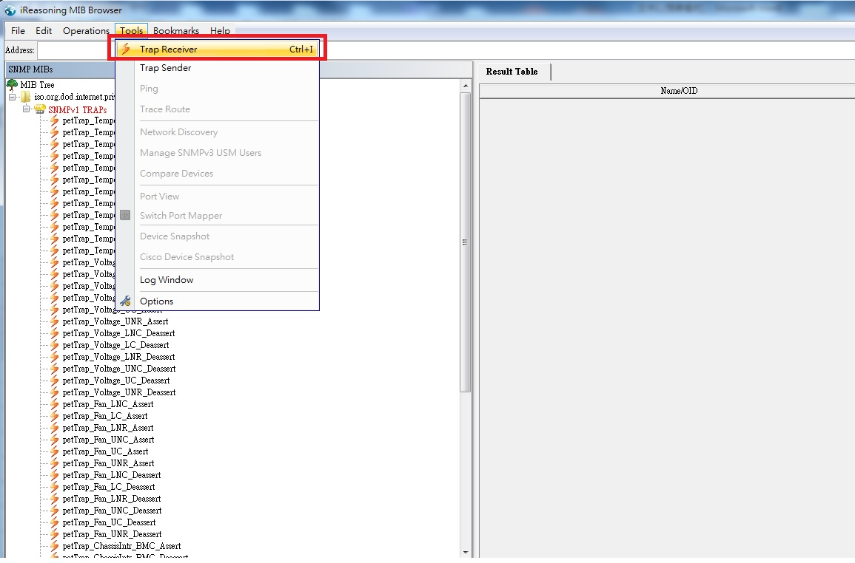
Finish! This function can get SNMP trap.
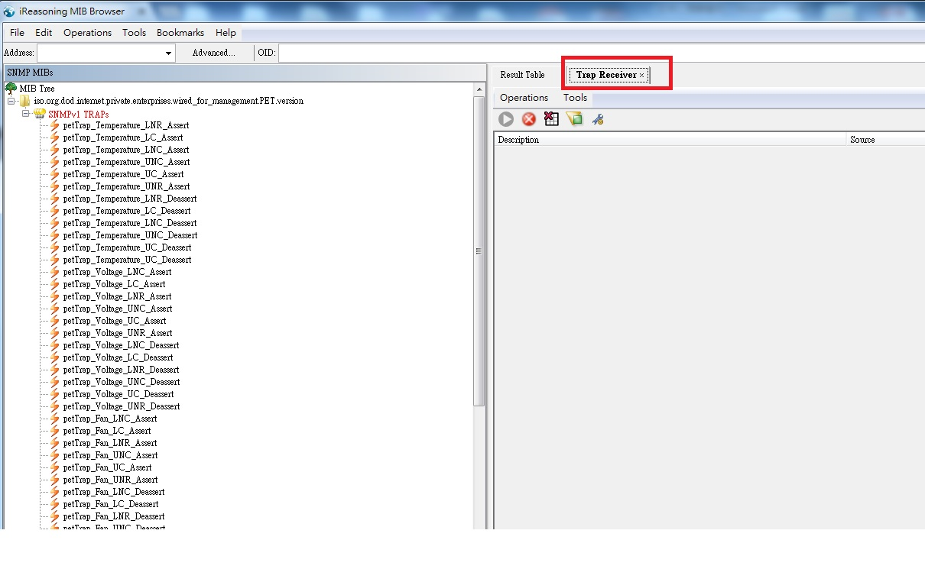

Step 4
Go to BMC web and enable PEF function.
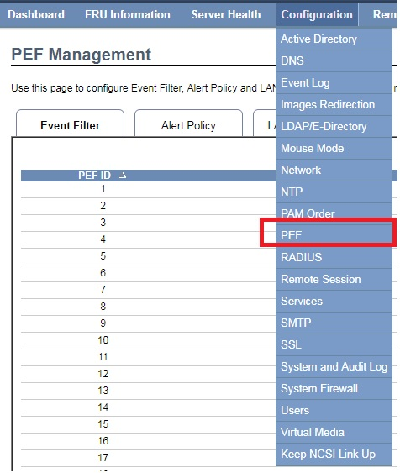
Event Filter page, this page by BMC default setting.
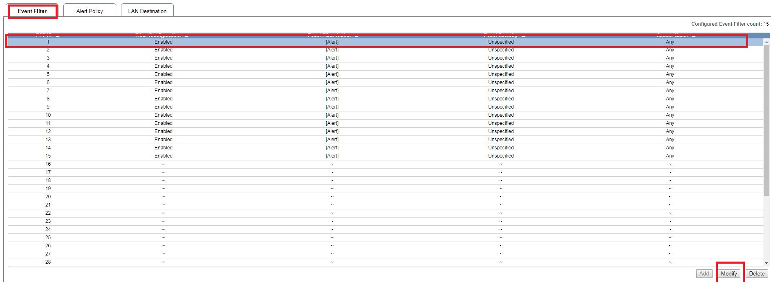

Alert Policy
Click Policy entry 1
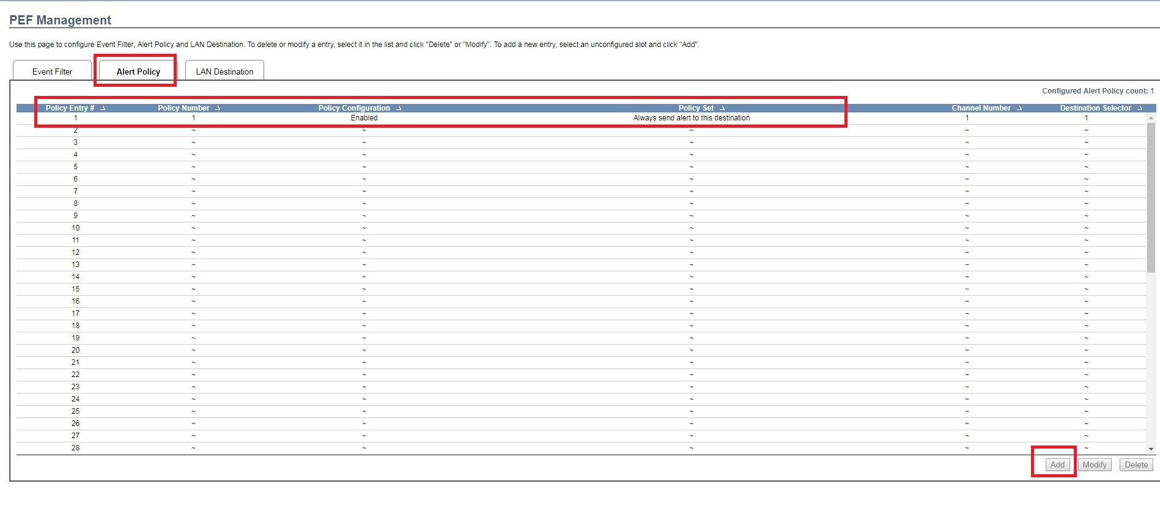
Enable Policy Configuration.
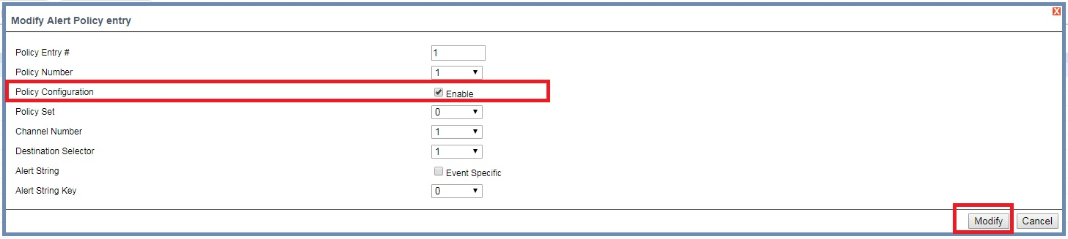

Lan Destination
Click Lan Destination 1
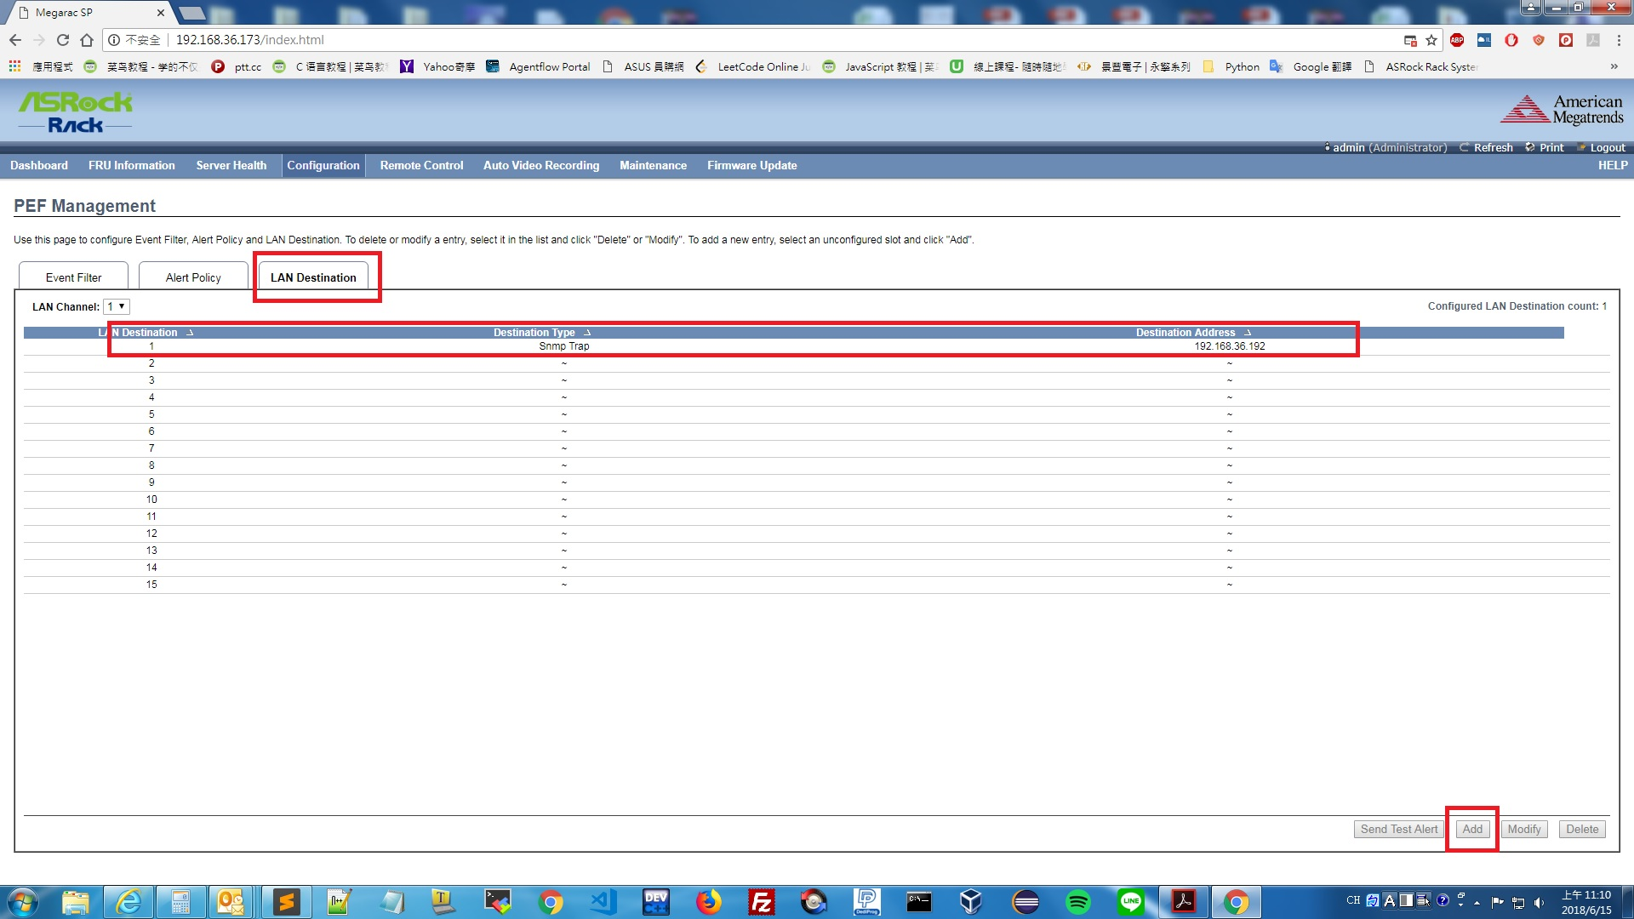
Set
Destination Type → Snmp Trap
Destination Address -> Set your Mib browser host IP
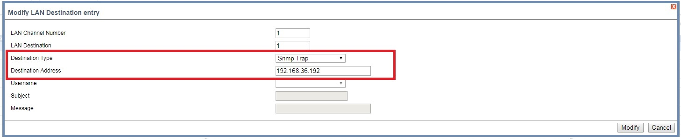

Step 5
Send test snmp trap
Click Lan Destination 1
And click send Test Alert button.
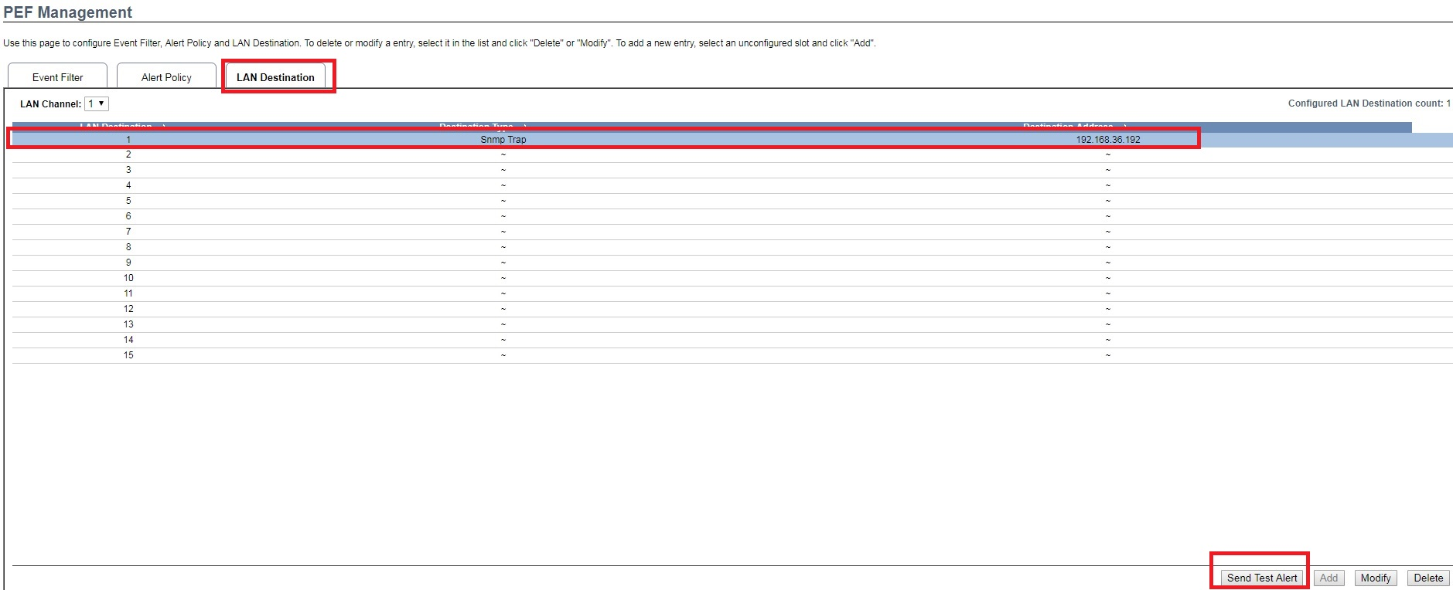
Check Mib browser.
Trap Receiver get Test trap.
