**FAN Settings**

The FAN Settings include the conditions for turning on and off, the fan actions corresponding to each temperature sensor, and the mode of each fan configuration. 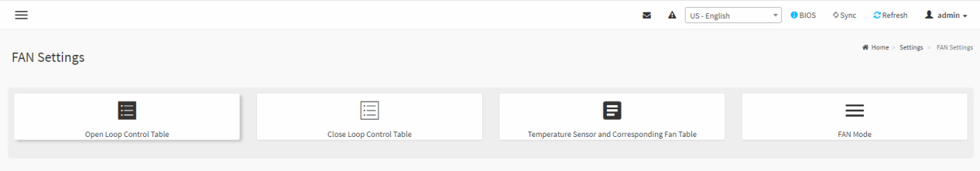

**Open Loop Control Table**

This table is used to set the fan speed corresponding to each temperature in customized setting.

**Default Setting :** Display the default configuration of the selected table.

**Customized Setting :** Display thecustomized configuration **of the selected table.**

**Table :** Switch the table of Default Setting or Customized Setting.

**Temp :** Set the temperature, When reaching the set temperature, set the fan duty cycle to the corresponding setting duty.

**Duty :** Set the duty, When the corresponding set temperature is reached, set the fan duty cycle.

**Clean Setting :** Clean the configuration of **selected table** in customized setting.

**Save :** Save the configuration of **selected table** to customized setting.

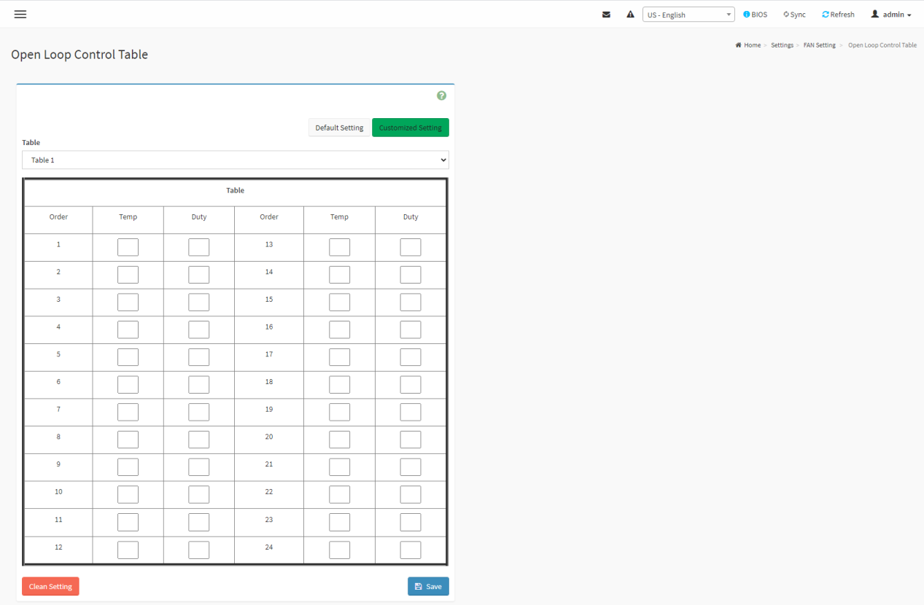

**Close Loop Control Table**

This table is used to set the fan speed to slow down or rise after reaching the set temperature and number of seconds.

**Default Setting :** Display the default configuration of the selected table.

**Customized Setting :** Display thecustomized configuration **of the selected table.**

**Table :** Switch the table of Default Setting or Customized Setting.

**The Temperature Of Slow Down Fan Duty Cycle :** Set temperature, When the set temperature arrives and reaches the set time, the fan duty will be slowly reduced to set duty cycle.

**The Duty Cycle Percentage Of Slow Down Fan Duty Cycle :** Set duty cycle, when the set temperature is reached, the fan duty will be slowly reduced to set duty cycle.

**The Time(Seconds) Of Slow Down Fan Duty Cycle :** Set Time, when the set temperature is reached after set Time, the fan duty will be slow down of set duty cycle.

**The Temperature Of Speed Up Fan Duty Cycle :** Set temperature, When the set temperature is reached and the set time is reached, the fan duty cycle will increase the set duty cycle.

**The Duty Cycle Percentage Of Speed Up Fan Duty Cycle :** Set the Duty Cycle. When the set temperature is reached and the set time is reached, the fan duty cycle will increase the set duty cycle.

**The Time(Seconds) Of Speed Up Fan Duty Cycle :** Set Time, When the set temperature is reached and the set time is reached, the fan duty cycle will increase the set duty cycle.

**Clean Setting :** Clean the configuration of **selected table** in customized setting.

**Save :** Save the configuration of **selected table** to customized setting.

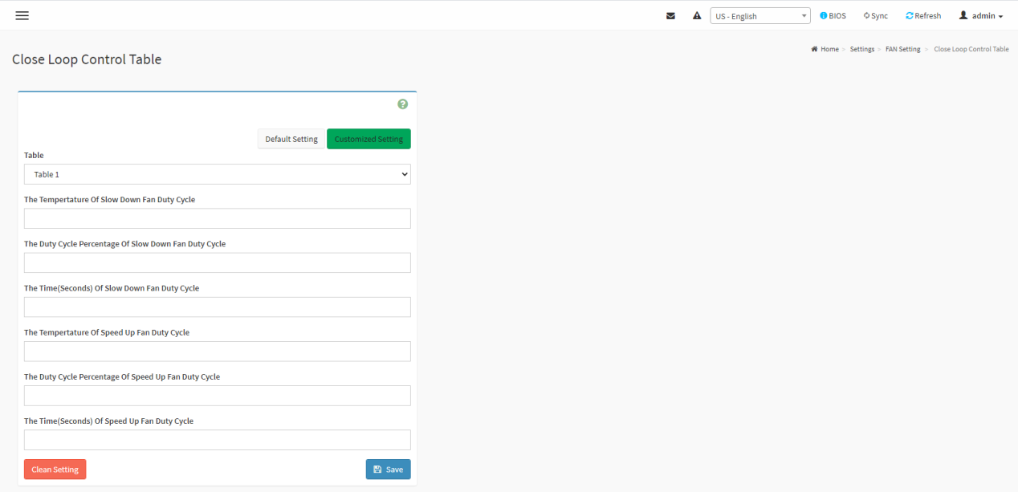

**Temperature Sensor and Corresponding Fan Table**

This page is used to set the open loop table and closed loop table corresponding to each temperature sensor and the fan used.

**Default Setting :** Display the default configuration of the selected sensor.

**Customized Setting :** ShowCustomized settings for corresponding sensor.

**ALL Sensor :** Set the configuration of all sensors.

**Sensor Number :** Display the number of the selected sensor.

**Select Open Loop Control Table :** Set the open loop table of the selected sensor.

**Select Close Loop Control Table :** Set the close loop table of the selected sensor.

**Select Fan :** Set the fan used by the selected sensor.

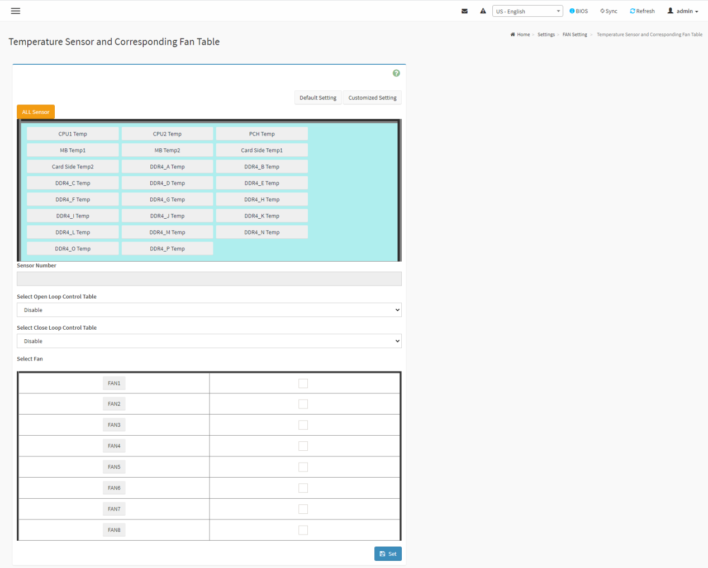

**FAN Mode**

This page is used to setting each fan mode for default, manual or customized and the manual mode each fan duty setting.

**Set Fan Duty For Manual Mode :** Set the duty of each fan in fan manual mode

**Set Fan Control Mode :** Set the fan mode of each fan.

**Clean All Fan Setting :** Clean ALL FAN Setting configuration.

