
ASRockRack Technical Document (August/2022)

Q: How to check S/N Number, MB Model & H/W Revision, PPID and Firmware Version for your ASRock Rack product?

- The Serial Number for your product is located here:
- For systems/ barebones:
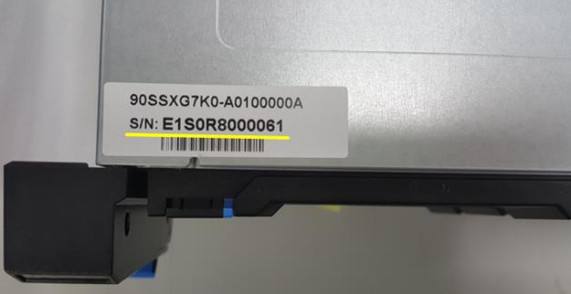

- For motherboards:
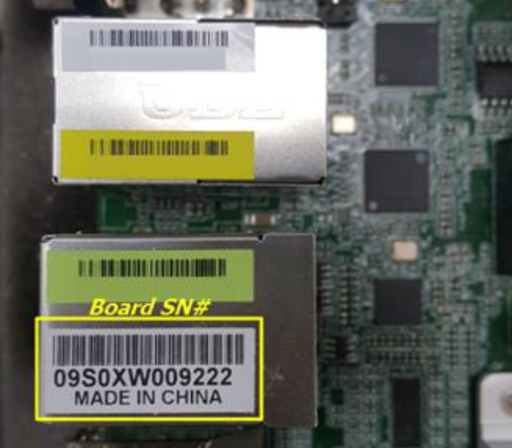

- Motherboard Model and H/W Rev. could be found on the board itself:
e.g. Motherboard Model = EP2C621D16GM, H/W Rev. = 1.00
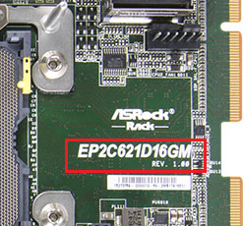

- Motherboard PPID is optional if you have the S/N numberyou’re your product. If the S/N number of the motherboard is missing, please find the white label on the board and key in the part framed in red.
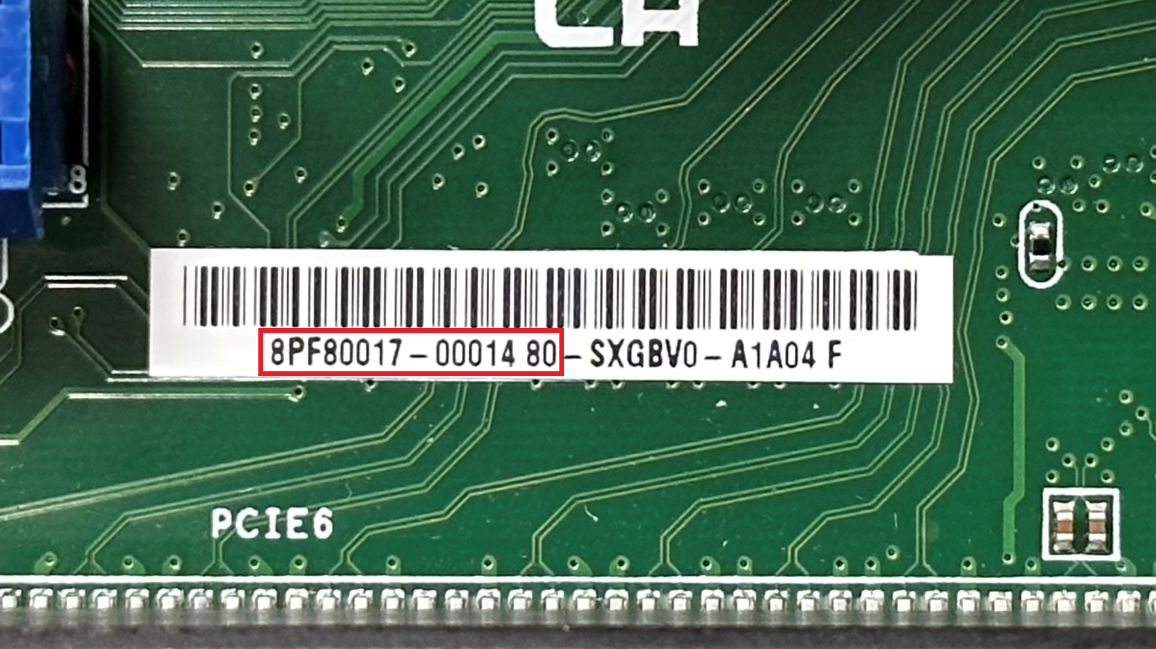

- BIOS version (UEFI Version) and BMC version could be checked in BIOS Main page:
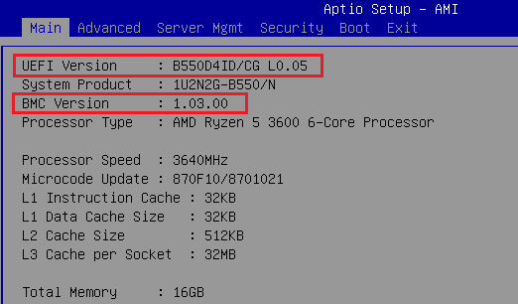

-Done-

