
ASRockRack Technical Document (May/2016)
Q: How to update E3C224D4I-14S on-board LSI 2308 to IR mode?

Update flow:
- Unzip “E3C224D4I-14S_IR_L_20_14.01.00.01.UEFI” to bootable USB Drive.
- BIOS setting: Advanced ->Storage Configuration ->LSI Controller : Enable
->Bootable LSI Controller : Yes
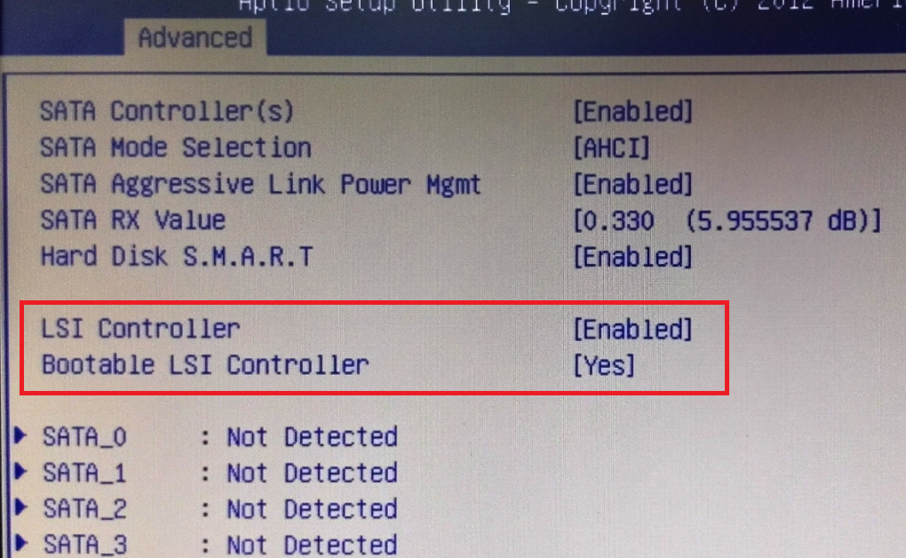

- Boot to DOS environment.
- Execute readaddr.bat (Program will save SAS address to info.txt in USB drive)
Example:
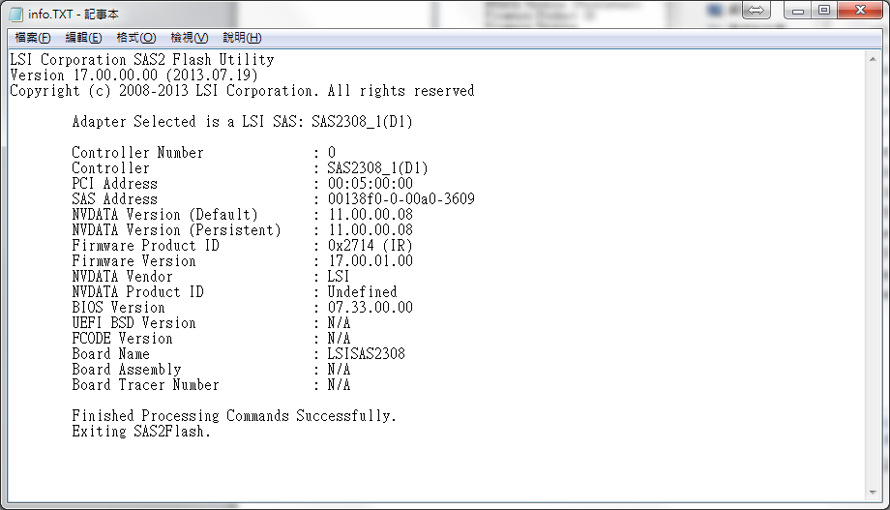

- Execute start_IT.bat to update LSI2308 FW in folder “LSI2308_P17_IT”, process will start and please wait 4 minutes.

- Restart and press Ctrl+C into LSI RAID ROM and you will see LSI2308 has been updated to IT mode.
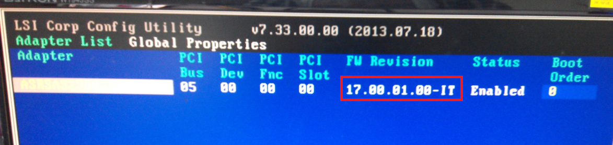
===================================================================
Note:
- If SAS address have been changed please type command (in DOS)
“sas2flsh.exe -o -sasadd XXXXXXXXXXXXXXXX” ⬅Your SAS address
- Restart and check SAS address
- Finish

