**How to use redfish to change boot order**

1. **Change redfish password**

When first time use redfish, you need to change the default redfish password.

Here is the path to change password: IPMI web=>settings=>user management=> choose user.3 Administrator

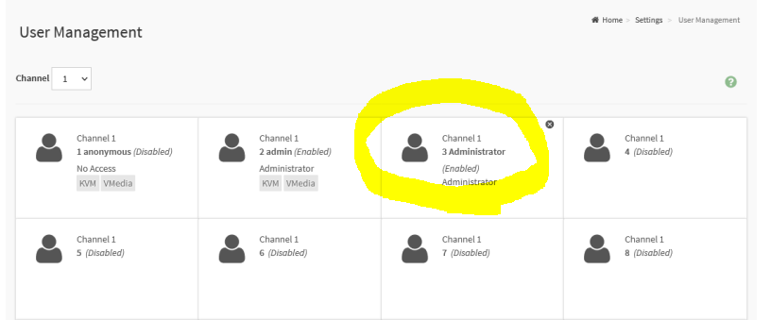

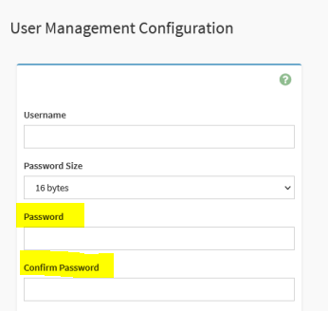

1. **Get boot option**

Check the BIOS option in redfish with browser => <https://BMC>_IP/redfish/v1/Systems/Self/Bios

On this example, the MB is X570D4U-2L2T, and bios boot order title in redfish is SETUP006

P.S Not every platform uses SETUP006 as boot order title. If you can’t find boot sequence in SETUP006, please search similar content in redfish menu.

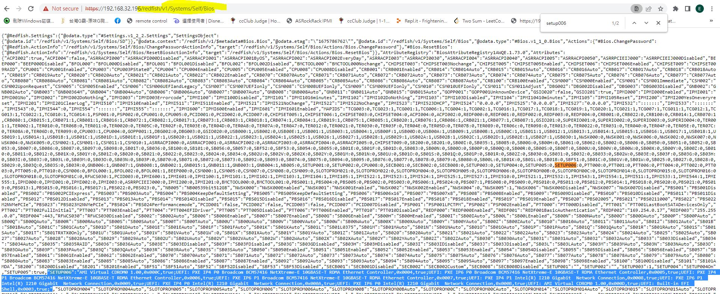

Normally there are many boot devices, so the string will be very long, and we will use **;** to distinguish each boot device

Ex: There are two boot devices (ami cdrom, pxe), the value of SETUP006 will display like  
=>AMI Virtual CDROM0 1.00,0x000C,true **;** UEFI: PXE IP4 P0 Broadcom BCM57416 NetXtreme-E 10GBASE-T RDMA Ethernet Controller,0x0004,true;   
  
**3. Set boot option**  
Set preferred boot order.

Following is the example

* get token

curl -k -v -X POST https://192.168.32.196/redfish/v1/SessionService/Sessions -d '{"UserName":"admin","Password":"12345678"}' -H "Content-Type: application/json"

* set boot order

curl -k -v -X PUT https://192.168.32.196/redfish/v1/Systems/Self/Bios/SD -d '{"Attributes": {"SETUP006":"AMI Virtual CDROM0 1.00,0x000C,true**;**UEFI: PXE IP4 P0 Broadcom BCM57416 NetXtreme-E 10GBASE-T RDMA Ethernet Controller,0x0004,true**;** "}}' -H "Content-Type: application/json" -H "X-Auth-Token: MTAxMTAyMjcxMTAzNDUzODE4MzE1MjEwMjIxOTE3NDE3MTkyMjAxMDAxNzUxMDEyNTIxMzUyMTQ2MTA5MTE1OTMzNTY2NTY4ODEwNDMy" -H If-None-Match:W/\"1675786843\"

**4. After reboot, you can check the boot order in bios=> boot menu**