BMC Firmware Update SOP

FW Flash Test
1. FW flash via Web 3
2. FW flash under Windows 7
3. FW flash under Linux 11
4. FW flash under DOS 14
5. YAFUFLASH usage 17

- FW flash via AST2400 Web

Step1. Log in BMC Web
- Enter Username
- Enter Password
- Click on Login button
Step2. Check the current firmware information
- Navigate to Dashboard page
- Check the Device Information and Network Information is current

Step3. Login BMC and navigate to Firmware Update.
- Login BMC
- Navigate Firmware Update page
- Click on Enter Update Mode button
Step4. Upload Firmware
Click Browse to select firmware

- The correct file has been selected
- Click on Upload button

Step5. Verify the firmware version
- Verify the firmware version information
- Click on Proceed button
Step6. Complete firmware update
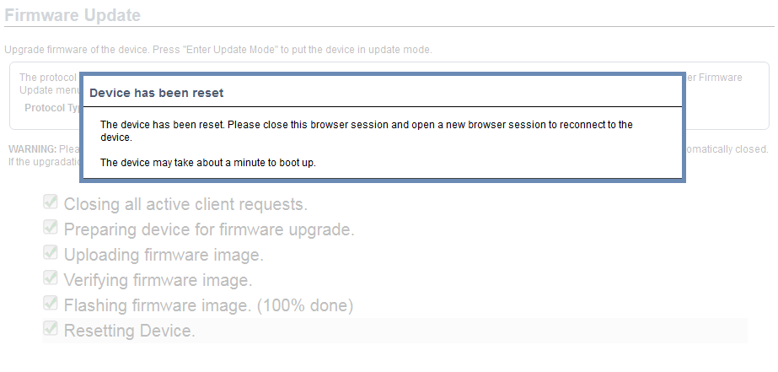 | - The end of the program  - The device may take about a minute to boot up  - Check the BMC heartbeat LED Blinking from to Solid On
Step7. Confirm firmware version and network information in web
- Navigate to Dashboard
- Check the Device Information and Network Information is current

Step8. Confirm firmware version information in BIOS
- Boot to BIOS Setup Main page
- Check the BMC Version correctly
Step9. Confirm network information in BIOS
Navigate to Server Mgmt -> BMC Network Configuration
- Check that the BMC MAC is correct
- Can get IP via DHCP

- FW flash under Windows

Step1. Copy the YaFuflash tool to OS disk
Place the YaFuflash tool in the OS disk
Note: Do not execute the YaFuflash tool in USB
Step2. Open the Yafuflash
- Open the Yafuflash tool
- Please click on your system if it is 32-bit or 64-bit, and click on the folder
Step3. Open the terminal
Enter string CMD in the Location field to open the Terminal
Step4. Enter the command to start firmware update
- Enter the command
- Yafulash.exe –nw –ip $BMCIP –u $username –p $password –full $file name
Enter “Y” to continue
Flash process without error, after the completion of display "Upgrading Firmware Image: 100% ... Done"

Step5. Confirm firmware version and network information in web
- Navigate to Dashboard
- Check the Device Information and Network Information is current
Step6. Confirm firmware version information in BIOS
- Boot in to BIOS
- Check the BMC Version correctly

Step7. Confirm network information in BIOS
Navigate to Server Mgmt -> BMC Network Configuration
- Check that the BMC MAC is correct
- Can get IP via DHCP

Note :
If you want to update BMC FW by local under Window OS that the command as below
  - Yafulash.exe -cd -full $file name

- FW flash under Linux

Step1. Copy the YaFuflash tool to OS disk
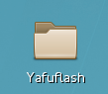 | Place the YaFuflash tool in the OS disk  Note: Do not execute the YaFuflash tool in USB
Step2. Open the terminal
- Open the Yafuflash tool
- Please click on your system if it is 32-bit or 64-bit, and click on the folder
- Right click to open the terminal
Step2. Enter the command
Enter the command.
- chmod 777 *
- ./Yafuflash –nw –ip $BMC IP –u $username –p $password –full $file name
 | Enter “Y” / ”y” to continue
 | Flash process without error, after the completion of display "Upgrading Firmware Image: 100% ... Done"
Step3. Confirm firmware version and network information in web
- Navigate to Dashboard
- Check the Device Information and Network Information is current
Step4. Confirm firmware version information in BIOS
- Boot in to BIOS
- Check the BMC Version correctly
Step5. Confirm network information in BIOS
 | Navigate to Server Mgmt -> BMC Network Configuration
- Check that the BMC MAC is correct
- Can get IP via DHCP
Note :
If you want to update BMC FW by local under Linux OS that the command as below
  - ./Yafuflash -cd -full $file name

4. FW flash under DOS
Step1. Boot to DOS
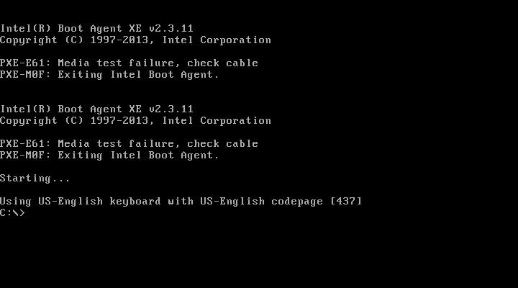 | - Put the Yafuflash’s file into USB DOS disk  - Power on SUT and boot to DOS
Step2. Execute command
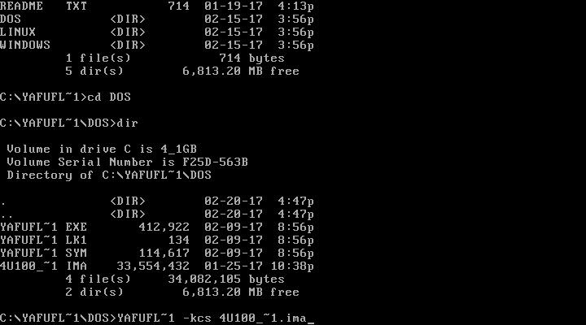 | Execute command  - Yafuflash.exe –kcs –full $file name
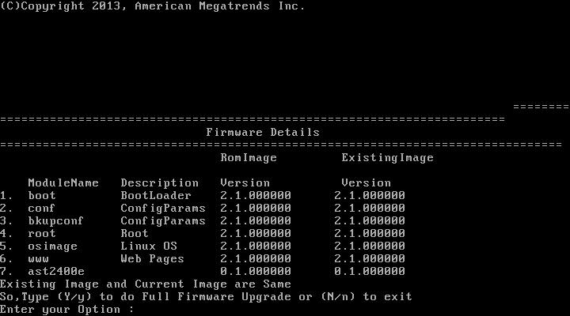 | Enter Y or y
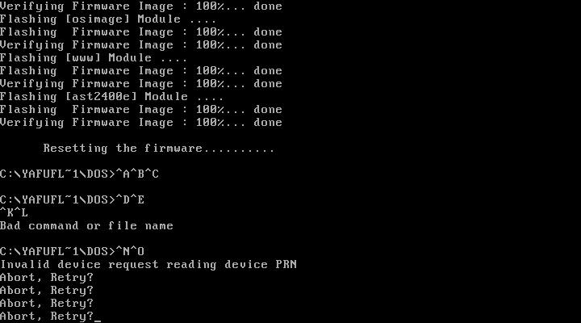 | Flash process without error, after the completion of display "Resetting the firmware………."
Step3. Confirm firmware version and network information in web
- Navigate to Dashboard
- Check the Device Information and Network Information is current
Step4. Confirm firmware version information in BIOS
- Boot in to BIOS
- Check the BMC Version correctly

Step5. Confirm network information in BIOS
Navigate to Server Mgmt -> BMC Network Configuration
- Check that the BMC MAC is correct
- Can get IP via DHCP

5. YAFUFLASH usage
Usage: Yafuflash [OPTION] [FW_IMAGE_FILE]
Perform BMC Flash Update
-? Displays the utility usage
-h Displays the utility usage
-V Displays the version of the tool
-e List outs a few examples of the tool
OPTION :
-info Displays information about current FW and new FW.
-msi,-img-section-info Displays information about current FW Sections.
-mi,-img-info Displays information about current FW Versions.
-fb,-force-boot Option to FORCE BootLoader upgrade during full upgrade.
Also, skips user interaction in Interactive Upgrade mode.
This option is not allowed with interactive upgrade option
-pc,-preserve-config Option to preserve Config Module during full upgrade.
If platform supports Dual Image, this option skips user
interaction, preserves config and continues update process.
This option is not allowed with interactive upgrade option.
-ipc,-ignore-platform-check If this image is for a different platform, this option skips
user interaction and continues update process.
-idi,-ignore-diff-image If this image differs from the one currently programmed, this
option skips user interaction and continues update process.
-isi,-ignore-same-image If this image is same as the one currently programmed, this
option skips user interaction and continues update process.
-iml,-ignore-module-location If module(s) of this image is/are in a different location, this
option skips user interaction and continues update process.
-ibv,-ignore-boot-version If bootloader version is different and -force-boot is not specified,
this option skips user interaction and continues update process.
The bootloader will be updated.
-iri,-ignore-reselect-image This option skips reselecting the active image.
-inc,-ignore-non-preserve-config If the Images of both flash share the same Configuration area.
Not preserving will restore to default factory settings, this option skips i
-msp,-split-img Use this option to flash split image.
-f-XXX,-flash-XXX Use this option to flash spection section where XXX denotes name of t
example -flash-conf. If it is split image need to give -split-img along with
-q,-quiet Use the option to show the minimum flash progress details.
-i Option to interactive upgrade (upgrade only required Modules)
-f,-full Performs full upgrade in Interactive Upgrade mode.
Skips module wise upgrade.
-sc,-skip-crc Option to skip the CRC check
-sf,-skip-fmh Option to skip the FMH check
-d Option to specify the peripheral(Only for Dual Image Support)
<BIT0> - BMC
<BIT1> - BIOS
<BIT2> - CPLD
-mse,-img-select Option to specify the Image to be updated
0 - Inactive Image
1 - Image 1
2 - Image 2
3 - Both Images
-a,-activate Option to activate peripheral devices
<BIT0> - BMC
<BIT1> - BIOS
<BIT2> - CPLD
-nr,-no-reboot Option to skip the reboot
-pXXX,-preserve-XXX Option to preserve XXX configuration and it will ask for other configu
where XXX falls in sdr, fru, sel, ipmi, auth, net, ntp, snmp, ssh, kvm, sysl
-pXXX,-preserve-XXX -ieo,-ignore-existing-overrides Option to preserve only XXX configuration
-ignore-existing-overrides must be used with preserve-XXX option
-rp,-replace-publickey Option to replace the Signed Image Key in Existing Firmware
-vcf,-version-cmp-flash Option to skip flashing modules only if the versions are same
MEDIUM :
-cd Option to use USB Medium
-nw,-ip,-u,-p,-host,-P Option to use Network Medium
'-ip' Option to enter IP, when using Network Medium
'-host' Option to enter host name, When using Network Medium
'-u' Option to enter UserName, When using Network Medium
'-p' Option to enter Password, When using Network Medium
'-P' Option to enter Port Number
-kcs Option to use KCS Medium
FW_IMAGE_FILE :
fw_image_file Firmware Image file name
-pe,-preserve-extlog Option to preserve extlog configuration during firmware flash

