

ASRockRack Technical Document (Jan/2015)

Q: I forget the Megarac SP GUI password, how could I do?
A: Please download BMCDefCh tool from below, and execute “bmcdefch y n” under DOS environment.
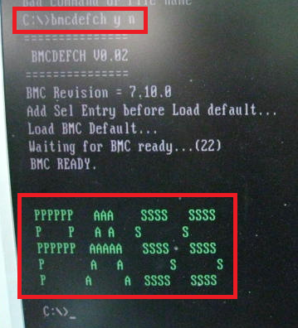
After that, it will shows pass, then please AC power off and power on once with the system.
It will load BMC default, and the default username and password are both “admin”.

BMCDefCh tool:

