

ASRockRack Technical Document (August/2022)

**Q: How to update BMC under EFI Shell?**

**Preparation:**

The BMC image file and BMC update tool should be at hand, here’s the update tool:



**Step:**

1. Decompress “uflash_v12207.zip” under a bootable USB drive.
2. Put the BMC image file you wish to update to in the same directory.
3. Boot up your system with UEFI: Built-in EFI shell.

(Press F11 while POSTing to enter boot menu and choose it)

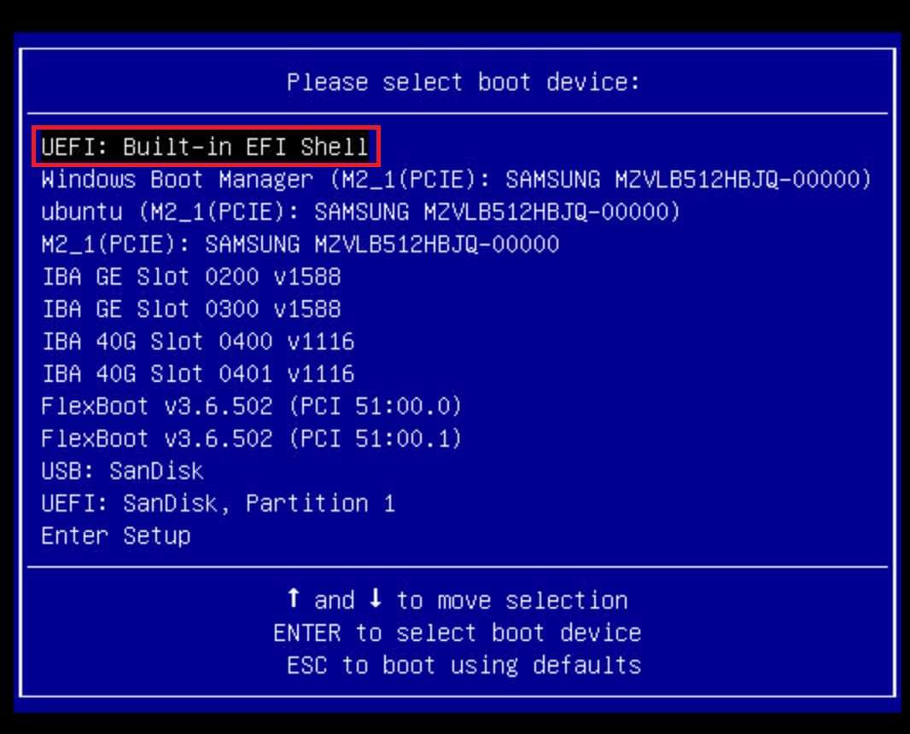

1. Execute: **socflash.efi if= *image_file_name\***

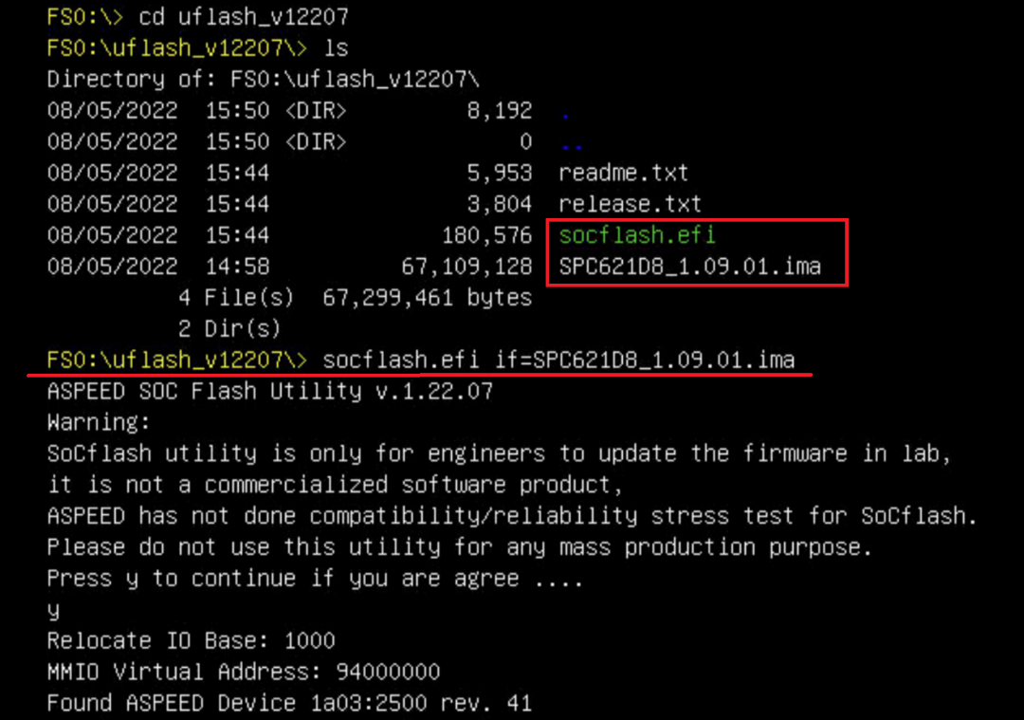

1. Wait until the update is finished. (It will show a message like “Update Flash Chip OK”)
2. Reboot and check the BMC version in the BIOS page.

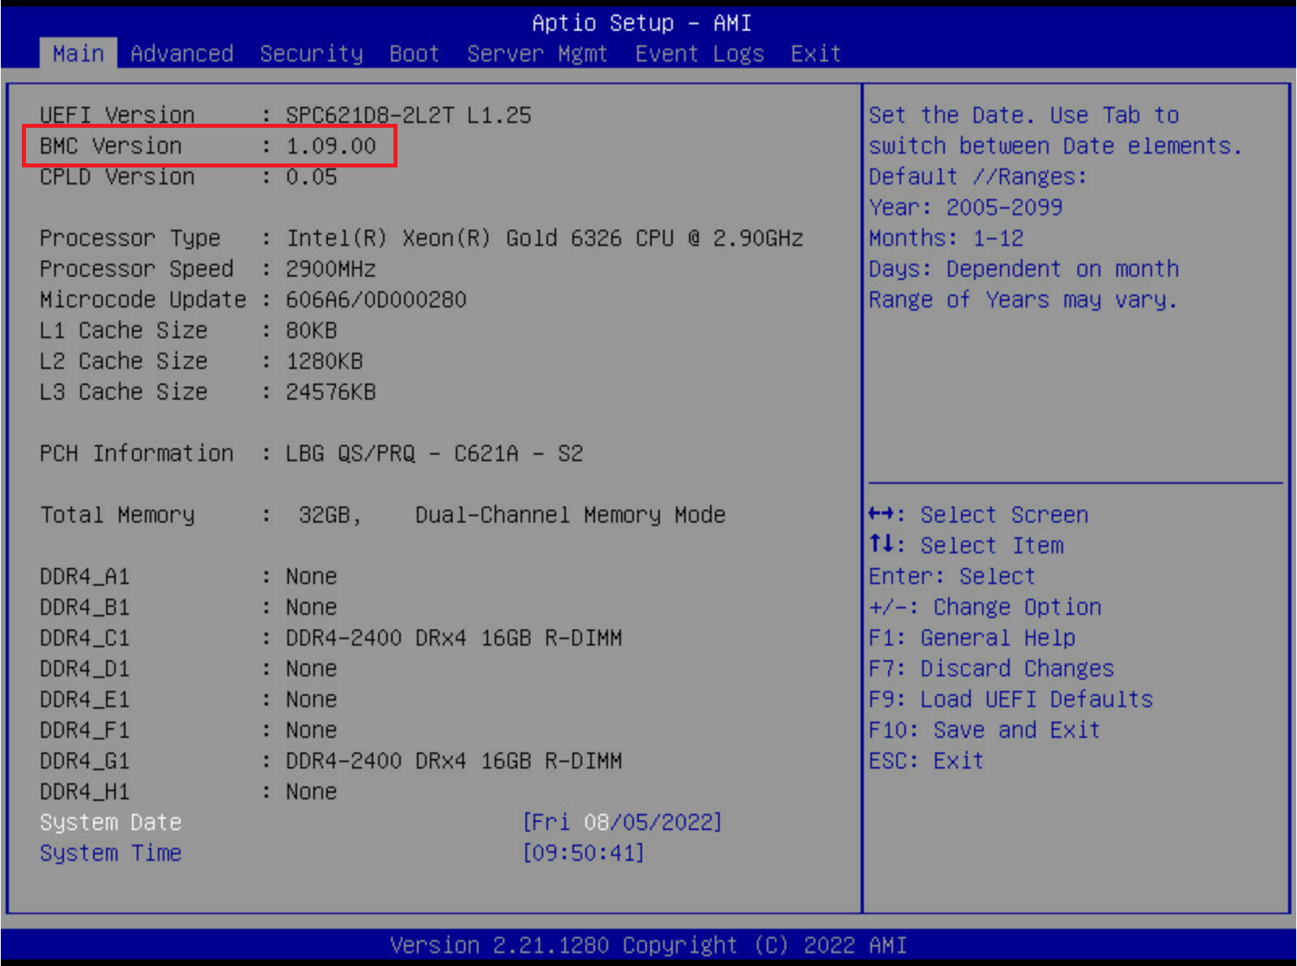

*\*If BMC version doesn’t show up, please disconnect AC power from the system for at least 20 seconds, then plug AC back on and check again.*

***-DONE-***