BIOS programmer user guide

ASRockRack Technical Document (May/2019)

Preparation:
- Operating system: WIN7(32bit 64bit)/WIN8。
- Driver: install by CD in programmer box

Steps:
- Insert BIOS programmer to your computer
- Use the CD in BIOS programmer box to install driver
- Follow the instruction to install driver
- After install complete, please open CH2013

- Check the link status at the bottom right of the window, then choose device type as “SPI flash”
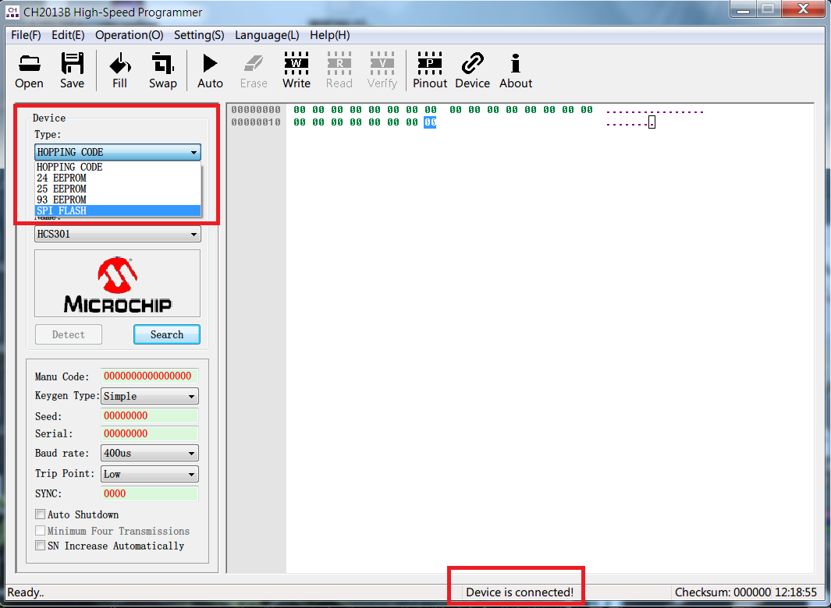

- Choose manufacturer randomly
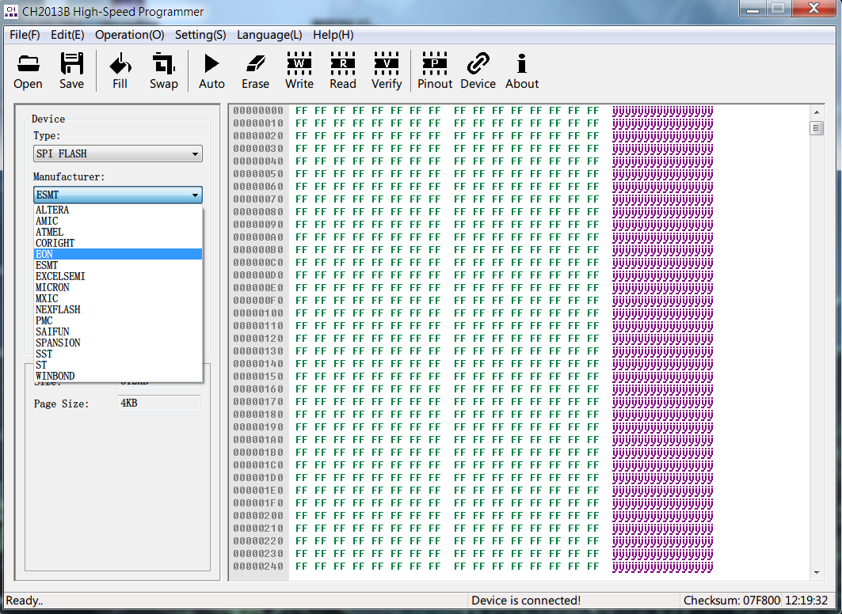

- Press detect to check if it can get the right ROM chip type (Ex: We send you the chip made by MXIC )
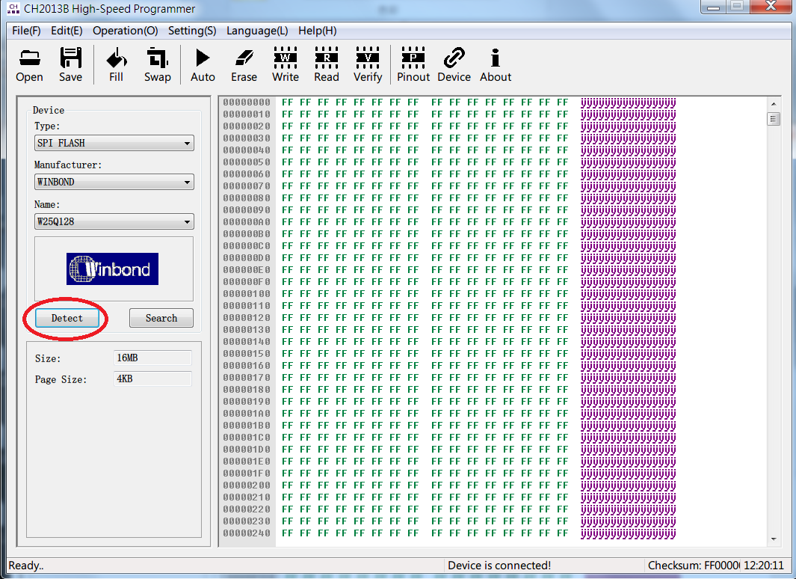

- Click open to select the BIOS image you want to update
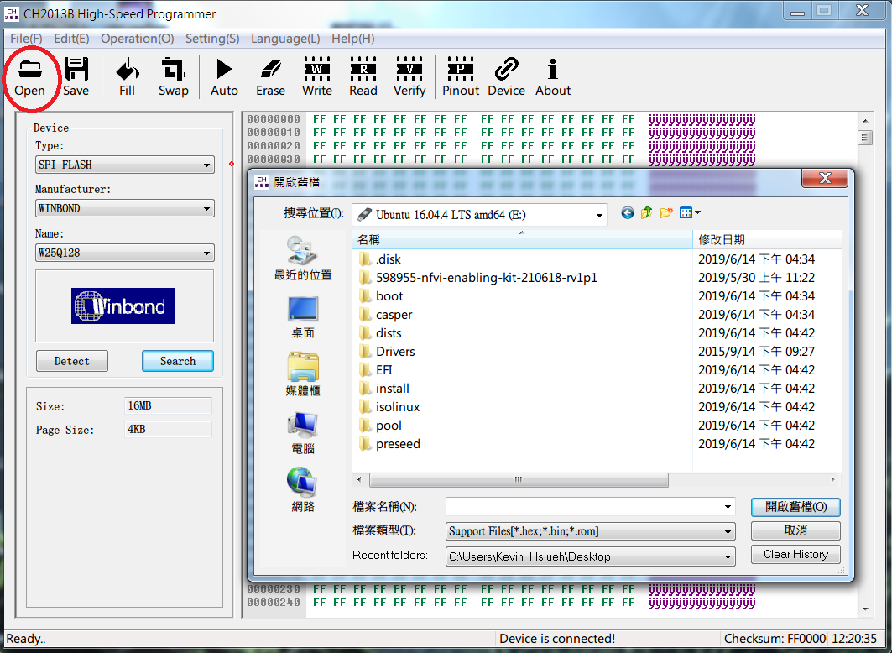

- Click Auto to flash ROM chip
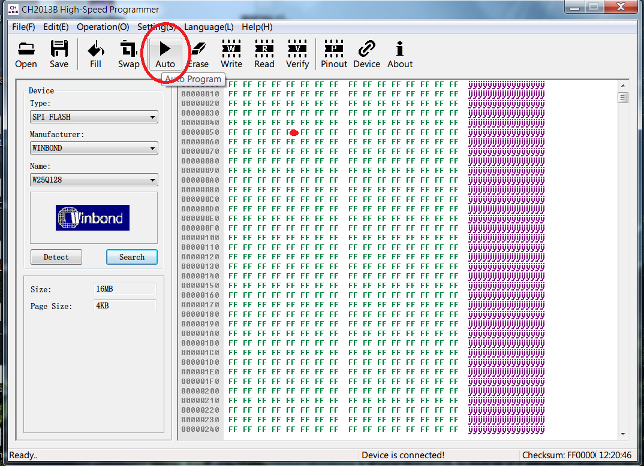

- During process
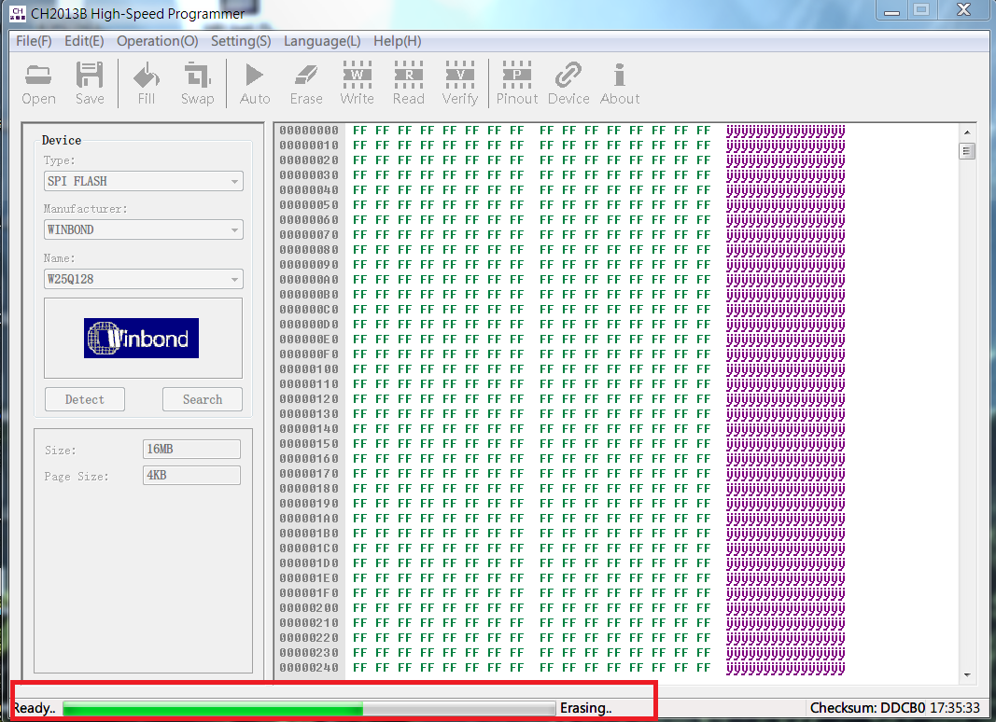

- It will show message at the bottom right after flash complete
