Clear CMOS (EPC621D8A)
- System AC OFF
- Remove coin battery (in yellow circle)
- Use coin battery to short CMOS jumper (in red circle)
(You need to keep touching about 5~10 second)
- Install coin battery back
- System AC ON
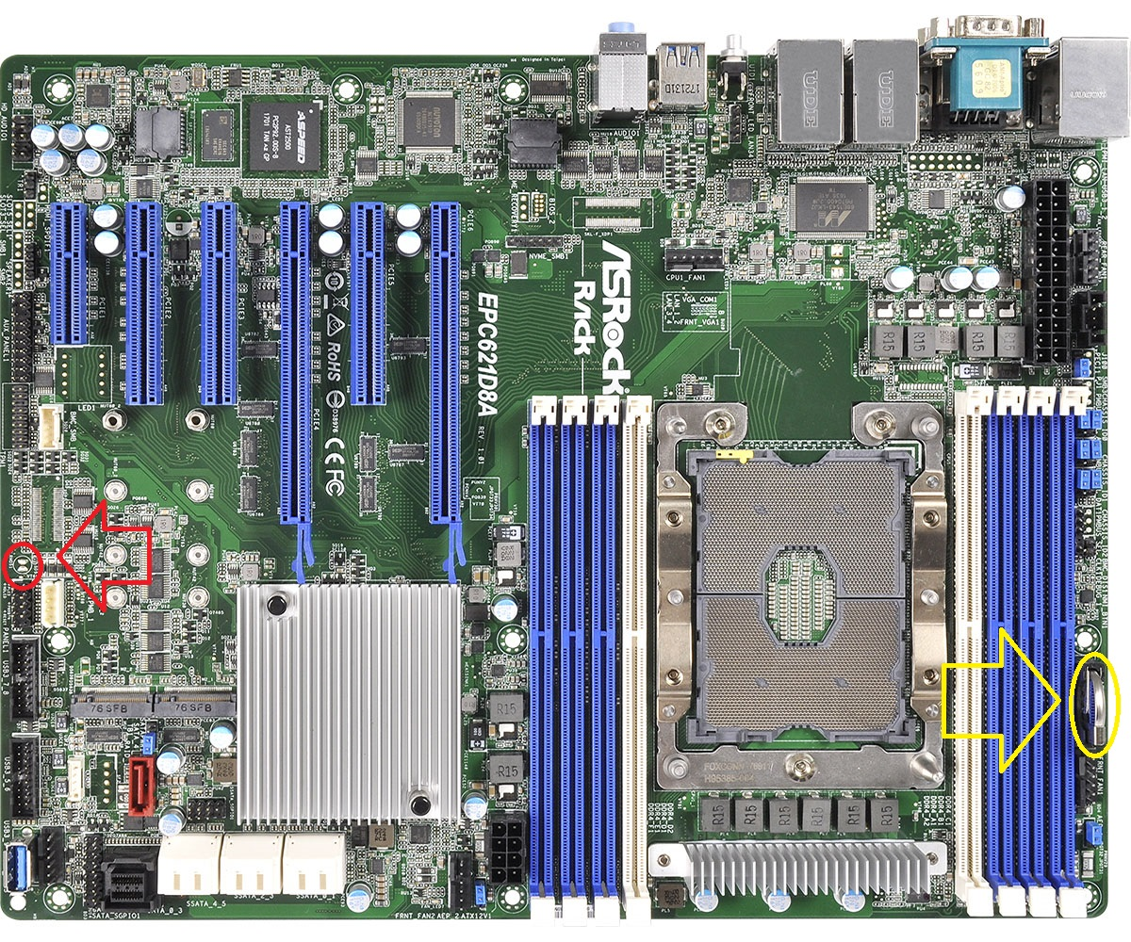
Zoom in picture for CMOS jumper & coin battery is in second page
