Clear CMOS (X299)
- System AC OFF
- Remove coin battery (in blue circle)
Then Change CMOS jumper (in red circle) location for 10 sec
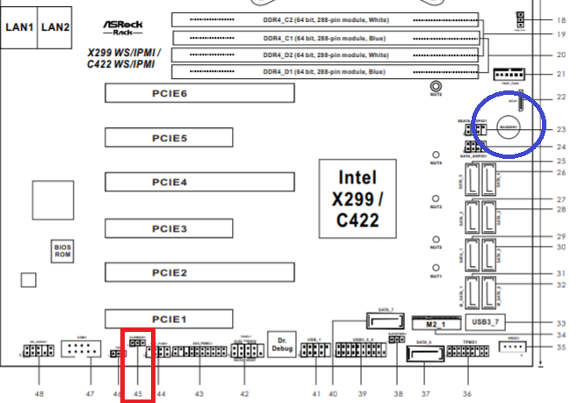
P.S Jumper setting
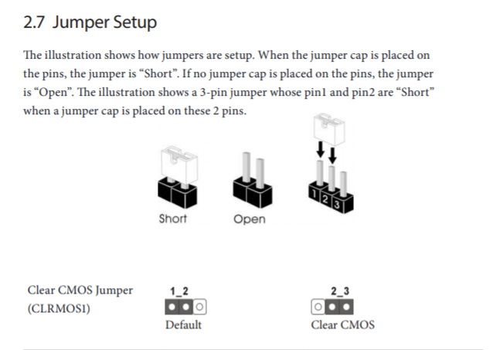
- Install coin battery back
- System AC ON

