ChangeLogo test SOP(EFI/Linux/Win)

Update time | Author | Note
2017/10/11 | Finnick_Jhou | First Release
2017/11/22 | David_Jhan | Update Support Platform
2019/02/25 | David_Jhan | Update ChangeLogoEfi Step3
2019/04/01 | David_Jhan | Update ChangeLogoEfi
2019/06/18 | David_Jhan | Update Support Denverton
Support Platform:
Purley
skylake-h (44e)
D1541D4Y (3U16N)
Denverton

Test tool link : \\ar-ebios-03\BIOS\UTILITY\ChangeLogo\5.02\ChangeLogoEfi.Package
Test Script link: \\ar-file-01\FWQT\TestTool\BIOS\Chagnelogoefi_nsh

ChangeLogoEfi
Step1.
- Format USB Flash of Aging test
- \\ar-ebios-03\BIOS\UTILITY\ChangeLogo\5.02\ChangeLogoEfi.Package
- Copy files and folder to USB Flash (ex. E:\ )
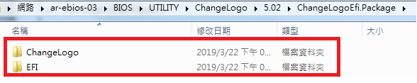
Step2.
- Test script : \\ar-file-01\FWQT\TestTool\BIOS\Chagnelogoefi_nsh --> Startup.nsh
- Copy files to USB Flash (ex. E:\ )
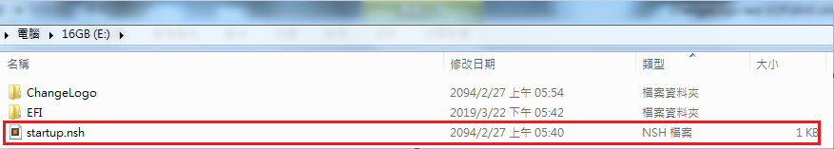
Step3. Sample-> EP2C621D12 WS
- Copy BIOS ROM(2P621WS2.04) and Logo file to USB Flash (ex. E:\ChangeLogo )
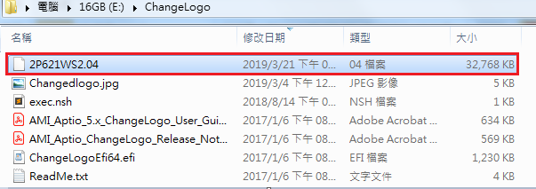
Step3. Sample-> EP2C621D12 WS
- Edit E:\Startup.nsh
- Change normal BIOS(ex. 2P621WS2.04) and special BIOS(ex. 2P621WS2.04L) for testing project
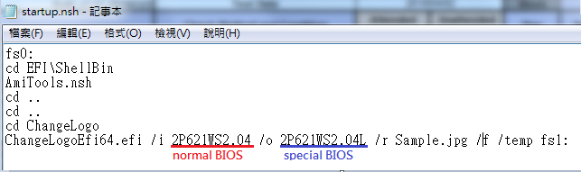

Step4.
- Boot to UEFI: USB Flash
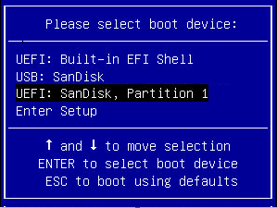
Step5.
- SUT will execute Startup.nsh automatically.
- System will halt to execute chagne logo app at screen about 10~30 sec .
- Check SUT will show information with red line is normal.
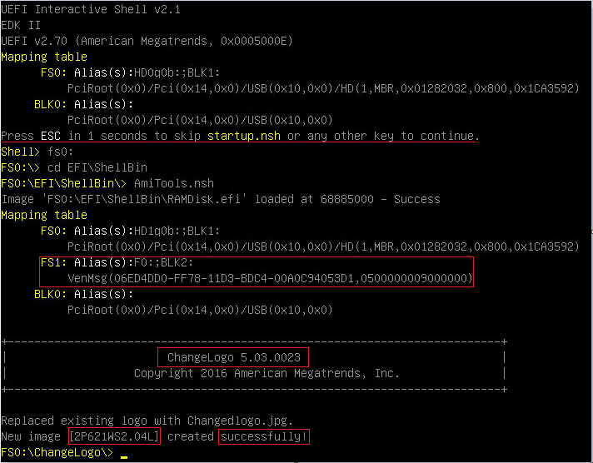
Step6.
- Reboot and press F6 and choose special BIOS (ex. 2P621WS2.04L) in instant flash list.
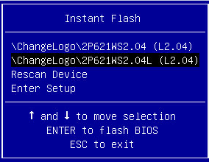
Step7.
- Update BIOS is completed, check Boot Logo will change to Test Logo.(Not ASrockRack Logo)
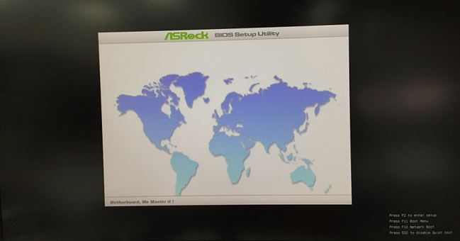
Step8.
- Check BIOS setup BIOS Version same to Normal BIOS.
- Update BIOS to normal BIOS (ex. 2P621WS2.04)
- Update BIOS is completed, check Logo and BIOS Version is normal.
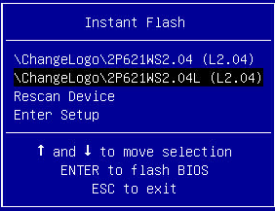
END

ChangeLogoWin
Step1.
- Open \\Ar-ebios-03\bios\UTILITY\ChangeLogo\5.02\ChangeLogoWin\64
- Copy files and folder to OS desktop
Step2. (sample ODC5200)
Test Logo: \\ar-ebios-03\BIOS\UTILITY\AsrUefiLogo --> Sample.jpg
- Copy BIOS ROM(hs1ba105.bin) and Logo file to OS desktop
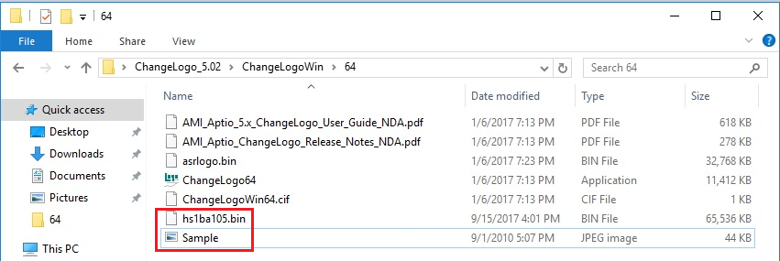
Step3.
- Under this folder open command.
- Execute ChangeLogWin tool follow “AMI_Aptio_5.x_ChangeLogo_User_Guide_NDA” format.
format : ChangeLogo64.exe /i BIOS_ROM /o New_BIOS_ROM /r Logo_file /f
- If New BIOSROM create is completed, system will show message “Replaced existing logo with Sample.jpg. New image [New BIOS.bin] created successfully!”
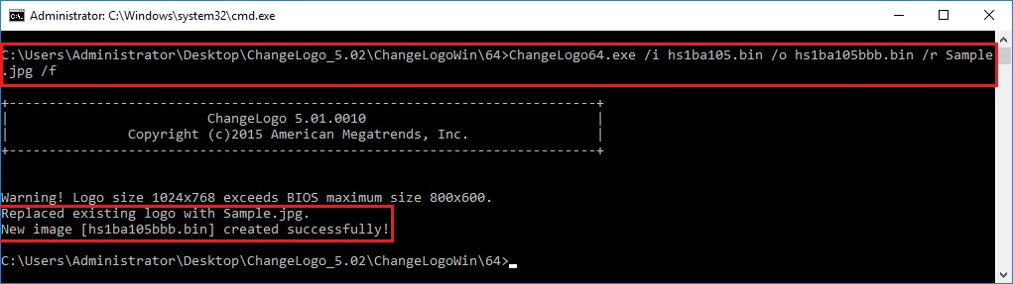
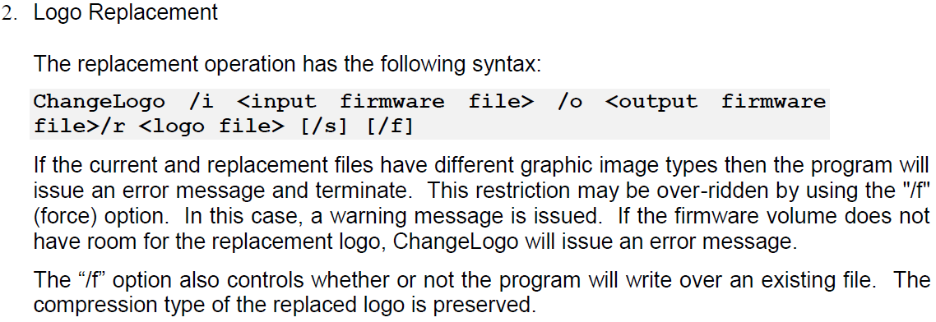

Step4.
- System will created New BIOS ROM on same folder.
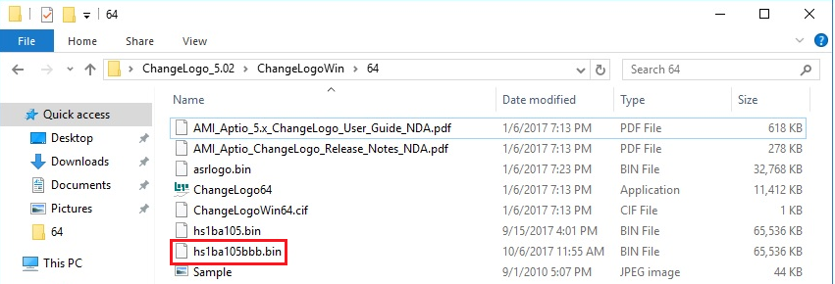
Step5.
- Copy BIOS ROM.
- Use this model support update Tool to flash BIOS.
- Update BIOS is completed, check Boot Logo will change to Test Logo.(Not ASrockRack Logo)
Step6.
- Check BIOS setup BIOS Version same to Normal BIOS, and can boot into OS work normal.
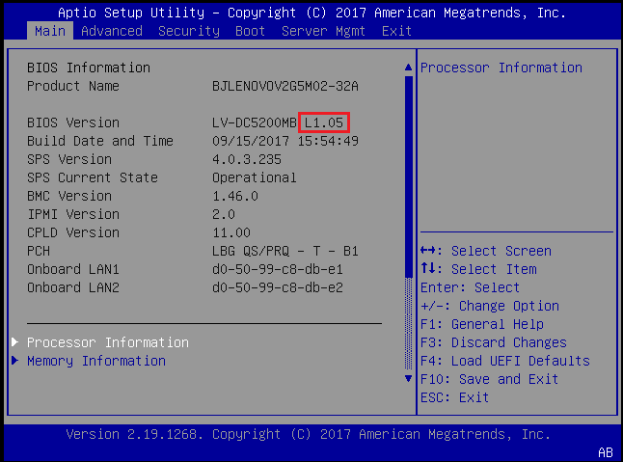

Step7.
- Use F6 to update Normal BIOS.
- Update BIOS is completed, check Logo and BIOS Version is normal.
END

ChangeLogoLnx
Step1.
- Open \\Ar-ebios-03\bios\UTILITY\ChangeLogo\5.02\ChangeLogoLnx\64
- Copy files and folder to OS desktop
Step2. (sample ODC5200)
Test Logo: \\ar-ebios-03\BIOS\UTILITY\AsrUefiLogo --> Sample.jpg
- Copy BIOS ROM(hs1ba105.bin) and Logo file to OS desktop
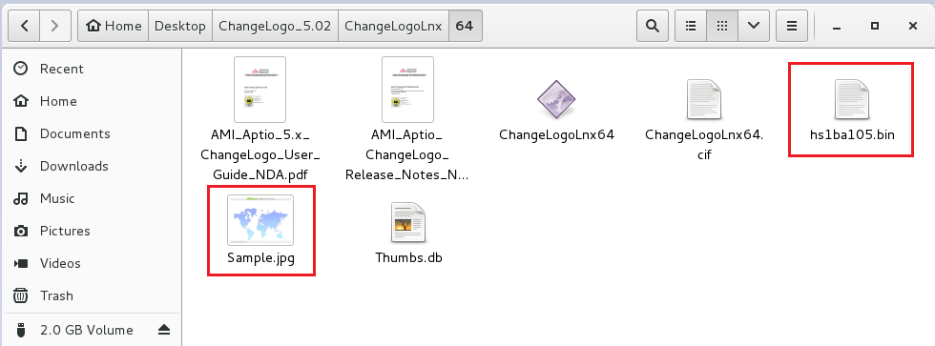
Step3.
- Under this folder open Terminal.
- Execute “ chmod 777 * “
- Execute ChangeLogLnx tool follow “AMI_Aptio_5.x_ChangeLogo_User_Guide_NDA” format.
format : ChangeLogoLnx64 /i BIOS_ROM /o New_BIOS_ROM /r Logo_file /f
- If New BIOSROM create is completed, system will show message “Replaced existing logo with Sample.jpg. New image [New BIOS.bin] created successfully!”
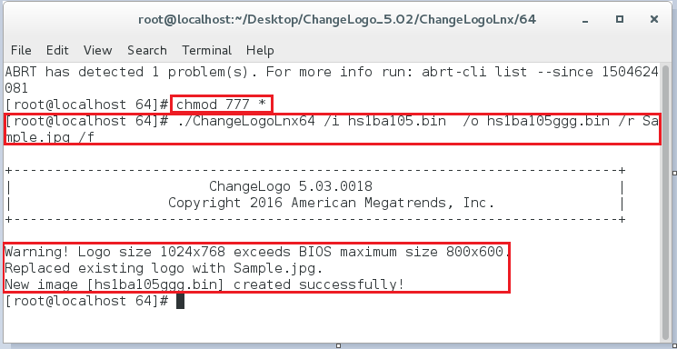
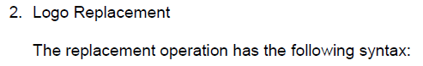
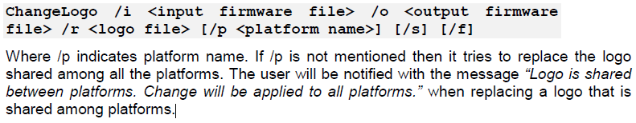
Step4.
- System will created New BIOS ROM on same folder.
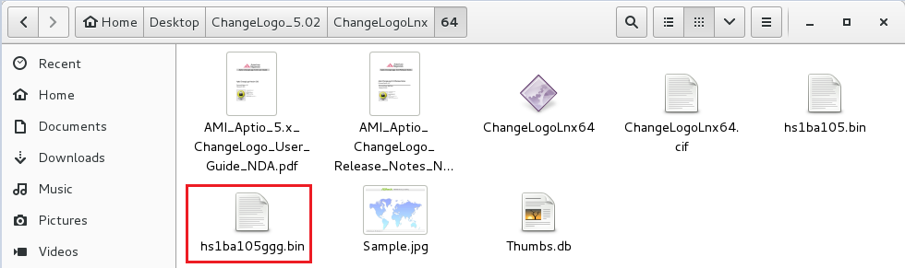
Step5.
- Copy BIOS ROM.
- Use this model support update Tool to flash BIOS.
- Update BIOS is completed, check Boot Logo will change to Test Logo.(Not ASrockRack Logo)
Step6.
- Check BIOS setup BIOS Version same to Normal BIOS, and can boot into OS work normal.
Step7.
- Use F6 to update Normal BIOS.
- Update BIOS is completed, check Logo and BIOS Version is normal.
END

