Com port BIOS debug mode SOP

- First you need to prepare a MB with com port then install “Putty” in it
- Use com port cable to link between the systems.
- Just use the setting in the red circle.
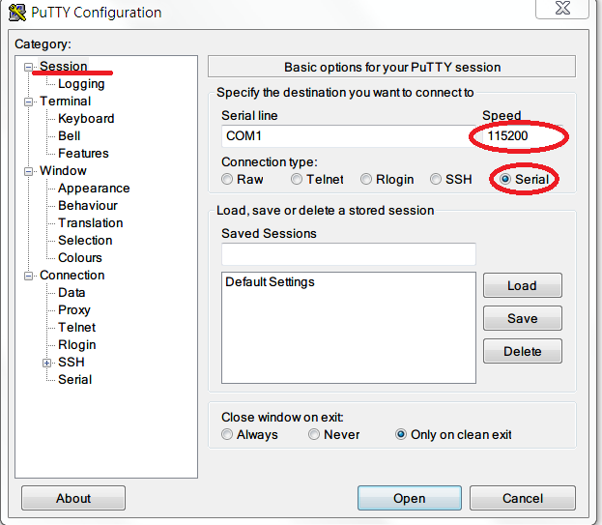
- Choose all session output.
And Log file name is to choose where you want to put the log file.
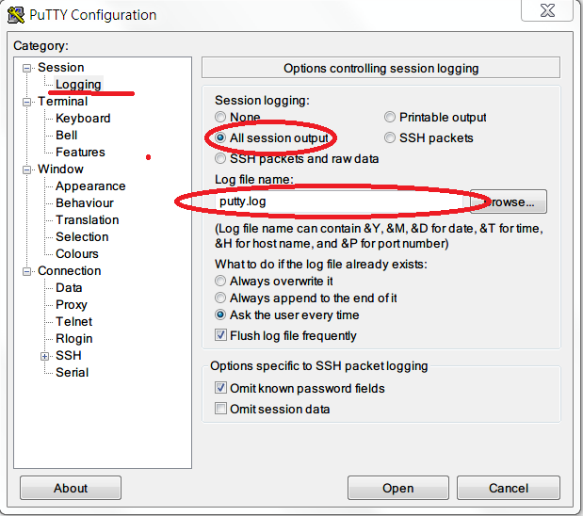

- Before you start to log the message, please turn off the system which you want to record, and then click open.
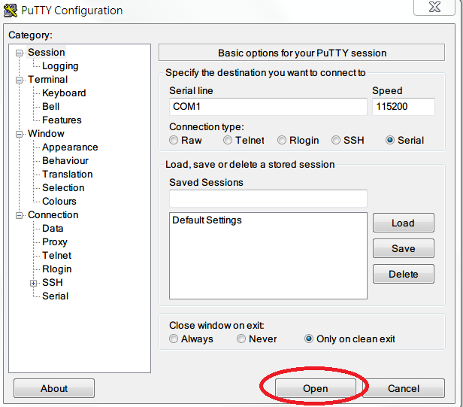

- Following window will show up after you start the Putty, and then you can boot up the system which you want to log (after you boot up the system, there should run a lot of message in below window.)
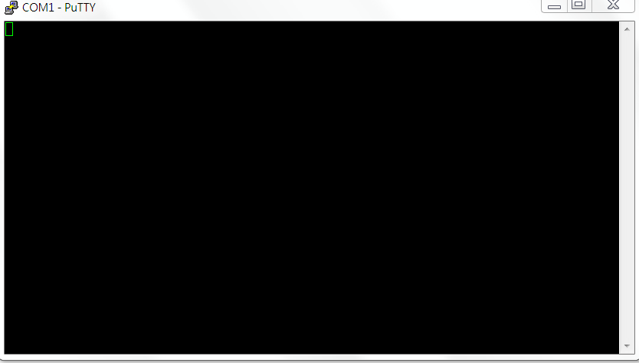
- If the log shows as garbled, you can use following setup:
Putty➔window➔translation➔”UTF-8”
