D1541D4I SNMP setting SOP

Preparation:
- SNMP detect tool: iReasoning
Download link➔ http://www.ireasoning.com/download.shtml
(Just download MIB Browser Personal Edition)
2. Host computer (receive SNMP trap)
3. Client computer (D1541D4I, with BIOS P1.20 or later)

Steps
- Update your BMC version to D1540D4I_L0.21.00 first
- Login IPMI GUI ➔ configuration ➔ SNMP
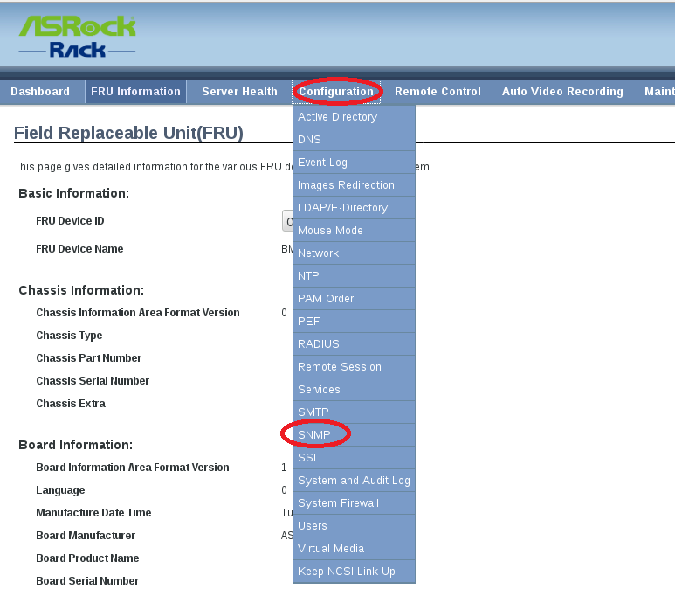

- Set “ro” & “rw” to any value you want (Ex: we set the value as “123”) and save
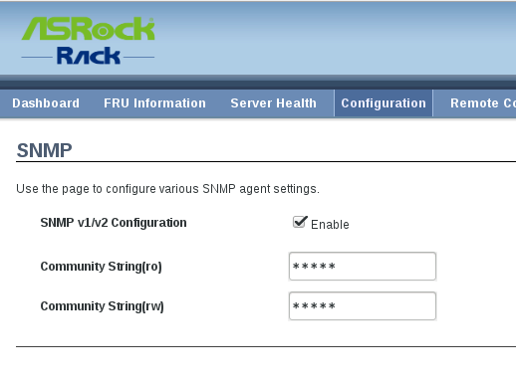
- Find PEF setting (path: configuration ➔PEF)
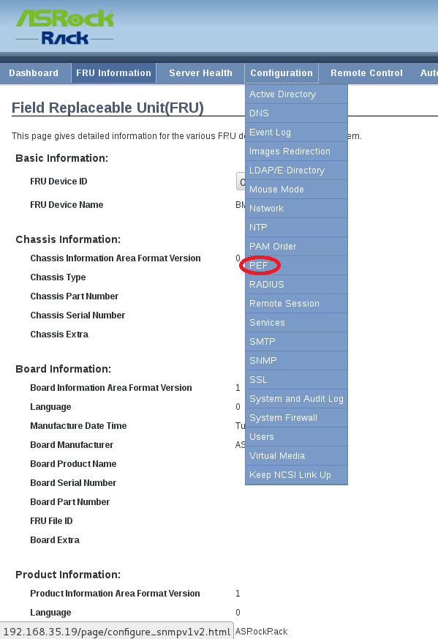

- Choose Event filter.
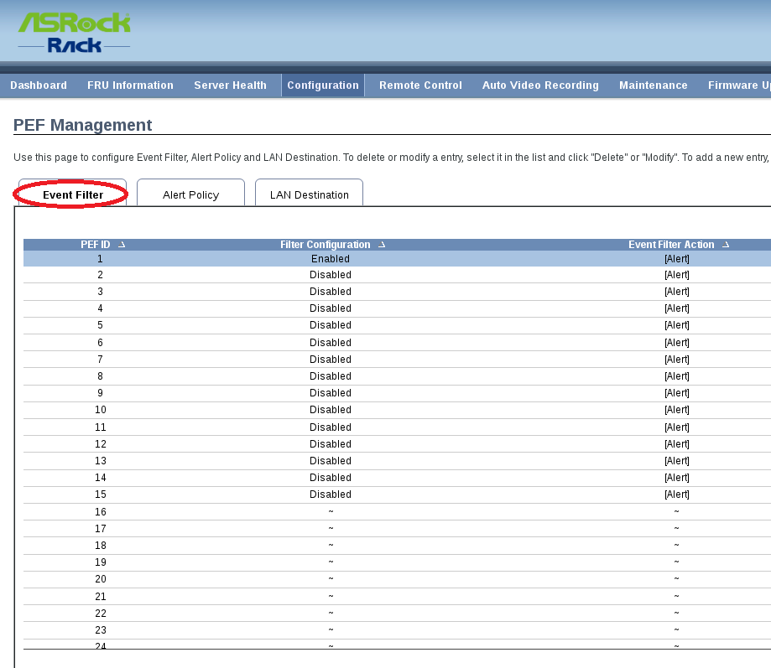
- Modify PEF ID.1 filter configuration as “Enable”
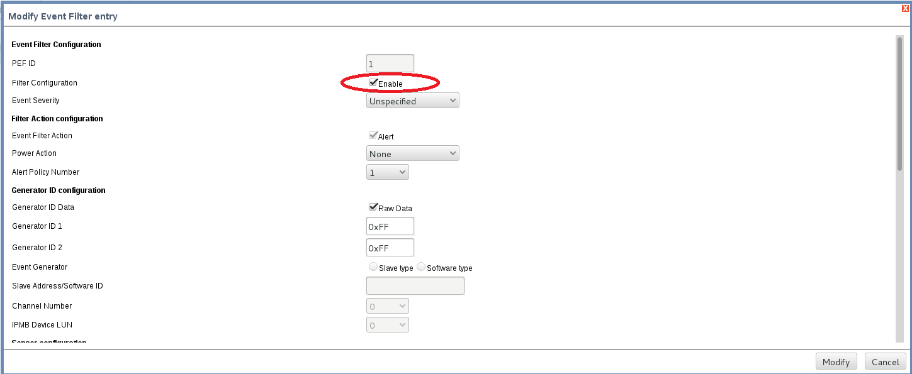

- Choose Alert policy
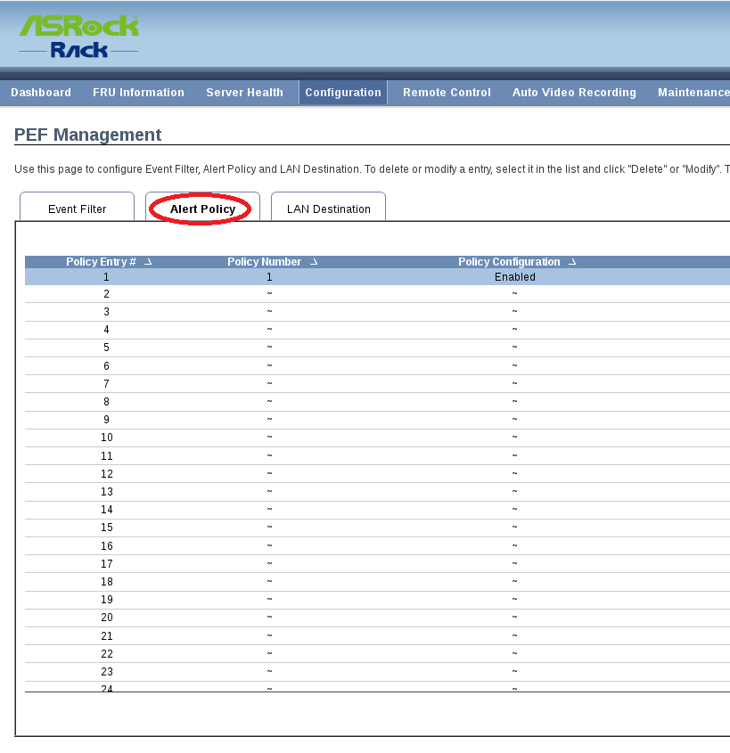
- Check if the policy number is set to “1” , and event specific must enable too.
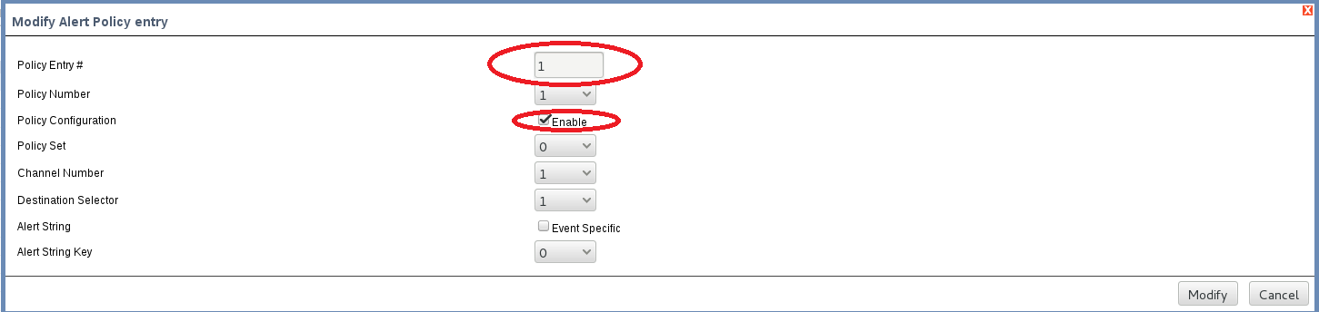

- Choose Lan destination
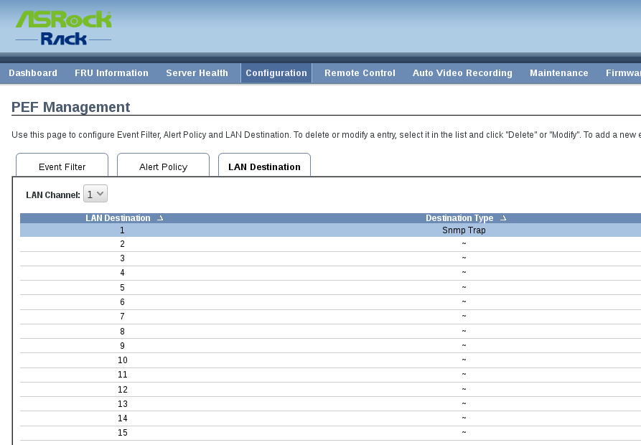

- Input your Host IP address and save.
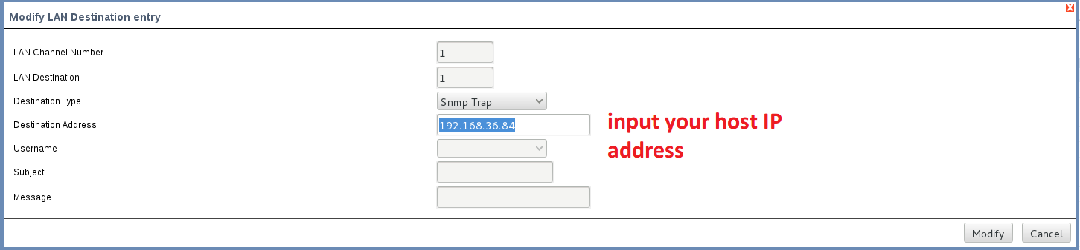

- Open iReasoning tool.
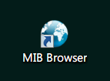

- Load your MIB file
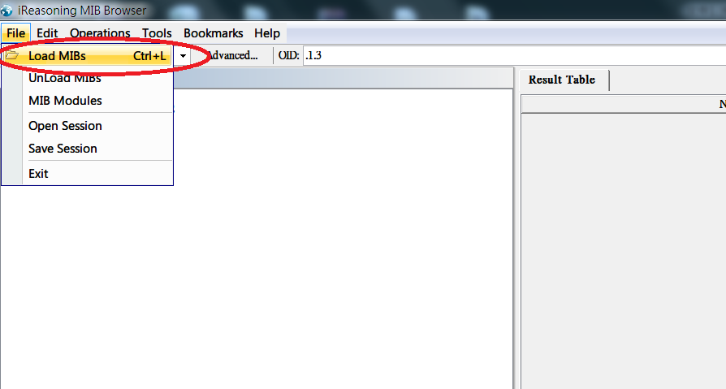

- Input client’s IP address.
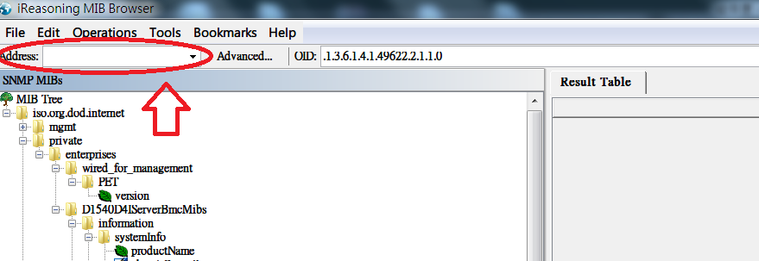

- Choose Advanced and set Read community (ro) and Write community (rw) the same value as step.3
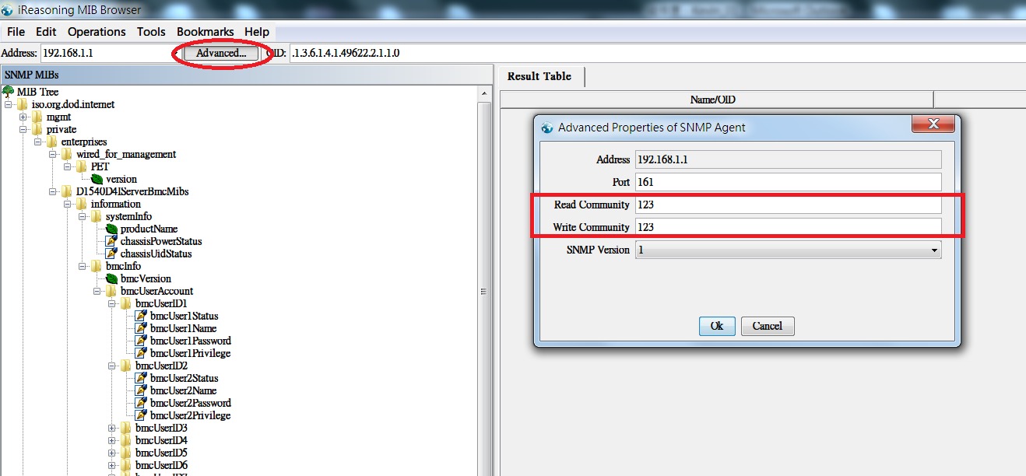
- Check if the sensor value can be read by clicking those sensor items in MIB tree….
(It will show description and data on the right window)
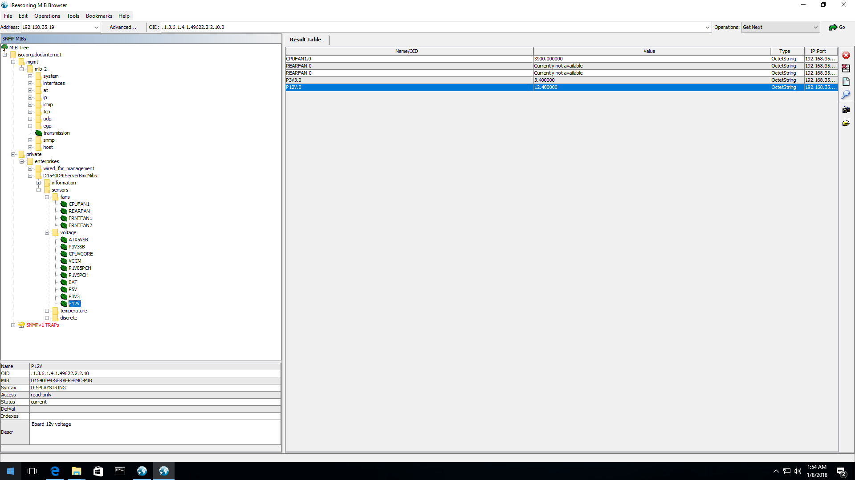

- Open trap receiver
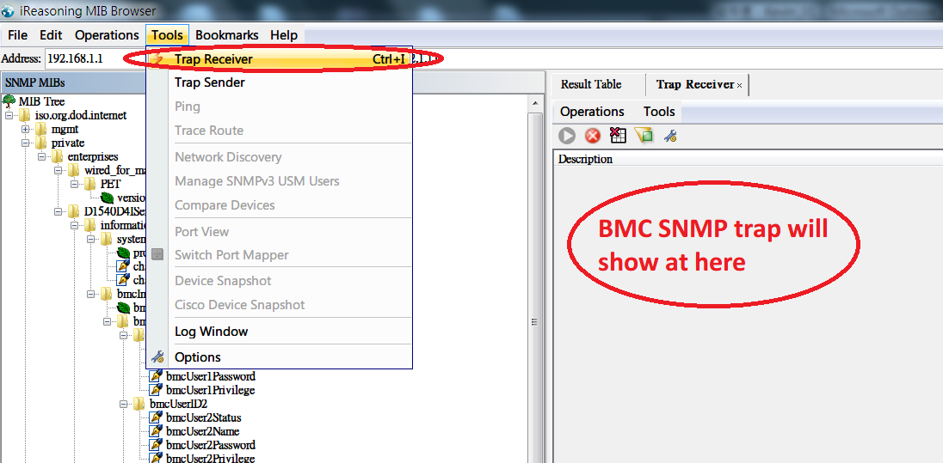

- Check Trap receiver function
IPMI GUI➔Server health➔sensor reading➔choose any sensor you want to test (For example: CPU tmp…)➔temporary set threshold to un-normal value (Ex: We set CPU tmp UNC to 40 Celsius)➔check if trap receiver can get warning message? ➔After the check complete, please restore default sensor value

>>>Sensor reading page
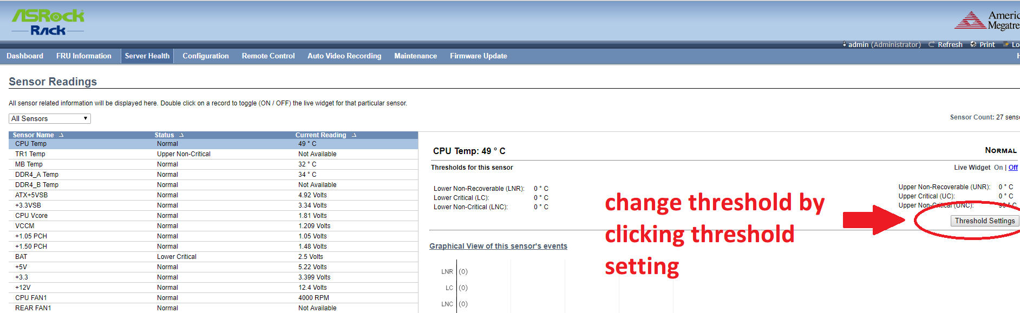

>>>iReasoning receive SNMP trap (CPU temperature warning)
