

ASRockRack Technical Document (Jan/2015)

Q: How could I re-write the Lan MAC address?
A: Please follow below steps to re-write the Lan MAC address:
- Find Lan MAC label on the rear IO of the motherboard, and write it down.
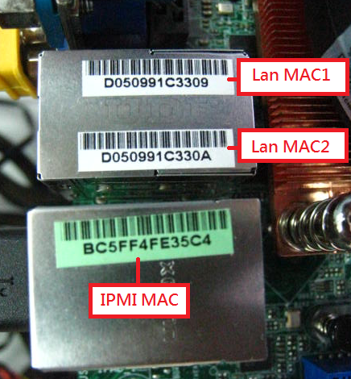
- Download MAC tool and keyin “mac c” under server DOS environment.

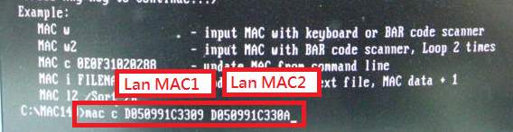
- When pass it will show below massage:
