

ASRockRack Technical Document (May/2015)
Q: How to flash BMC FW in DOS?
Preparation | :
- A boot USB drive
(P.S. you can build a boot USB drive by rufus https://rufus.akeo.ie/ )
- Update BMC Batch files folder
Step:
- Copy BMC ROM to “FlashBMC_DOS” folder and modify BMC ROM name to ROM.ima
- Use a bootable USB drive boot to DOS.
- Execute command “SOCwMAC.exe” to flash BMC firmware.
Flash process will take about 4 minutes, please wait.
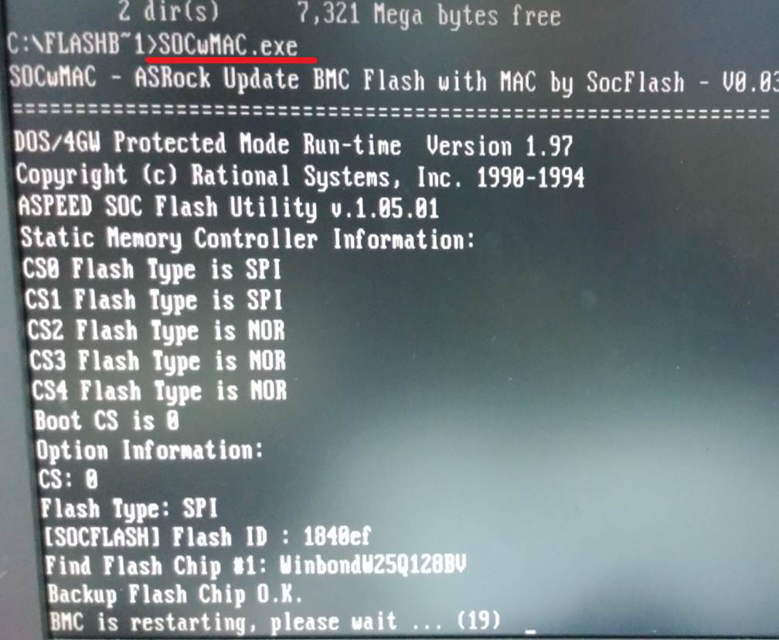

- Check BMC version in BIOS.
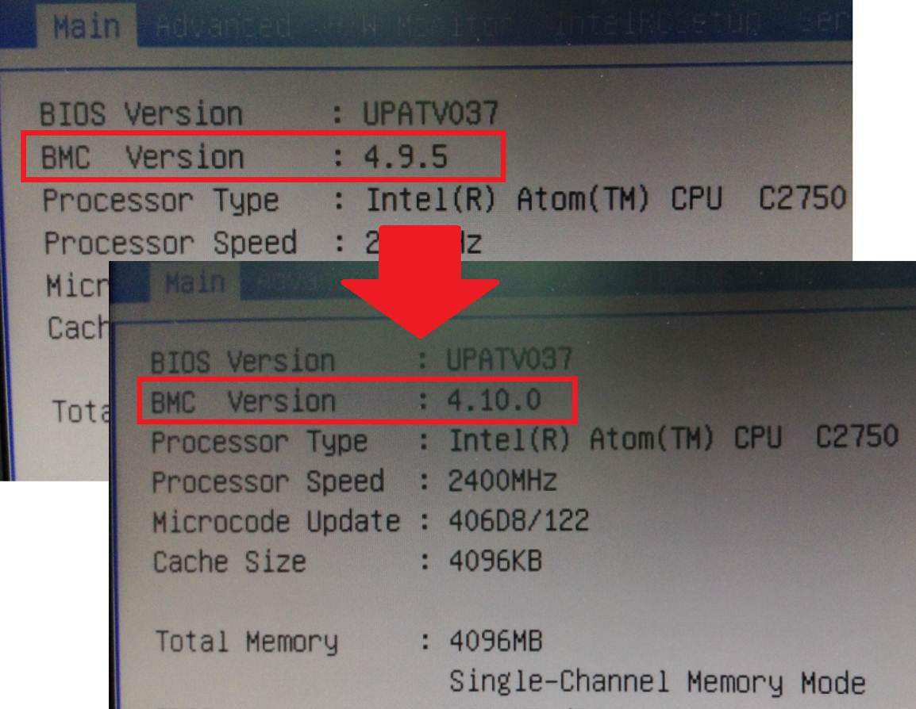
========================================================
Flash BMC firmware completed!

*If MAC address of IPMI and NCSI became 00-00-00-00-00-00, please use BMC Mac backup Tool in BIOS-> Server Mgmt-> Restore BMC MAC from backup to restore MAC address.
