EPYCD8-2T replace ROM chip and update FRU SOP
Install BIOS & BMC chip
- Make sure MB is in AC OFF mode
- Open BIOS & BMCROM socket

Location of BIOS/BMC socket
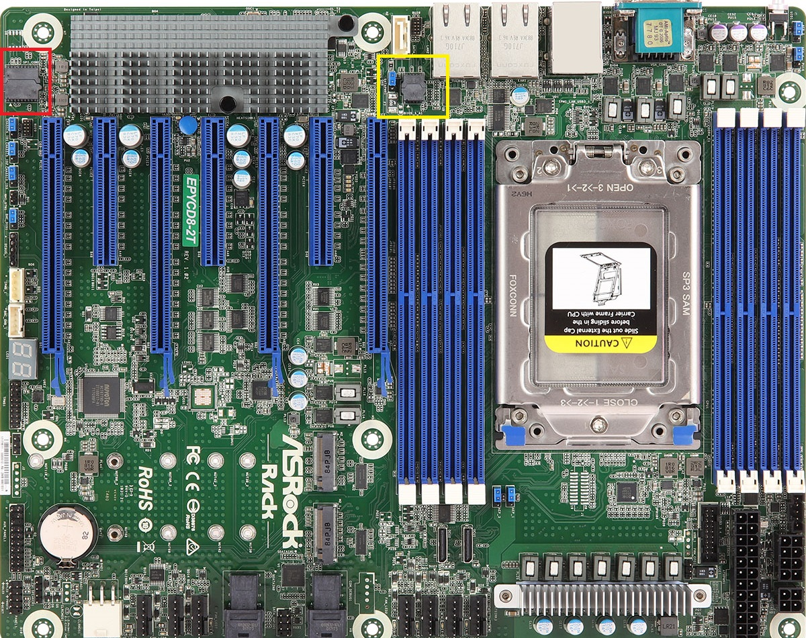
- Make sure the black dot on rom chip is at the same side of white arrow
BIOS:
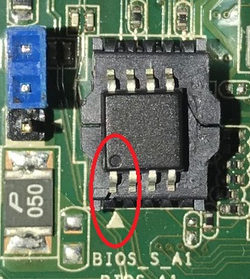
BMC:
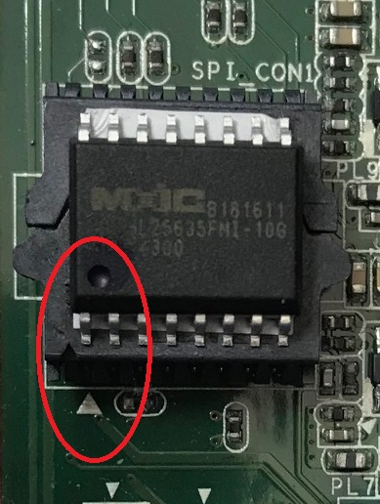

- After install AC ON system and check the version in BIOS. (version should be BIOS:L2.01Z BMC:L1.83.01)
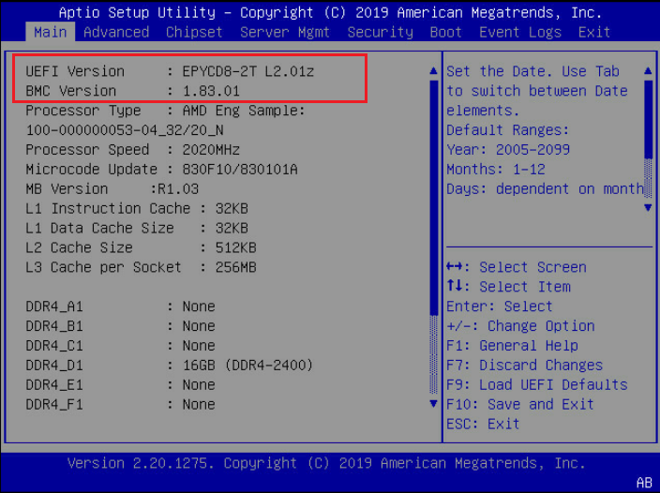

Update FRU SOP

Preparation:
- Download following FRU tool
- Bootable USB

Step:
- System power on and login BIOS main page
- Change BIOS>>Boot>>CSM “Enable”
- BIOS>>Boot>>Boot option filter “UEFI and Legacy”
- Press F10 to save setting and leave
- Put FRU file into USB then boot with USB
- Execute BPA.BAT file
- Reboot and check if FRU info is correct in IPMI web page or not?
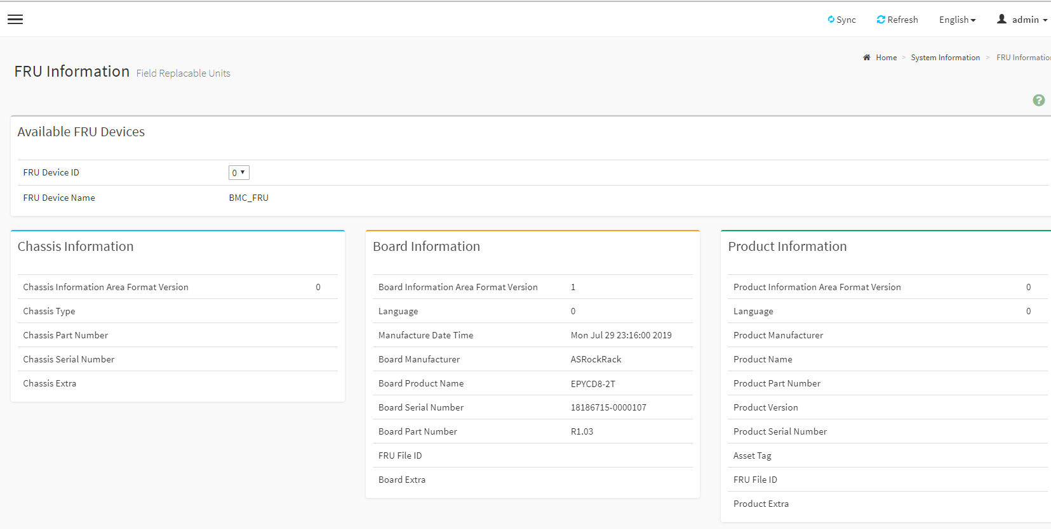
- Restore BIOS default by pressing F9 in BIOS main page, then Press F10 to save and leave

In addition, here is the stick location for showing BMC/BIOS version

BMC
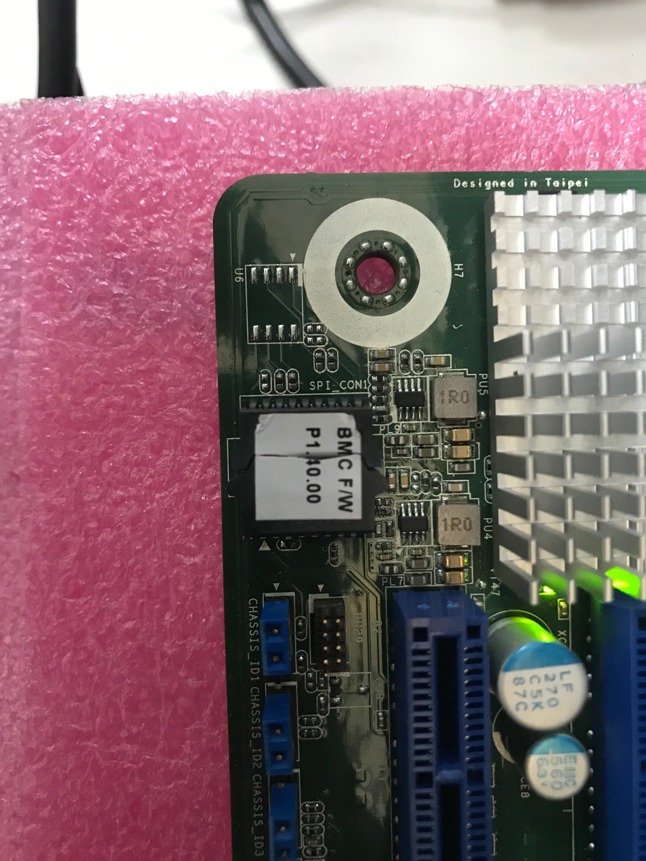
BIOS
