How to Launch VNC through putty/windows.
1. Download putty
2. Open command prompt and navigate to directory where putty.exe is placed.
3. Enable SSH session with BMC by issuing following command in terminal.
4. putty.exe -ssh -L {Any Port}:{BMC IP}:{VNC Non Secure Port} {BMC username}@{BMC IP} -pw {BMC password}
e.g. putty.exe -ssh -L 1234:localhost:5900 admin@10.0.124.130 -pw admin
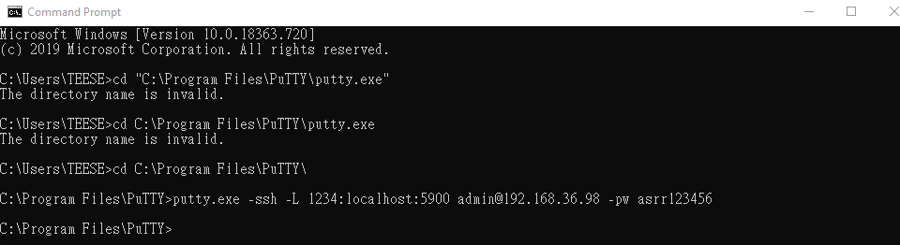
5. When you see the screen below in putty, it means putty link to VNC successfully
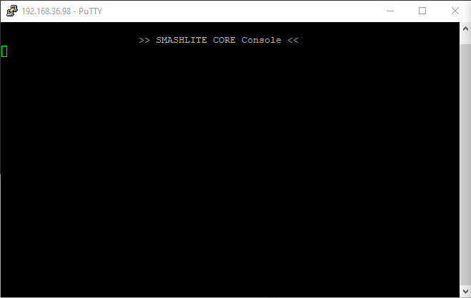

6. Launch VNC client with loopback IP address and port value (given in Any Port field). If successful VNC redirection should be started.
e.g. Launch VNC using 127.0.0.1:1234 by Tight VNC

