How to clean the thermal paste on heatsink

First you need to prepare:
- A pliers
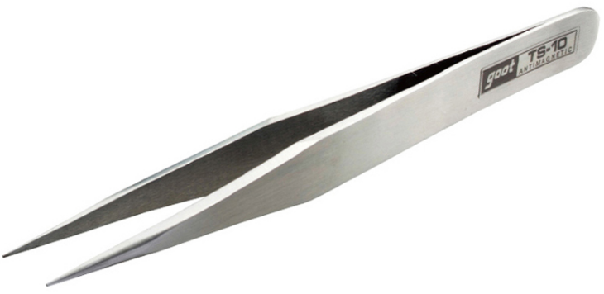
- A scraper
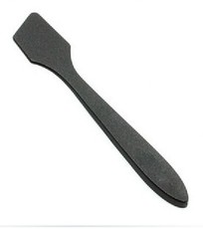
- Naphtha, Thinner or Alcohol
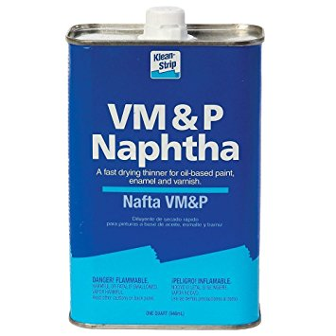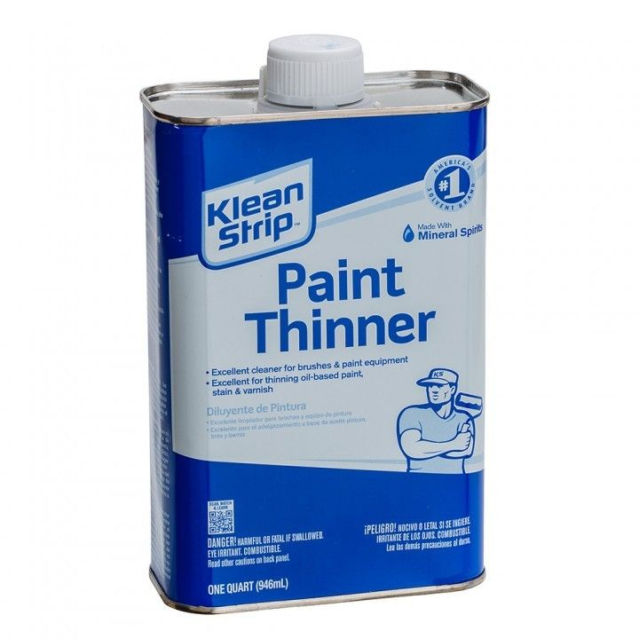

Step:
- Locate the Heatsink.
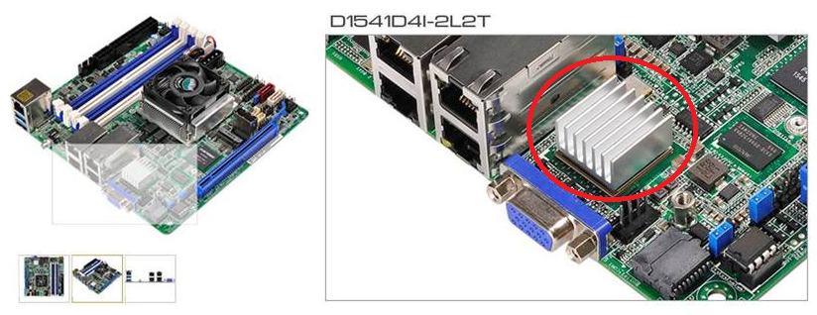
- Prepare a Heat Gun, set the temperature around 350 celsius, and the lowest wind speed, then heat the heatsink about 5 minutes (it should separate by 5 ~8cm between heatsink and heat gun), and then use tweezers to remove it.(Be careful not to touch the heatsink , because it is very hot at this moment)
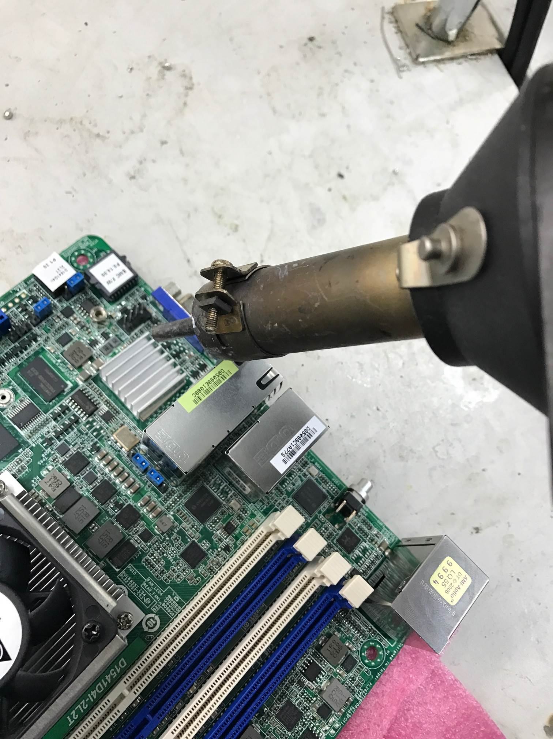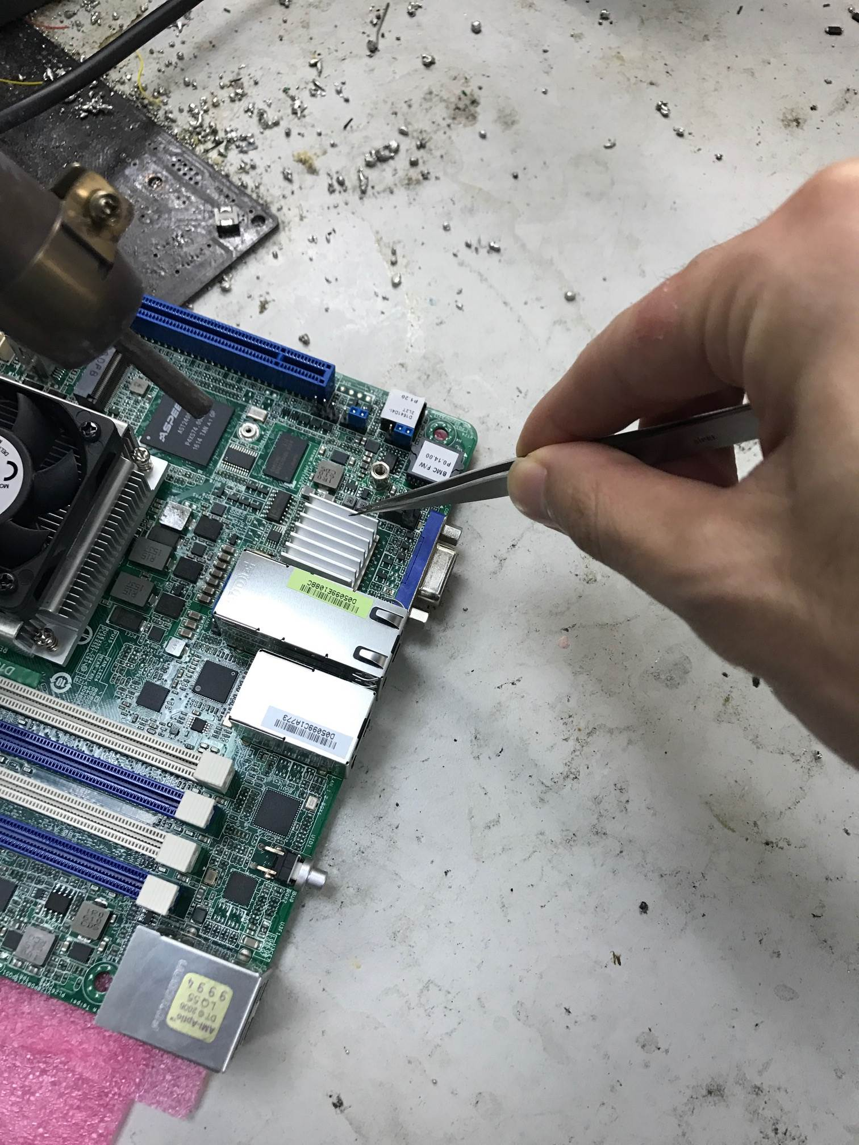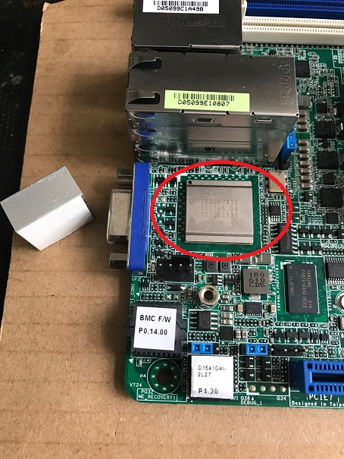
- There are two ways to clean the heat paste
- wipe clean with Naphtha or Thinner ➔ this cleaning effect is stronger and faster.
- wipe clean with Alcohol ➔ this cleaning effect is slower.
