How to remove X557 heat sink from D1541D4I-2L2T?

- First you need to prepare:
- A pliers
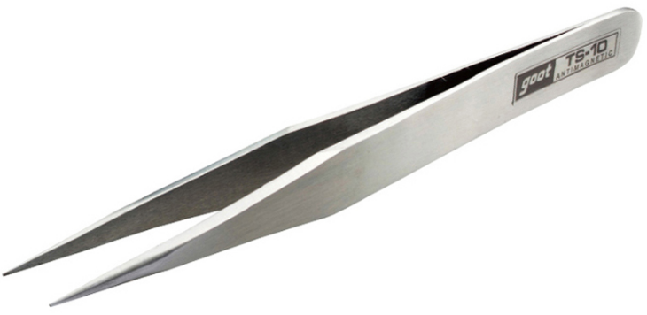
- Alcohol
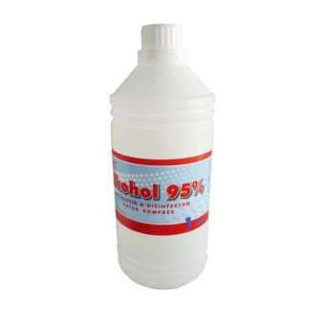
- Hair dryer
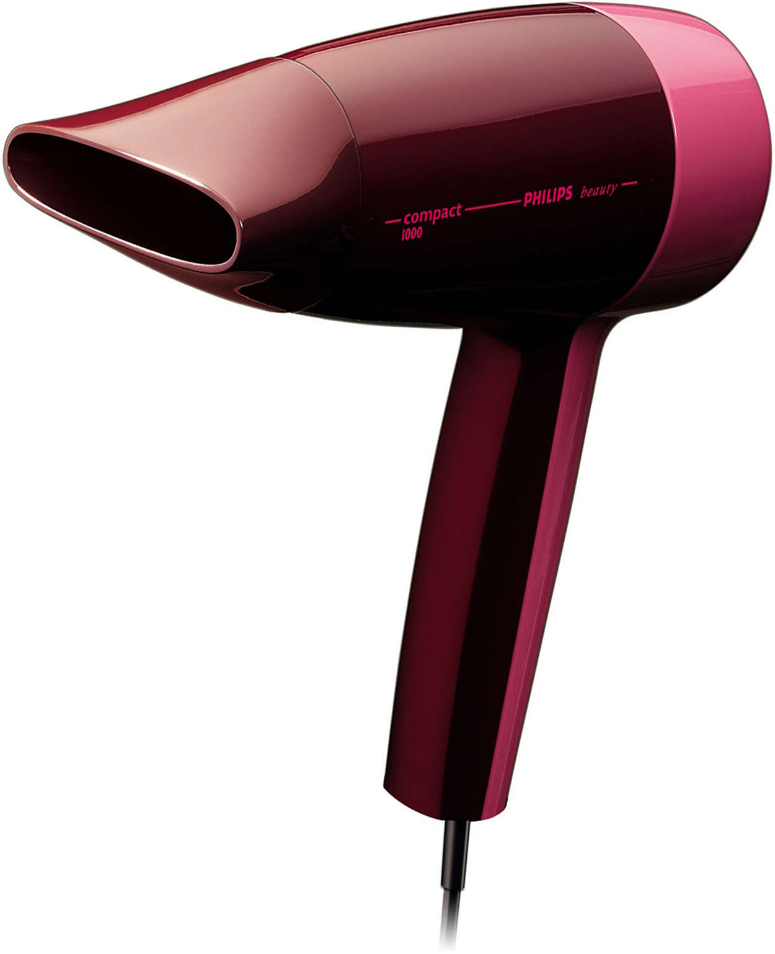

- Remove D1541D4I-2L2T X557 heat sink steps:
- X557 heat sink location of D1541D4I-2L2T.
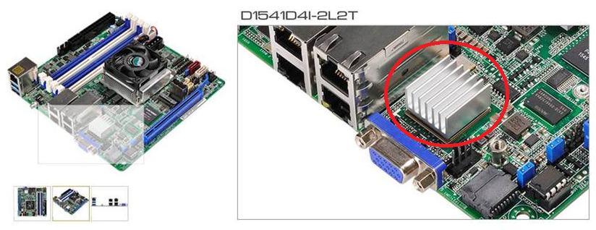
- Prepare a hair dryer, then heat the heatsink about 15 second (it should separate by 8~10 cm between heatsink and hair dryer), and then use tweezers to remove it.(Be careful not to touch the heatsink , because it is very hot at this moment)
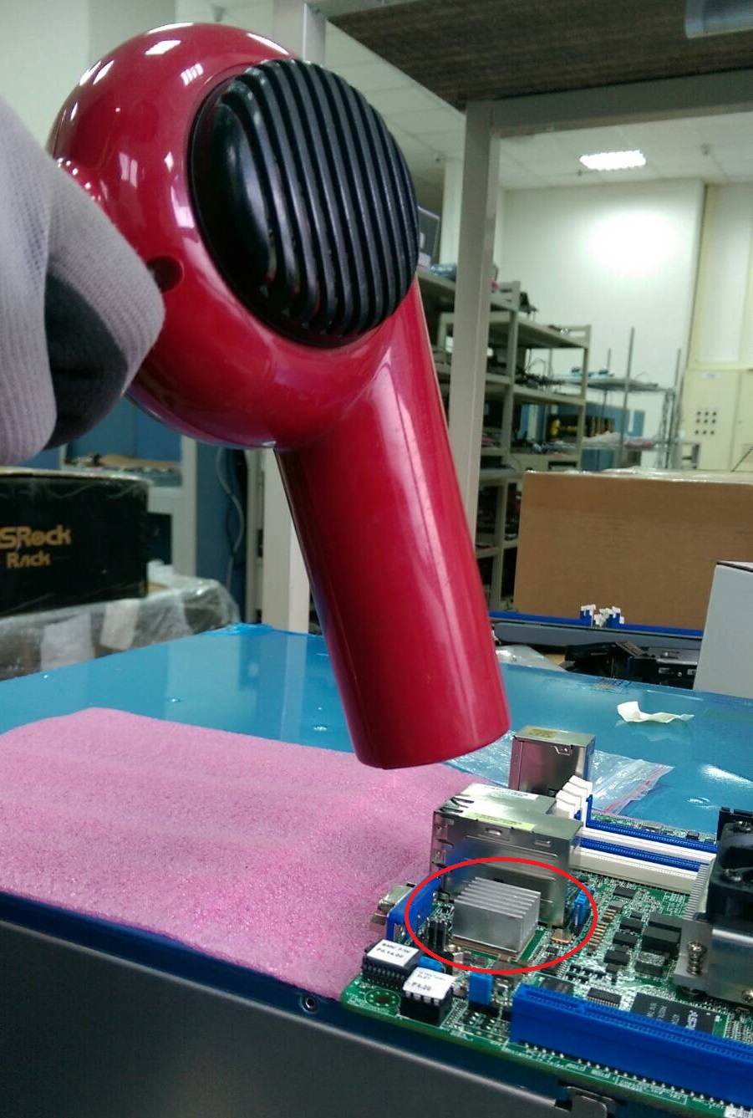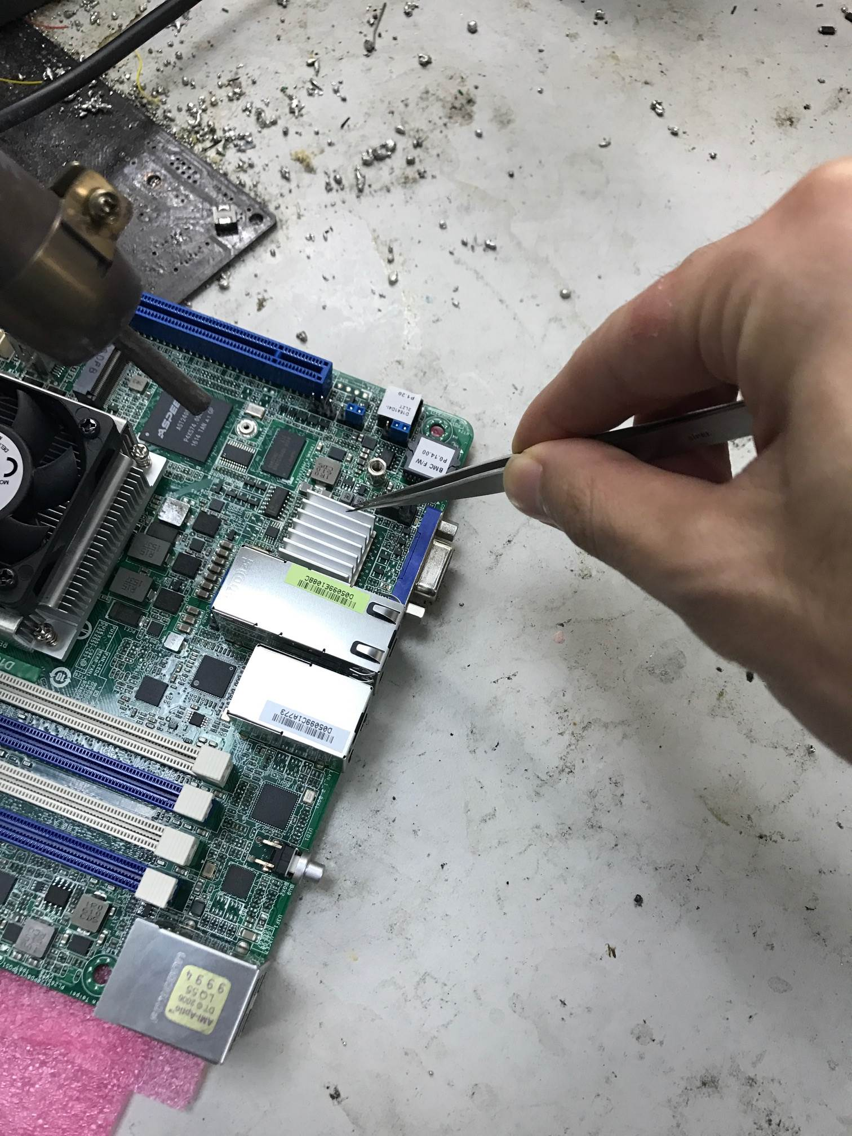

- Wipe clean with Alcohol.

(After remove heatsink) (Wipe clean with Alcohol)
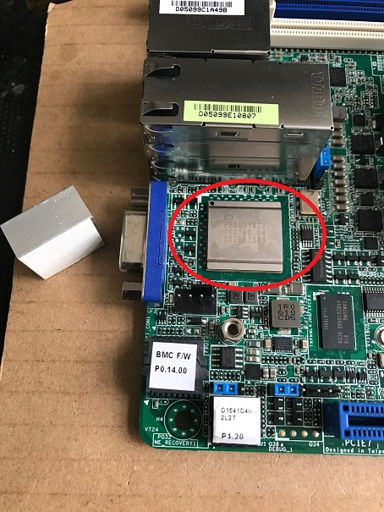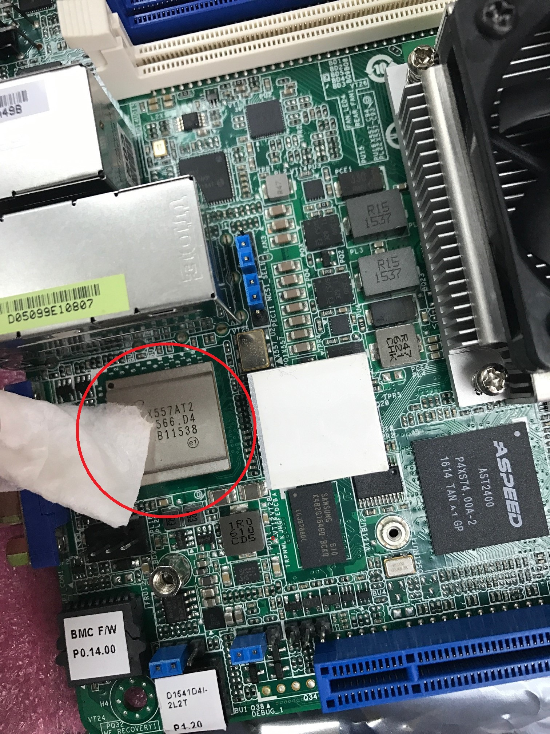
- Finish.

