How to download IPMI log?
- Log in IPMI web and select following item
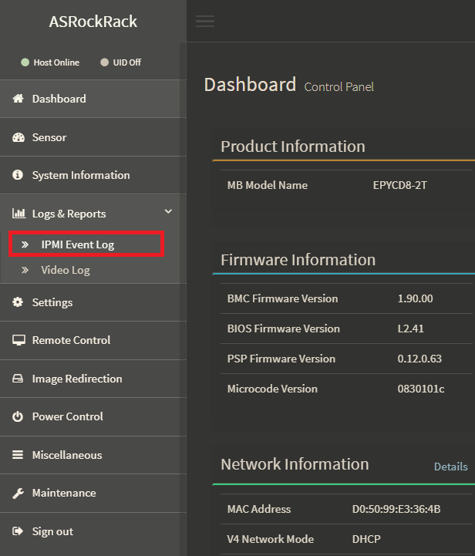
- save both event log and raw data
