

ASRockRack Technical Document (OCT/2017)
Q: How to flash BIOS in Linux?
Preparation
- BIOS Update Tool for Linux
Execute Environment: Linux

Step:
- Before using AfuLnx64, you have to install some kernel source tool by terminal.
- Open terminal as a super user, then install following package.
apt-get install linux-headers-$(uname -r)
apt-get install dpkg-dev
apt-get source linux-image-$(uname -r)

Apt-get install process is like following picture:
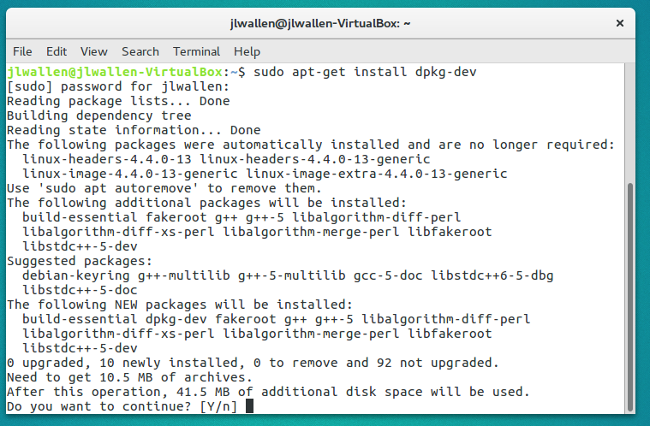
- After Unzip AfuLnx64, you can see the file “afulnx_64”.
- Execute command in terminal: chmod 777 afulnx_64
- Put BIOS image file into AfuLnx64 folder.
- Execute ./afulnx_64 {your BIOS image file name} /p /b /n
Flash process will take about 3 minutes, please wait.
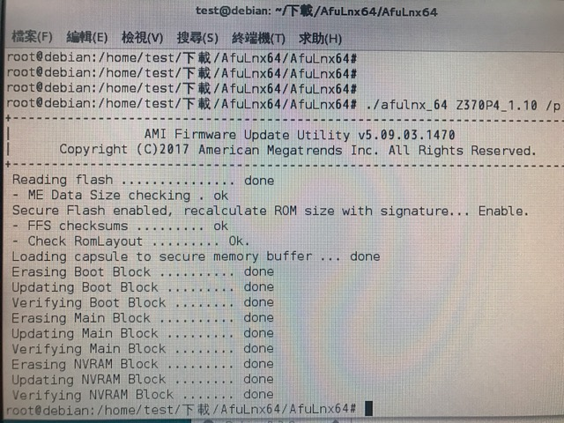

- Reboot, then check BIOS version.
