How to install 3U8G MB tray
- Press the black button to release the grip of MB
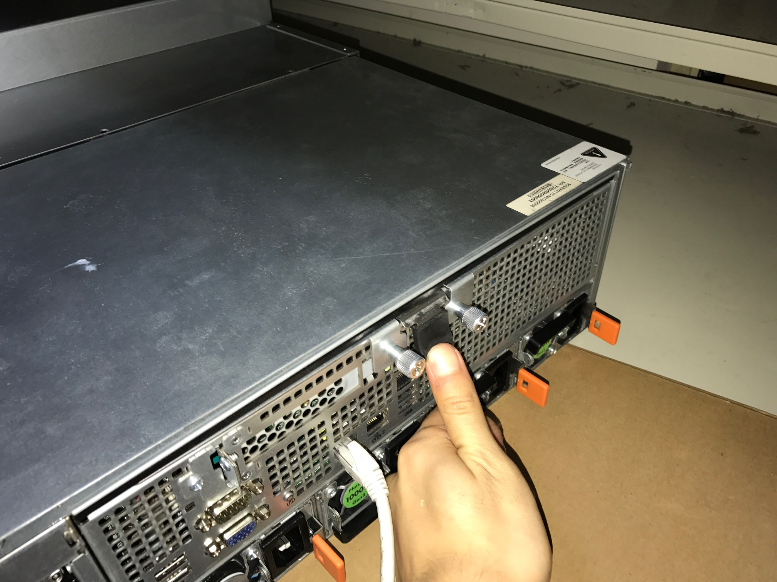
- Hold the both grip and pull off the MB tray
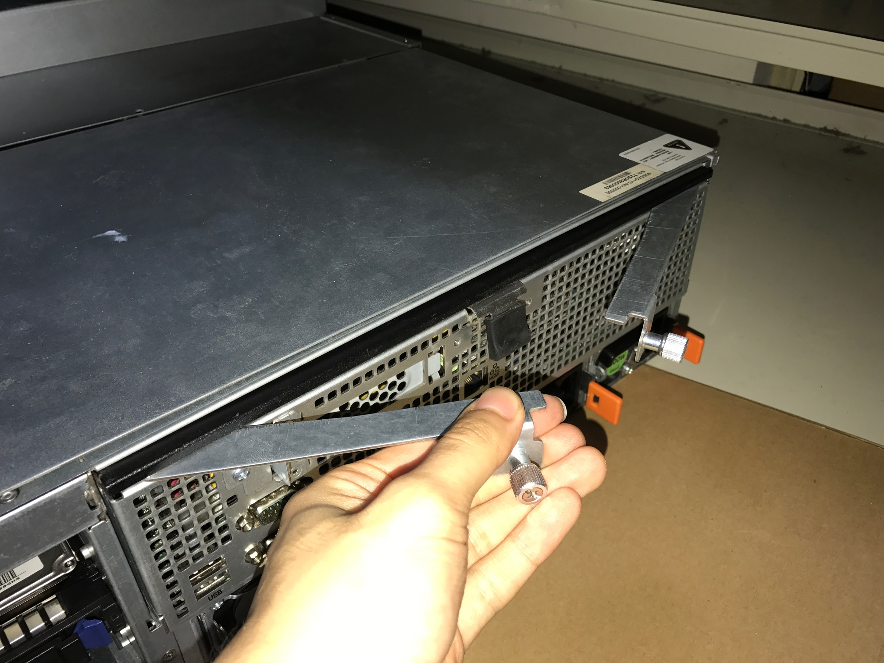
- Push back the MB tray and check contact of golden finger
The golden finger shouldn’t been seem
For example:
Red circle: Golden finger contact bad
Yellow circle: contact well
