

ASRockRack Technical Document (Apr/2018)
Q: How to modify BIOS default setting?
Preparation | :
- BIOS default setting tool : Scelnx_64
Step:
- Open terminal under Linux environment
- Decompress Scelnx_64
- Put your BIOS image in Scelnx_64 folder
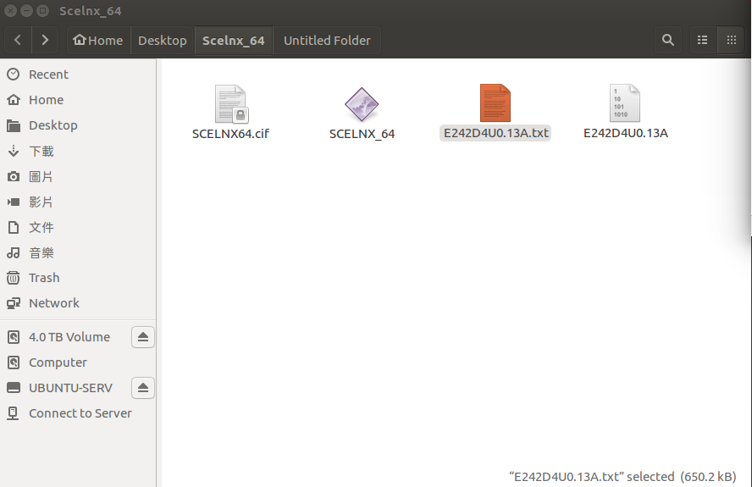
- Change Scelnx_64 to executable by entering:
chmod 777 Scelnx_64
- Execute: ./SceLnx_64 /o /s {image name}.txt
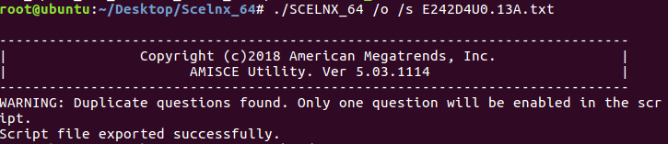
- Execute: chmod 777 {image name}.txt
- Edit {image name}.txt to change default
P.S
In this case, we change smbios event log from Enable to Disable.
Original setting:
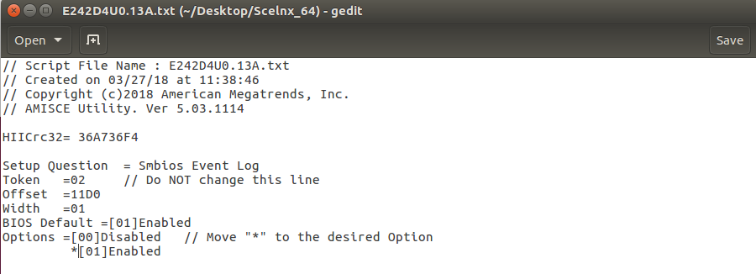

After changed:
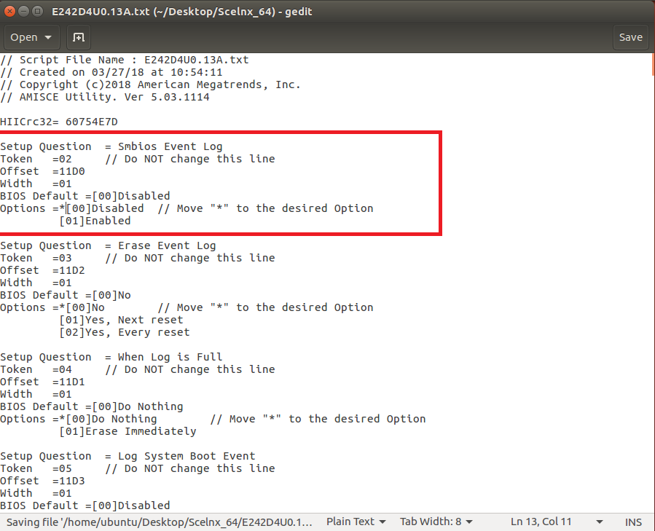
- After finish edit {image name}.txt , please Execute:
./ SceLnx_64 /i /s {image name}.txt to import the BIOS setting

P.S You can ignore the warning message
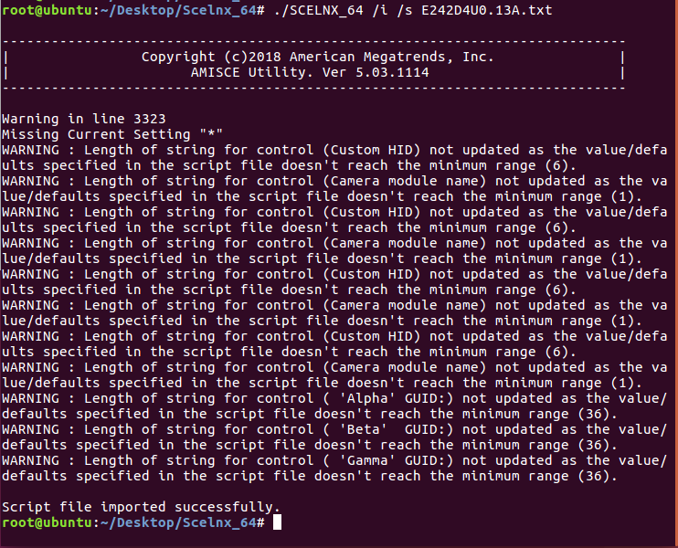
- Reboot and check if BIOS setting has been changed successfully.
