

ASRockRack Technical Document (Aug/2015)
Q: How to modify BIOS default setting?
Preparation | :
- A boot USB drive
(P.S. you can build a boot USB drive by rufus https://rufus.akeo.ie/ )
- SCEDOS folder and copy it into bootable USB.
Step:
- Export:
Please press command “SCEDOS /o /s <output file name>” in DOS environment to dump the file with the whole variable of BIOS SETUP and generate a file in USB drive.
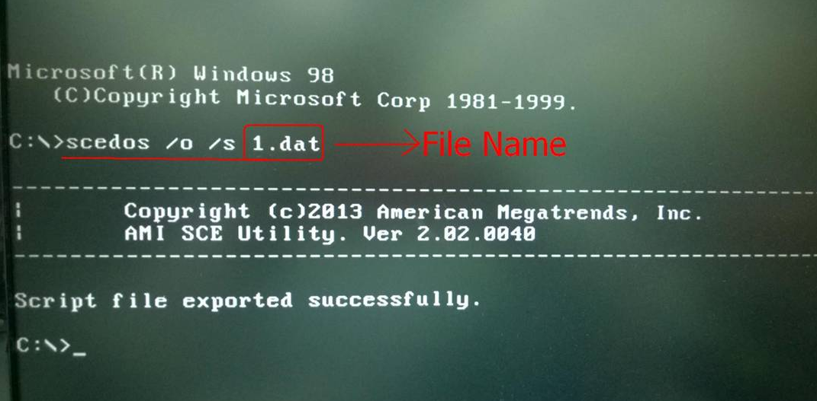

For Example, Onboard VGA default value = Enabled.
It has three options, Disabled, Enabled & Auto, and its current value will have “*” at top. You can modify it by text editor.
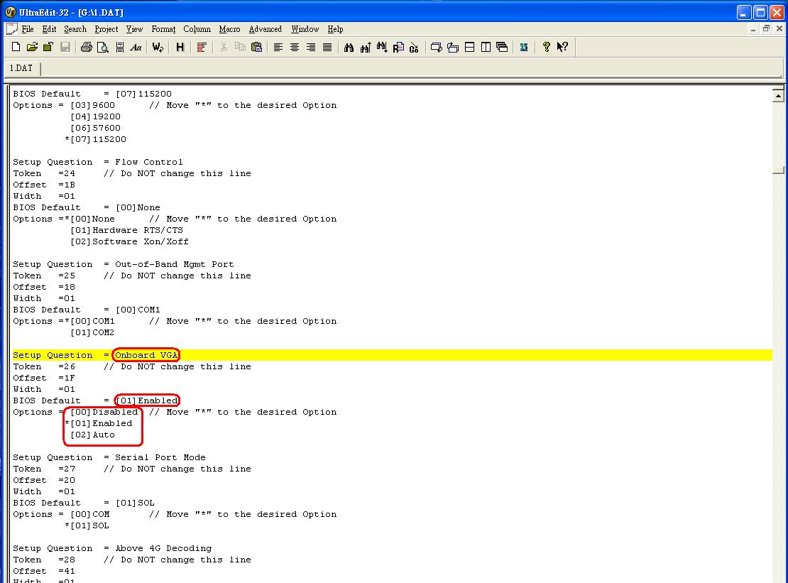

- Import:

With the data we modify from previous file, we have change default to “Auto” and current value to “Auto”.
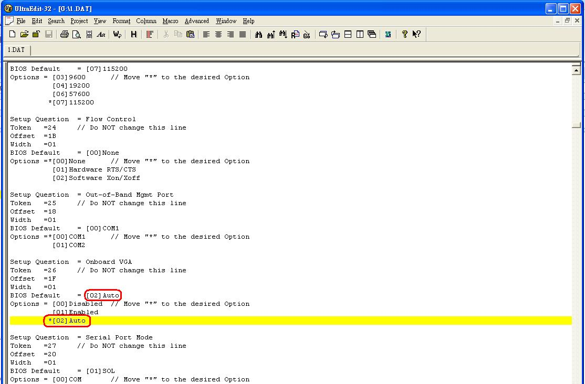

Then boot to DOS and type “SCEDOS /i /s <input file name>”
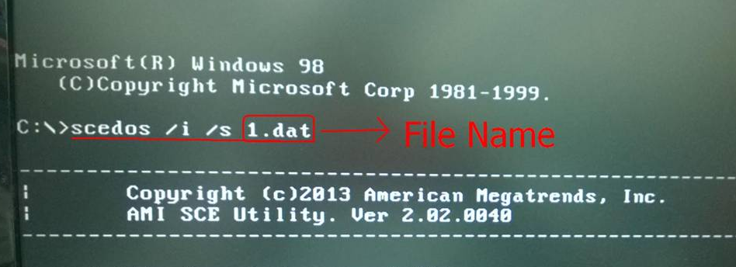

Check in BIOS setup menu, the value & default value is changed.




