How to modify Nvidia fan setting
OS: windows 10 & windows 7
- After finish install the NV driver , click right button on mouse to open NV control panel
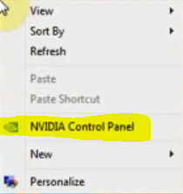

- Find device setting and fan control
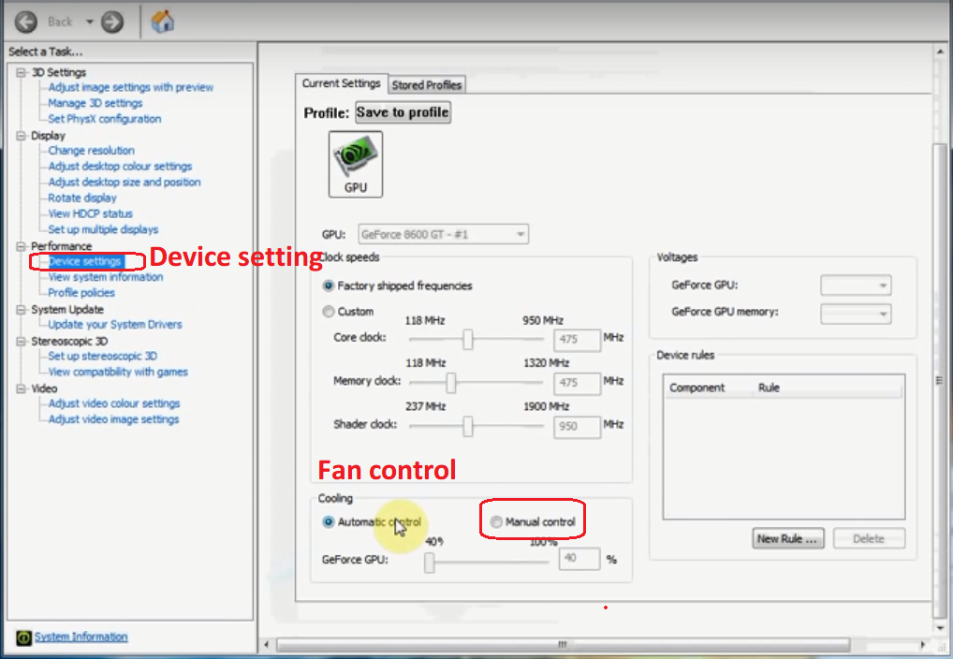

- Set Manual control then modify fan speed to 100% and Apply.
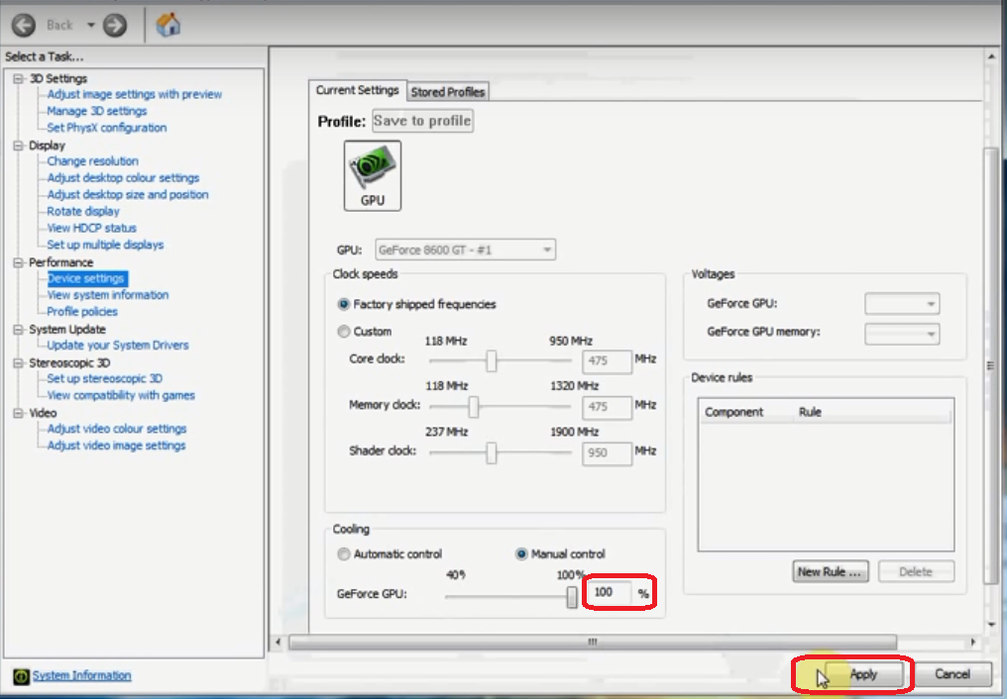
- Check fan speed with GPU-Z
GPU-Z website for download:
https://www.techpowerup.com/gpuz/
