**How to set VNC and use password to login VNC**

**Steps:**

1. Login IPMI webpage
2. Go to Home->setting->media redirection->remote session
3. Set KVM client type to VNC (if you need password to login VNC, please do not chose VNC non-secure connection)
4. Save setting

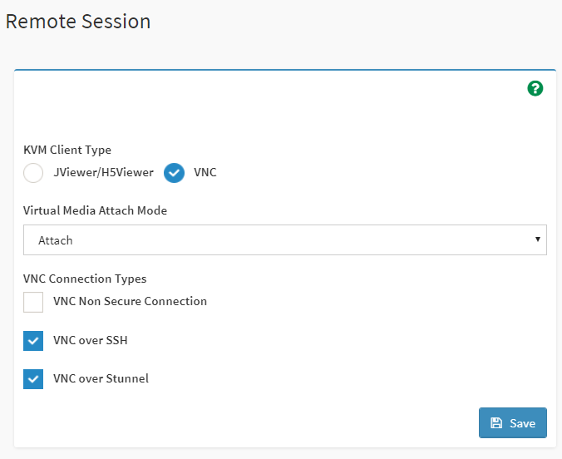

1. Go to Home->setting->user management
2. Select the user you want to add

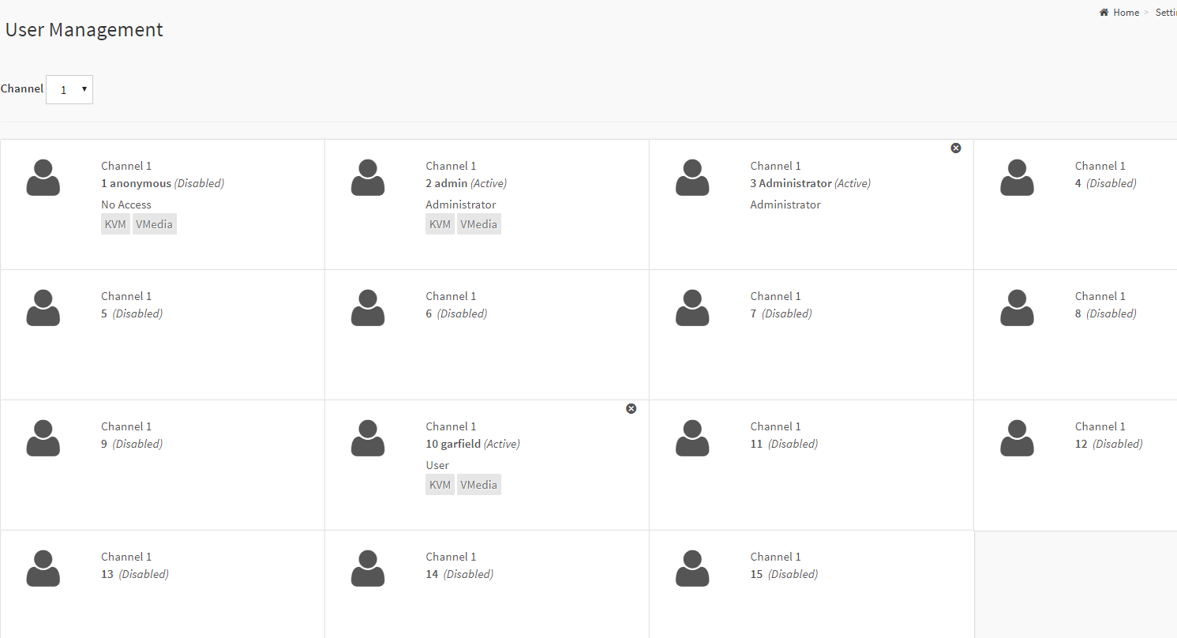

1. Key in the user name password, privilege setting etc.

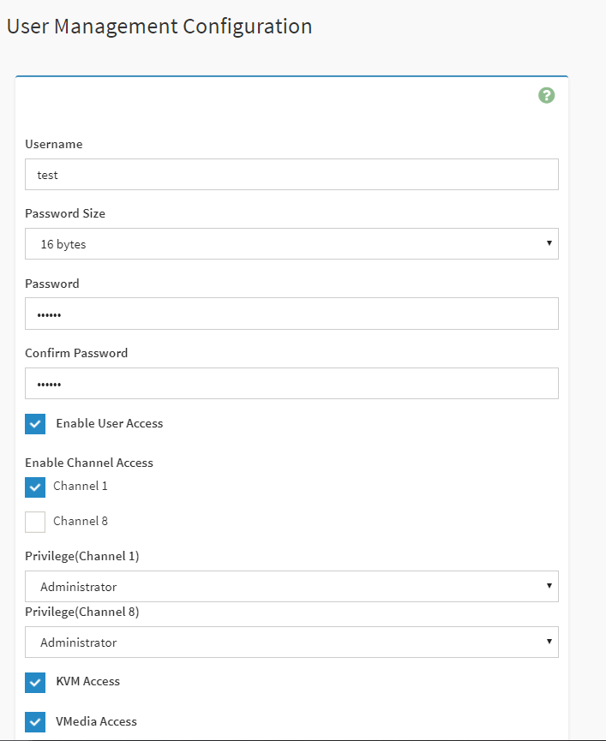

1. Now you can use the ID/password you set before to login VNC

Example:

**How to Launch VNC through putty/windows.**

1. Download putty

2. Open command prompt and navigate to directory where putty.exe is placed.

3. Enable SSH session with BMC by issuing following command in terminal.

4. putty.exe -ssh -L {Any Port}:{BMC IP}:{VNC Non Secure Port} {BMC username}@{BMC IP} -pw {BMC password}

e.g. putty.exe -ssh -L 1234:localhost:5900 admin@10.0.124.130 -pw admin

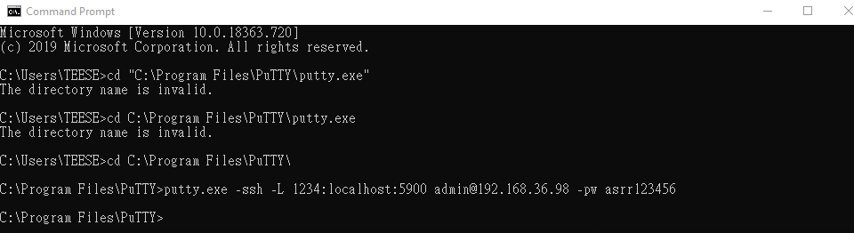

5. When you see the screen below in putty, it means putty link to VNC successfully

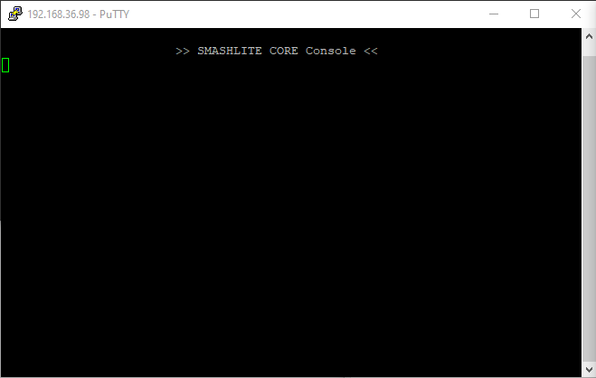

6. Launch VNC client with loopback IP address and port value (given in Any Port field). If successful VNC redirection should be started.

e.g. Launch VNC using 127.0.0.1:1234 by Tight VNC

