

ASRockRack Technical Document (Mar/2018)

Q: How could I re-write the BMC MAC address?

Preparation | :
- USB drive
- BMCMAC tool “S_BMCMAC” and copy it into USB drive

A: Please follow below steps to re-write the BMC MAC address:
- ASRockRack has one NCSI(Yellow) and one IPMI(Green) MAC address. Please find it on the rear IO of the motherboard, and write it down.
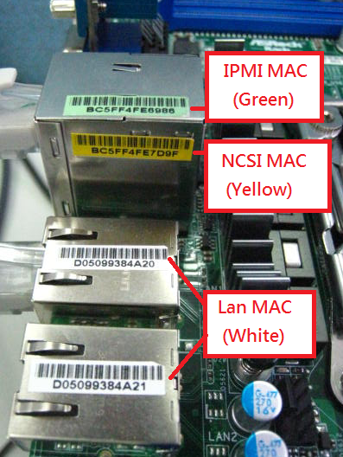

- Download S_BMCMAC tool and key-in the following command under server DOS environment and press enter.
S_BMCMAC 1= {yellow label MAC} 2={green label MAC} C

Sample:
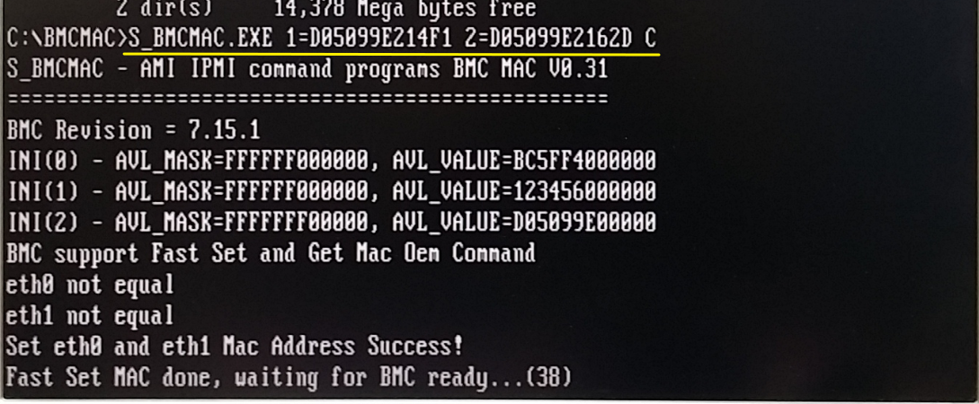

- Wait for few minutes for the updating. When the process finished there will show message with PASS on the screen.

Sample:
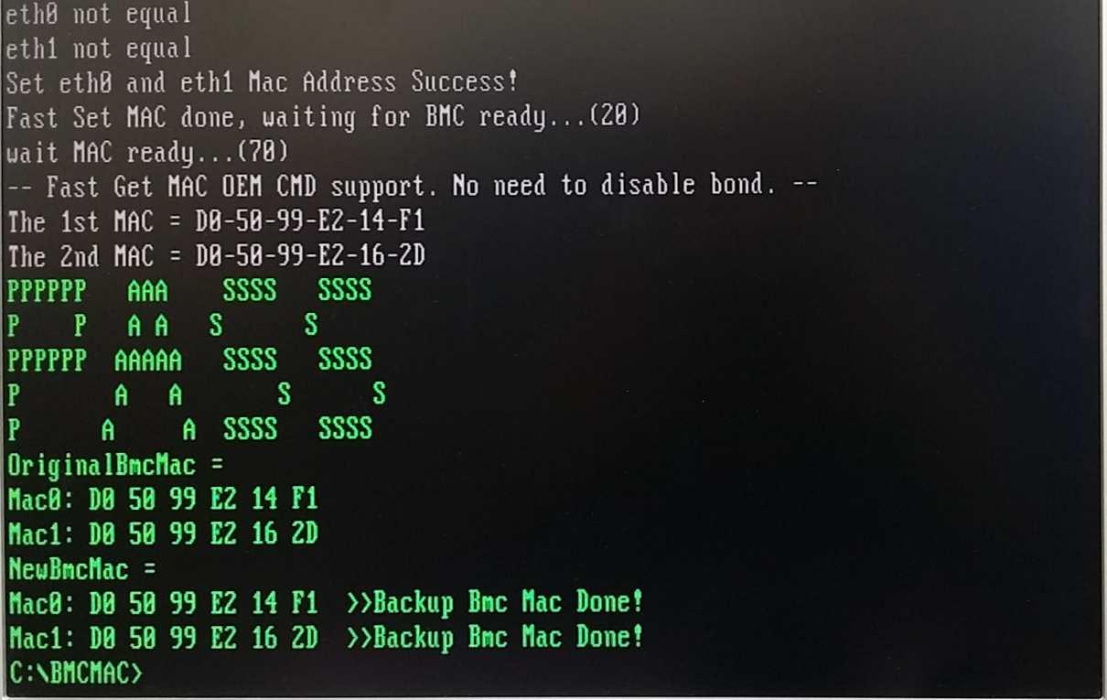

---- END ----

