

**ASRockRack Technical Document (May/2018)**

**Q: How to update BMC under Linux**

**Preparation:**



**Step:**

1. Decompress “socflash_linux.zip” under linux
2. Put BMC image file in the same folder too
3. Excute: sudo ./socflash_x64 if=rom.ima cs=0 flashtype=2 skip=0x40000 offset=0x40000

Note: rom.ima is just as the name of the example, it must be modified to use the correct image name.

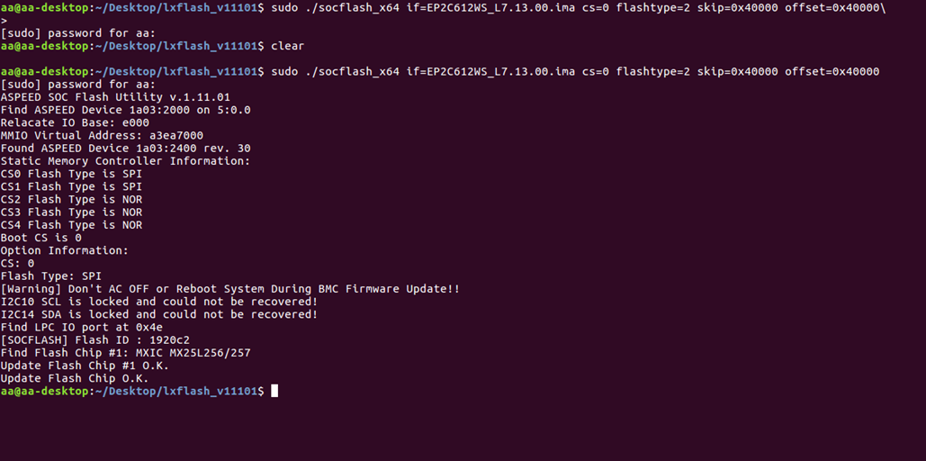

1. Wait for update finish (There will show the message like “Update Flash Chip OK”)
2. Reboot then check the BMC version.

P.S If BMC version doesn’t show up , please AC off the system for 20 sec , then AC on and check again.