How to use “eeupdate.efi” to update MAC address

- Prepare a bootable USB disk and “eeupdate.zip”
- Decompress “eeupdate.zip” and put .efi file into USB.
- Choose UEFI shell to boot up.
- Find eeupdate64e.efi and execute below command to change MAC:
Eeupdate64e.efi /nic=1 /mac={LAN1 MAC address}
Eeupdate64e.efi /nic=2 /mac={LAN2 MAC address}
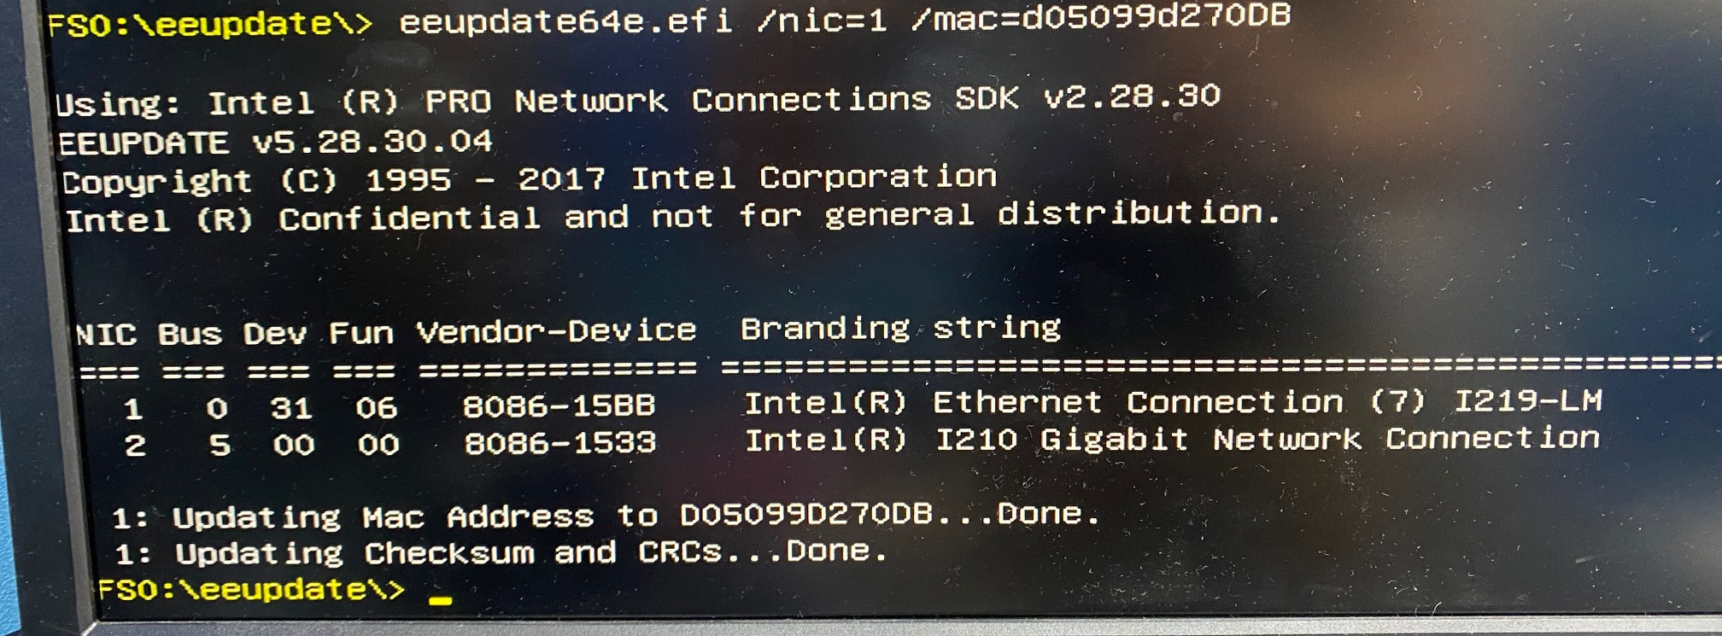
After finish update MAC address, re-boot the system and check MAC address with following CMD.
Eeupdate64e.efi /nic=1 /mac_dump
Eeupdate64e.efi /nic=2 /mac_dump
