

ASRockRack Technical Document

**Q: How to update i210 Firmware under EFI Shell?**

**Preparation:**

Here is the i210 image file and update tool.

Update tool:



I210 NVM rev 3.25:



**Step:**

1. Put “lanconf64e.efi” and “I210A2.bin” to a USB drive.
2. Boot up your system with UEFI: Built-in EFI shell.

(Press F11 while POSTing to enter boot menu and choose it)

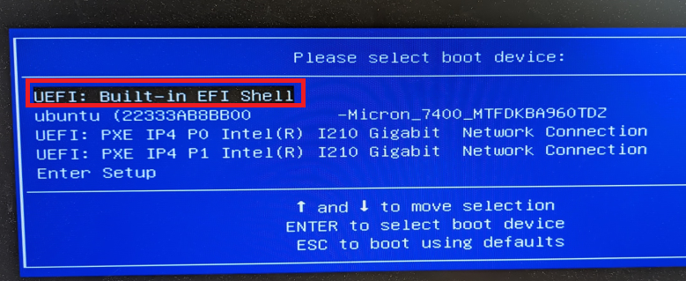

1. Execute: lanconf64e.efi

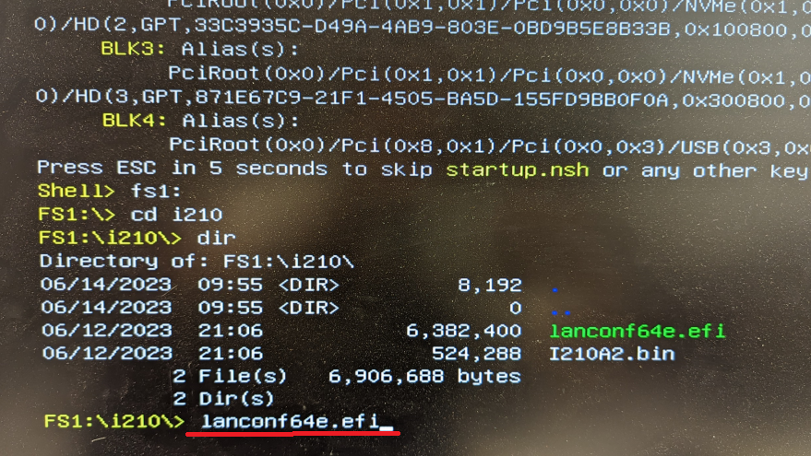

1. Select and update both i210.

Ex:

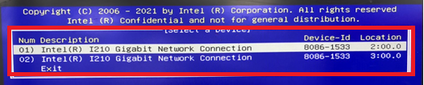

1. LANConf Menu > EEPROM/FLASH > NVM Image >

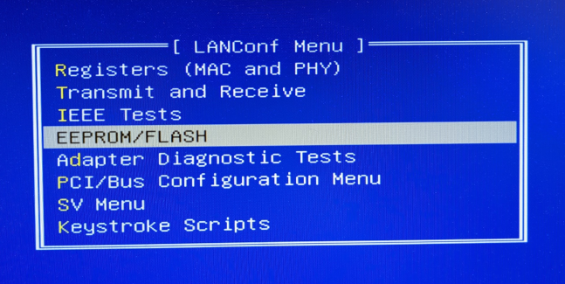

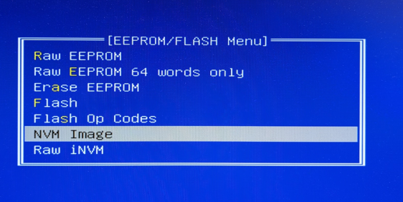

1. Select “Update Image” icon:

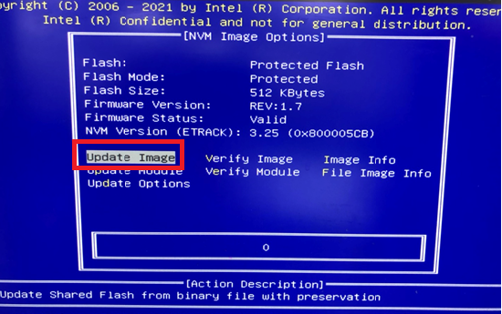

1. Select SPC621D8.bin to update. 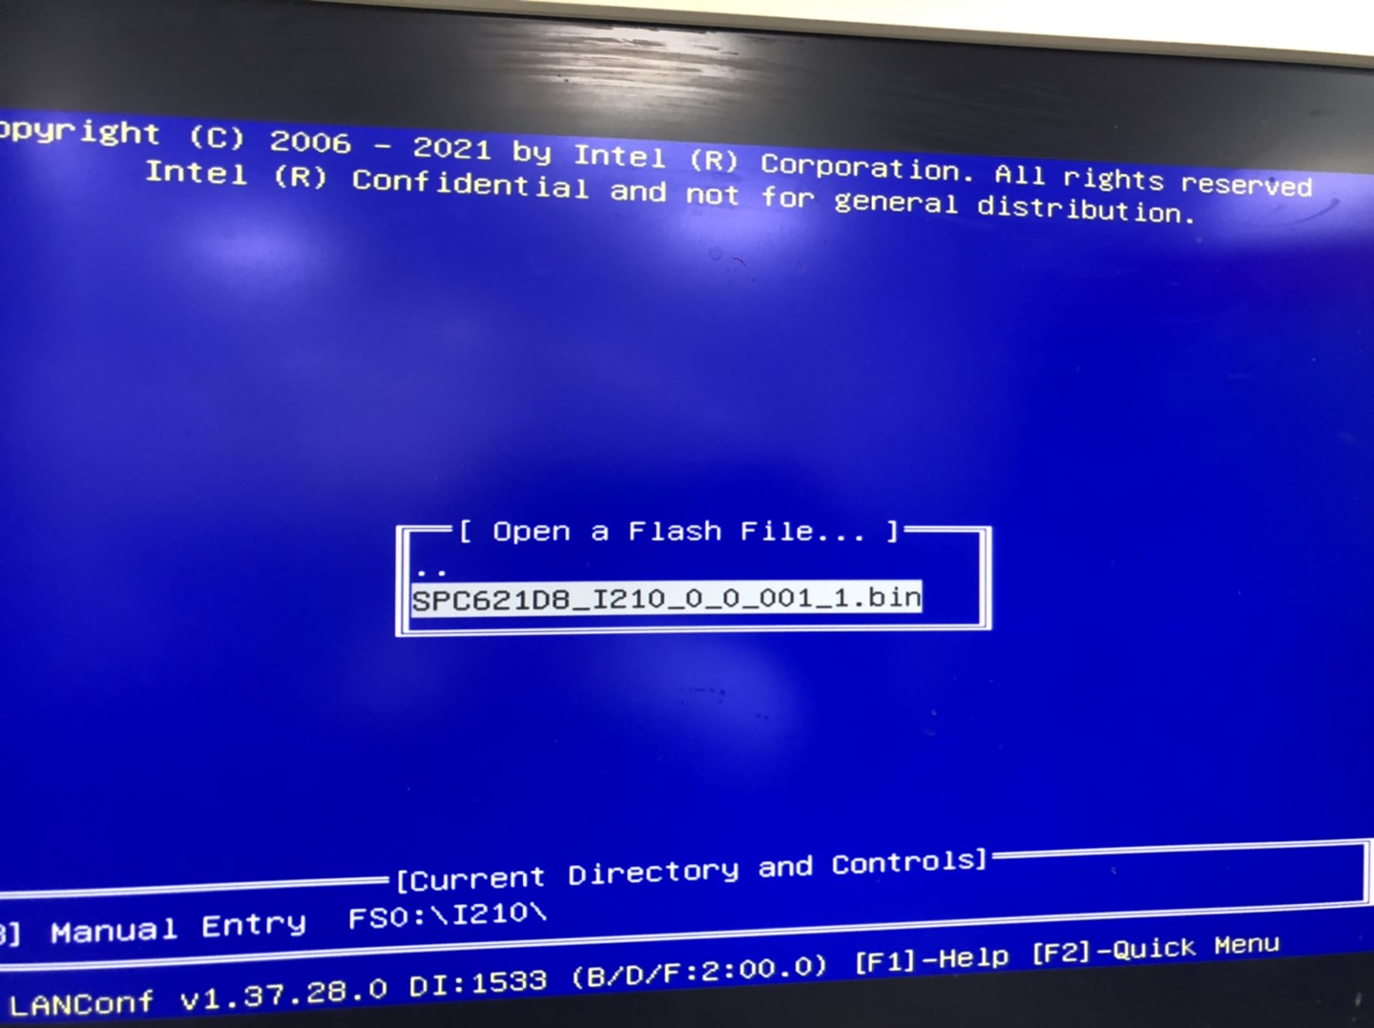
2. Wait until the update is finished.

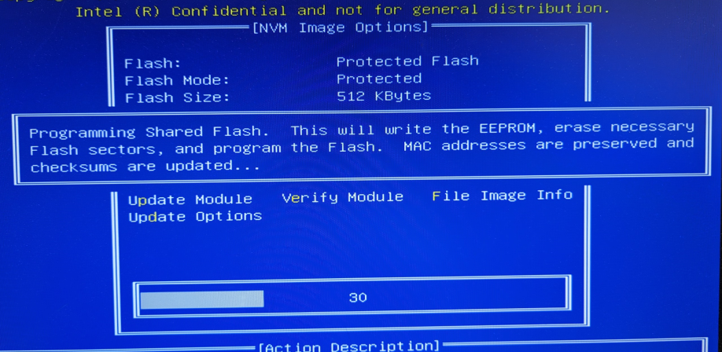

1. Update i210 FW successfully.

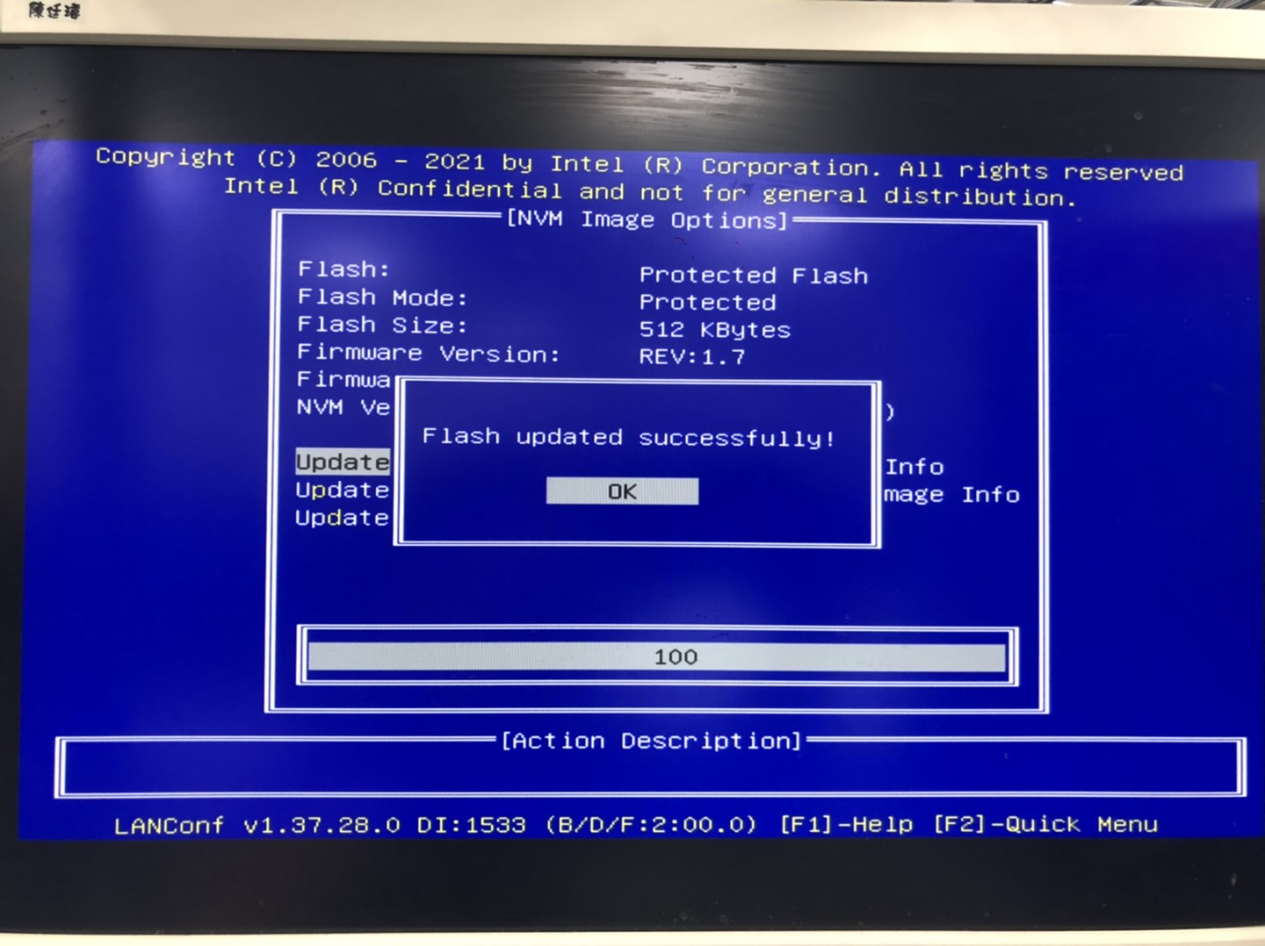

1. Check the i210 version, it should be NVM Version Rev. 3.25.

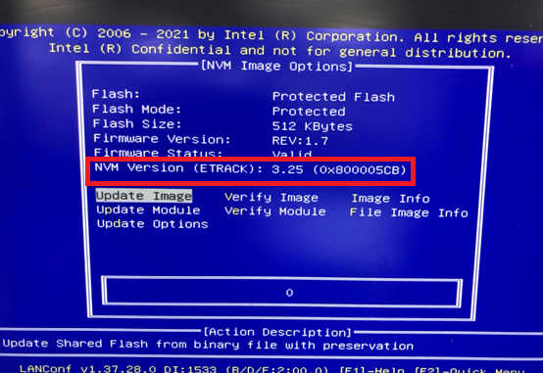

1. After flash both i210 FW, please do AC on/off once.

***-DONE-***