How to use DIGITS on Ubuntu
Preparation:
Check if BIOS->Chipset configuration->ACS “Disable”
Steps:
- Boot up the 3u8g with 4*V100
- Login Ubuntu
User: aa
Password: aa
- Open terminal (you can find terminal by click right button of mouse)
- Execute nvidia-smi to check GPU number first
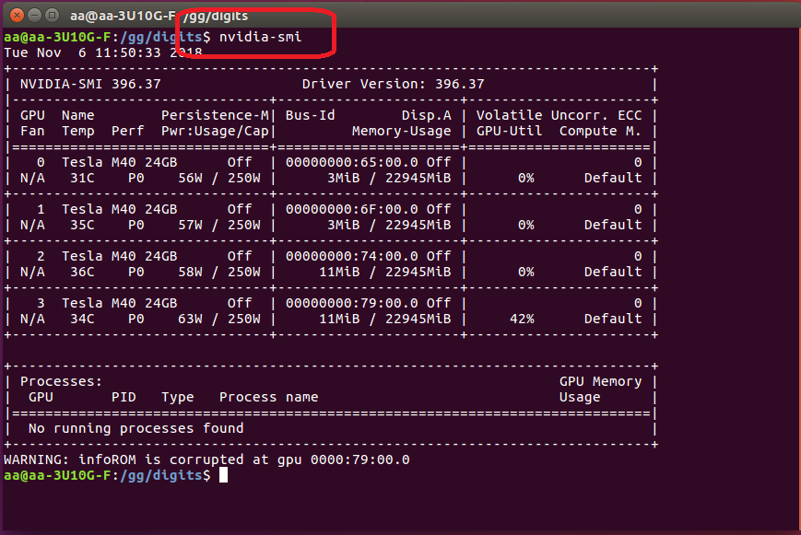
- Execute cd /gg/digits/ then execute ./go.sh
- If the process is good the windows should be like below
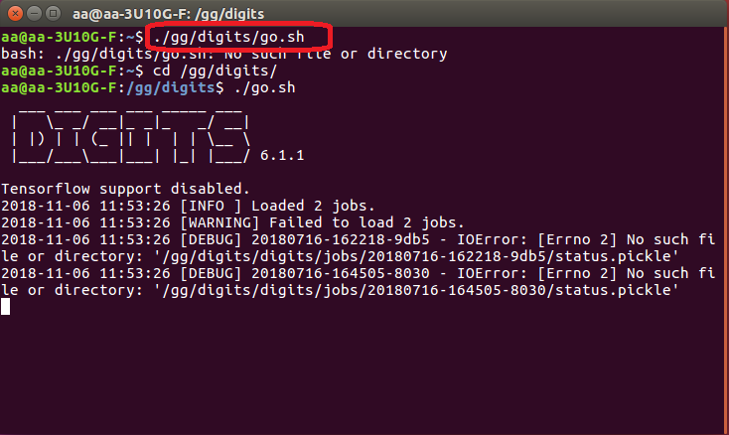
- Open firefox and go to the website http://localhost:5000/
P.S Also there should have the information on upper right of how many GPU is available now
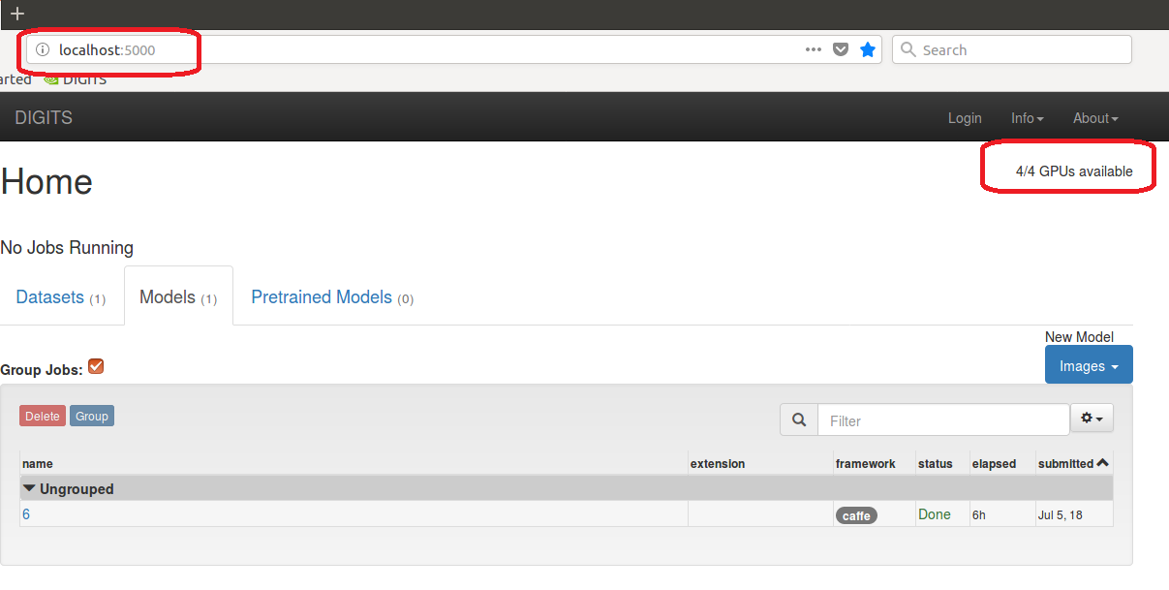
- Click models and choose classification
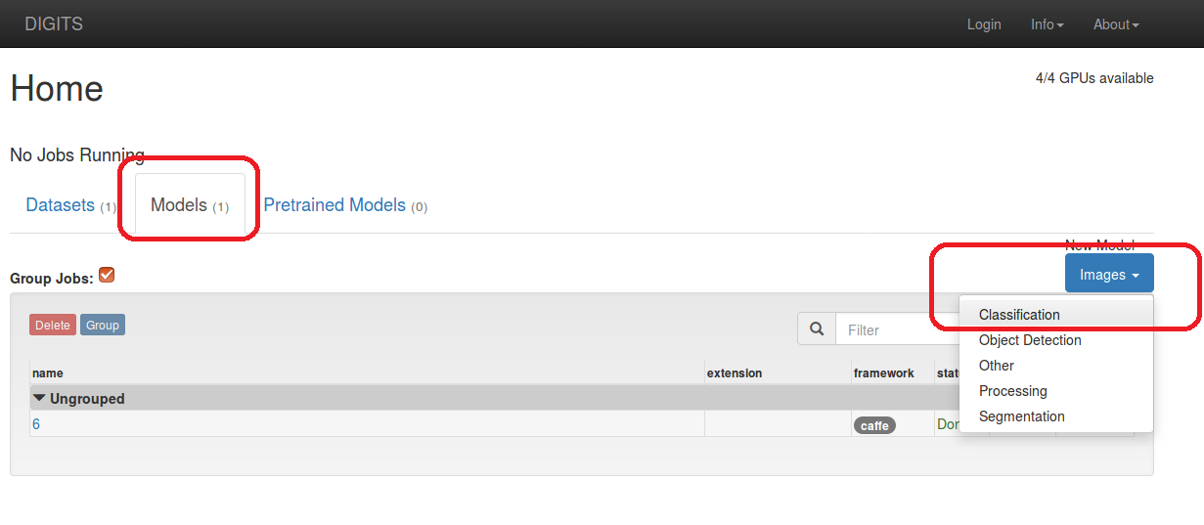
- You can fill the name whatever you want.
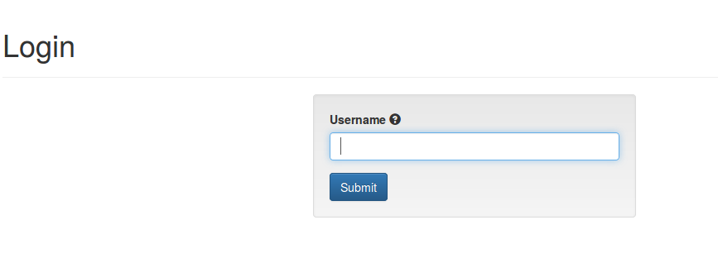

- Select dataset Ex: dolphins and seahorses
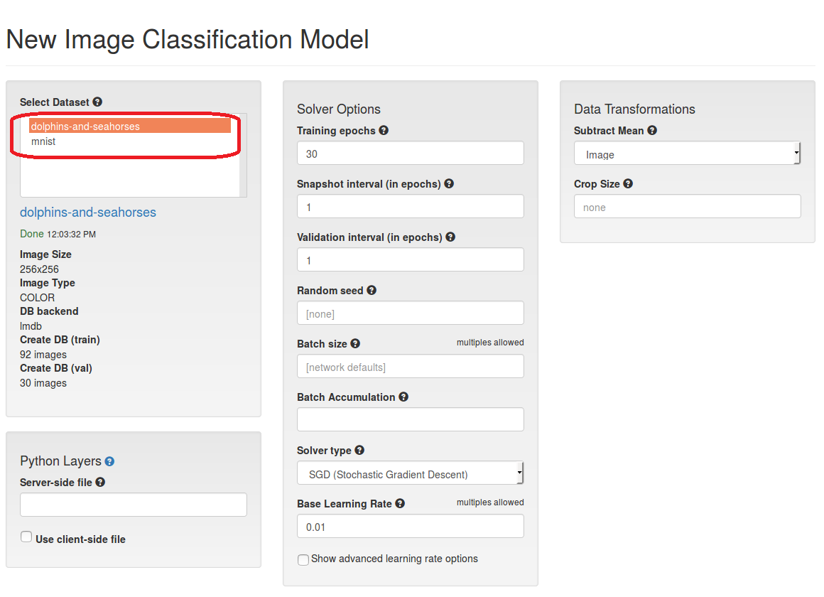
- Choose standard network as “GoogleLenet”
Select your number of GPU as “4”
Setup your test module name then click “Create”
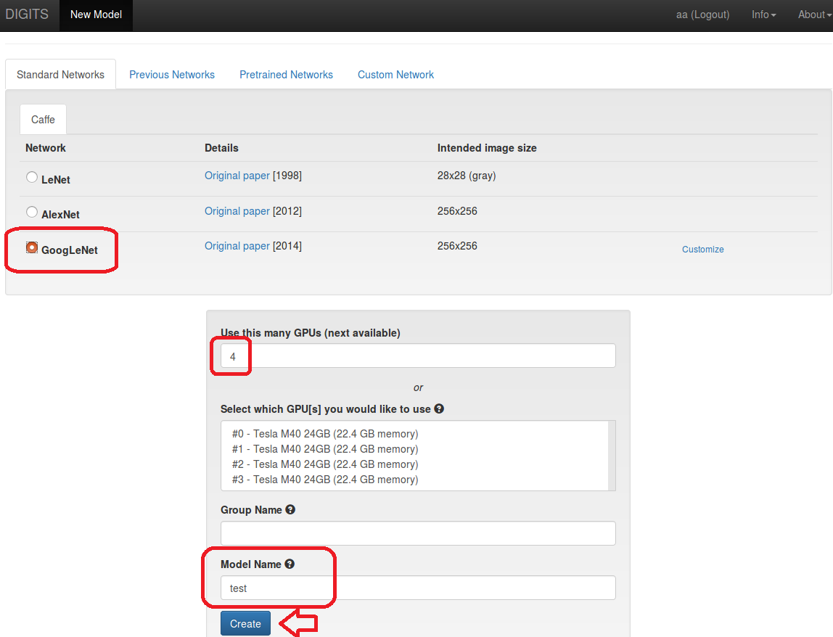
- While GPU is running the website should be like following picture
P.S Information in the red frame is estimate time
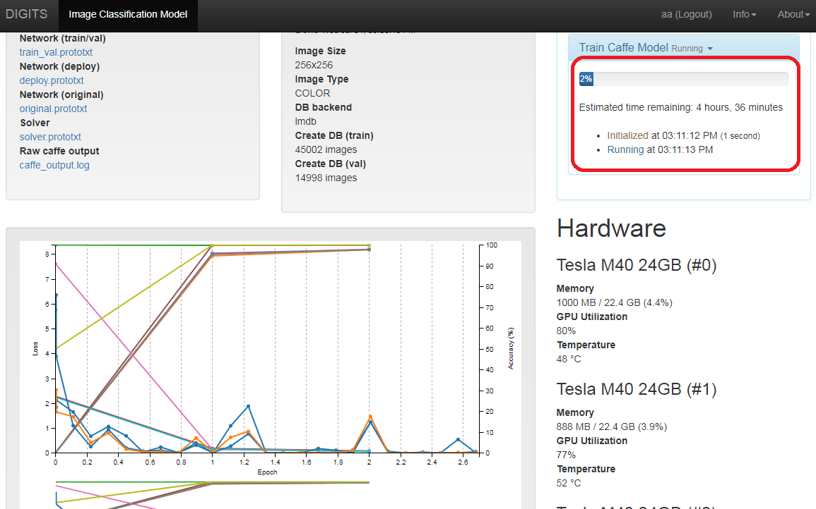
- After finish the calculating, you can also select an image to test at the bottom of the website
Ex: Click Browse to found a sample picture
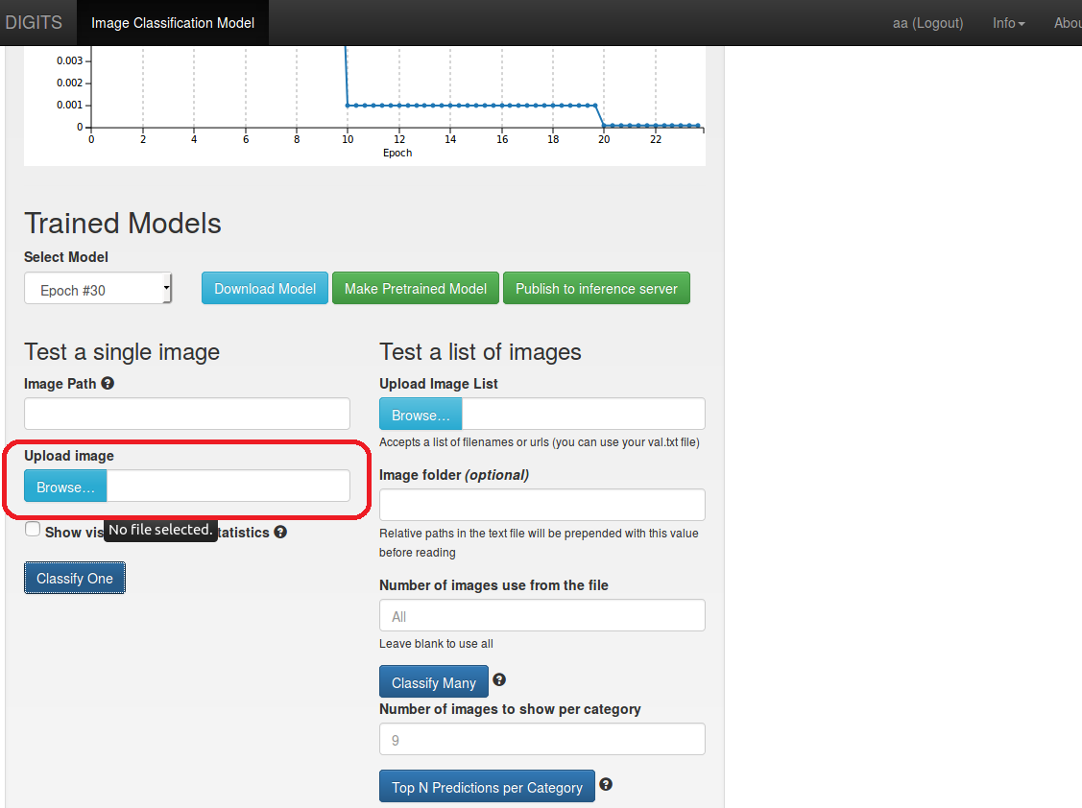
- In this case, we use GPU to train the image classification between dolphins and seahorses, so we select a photo of dolphin which is not in the training dataset to identify.
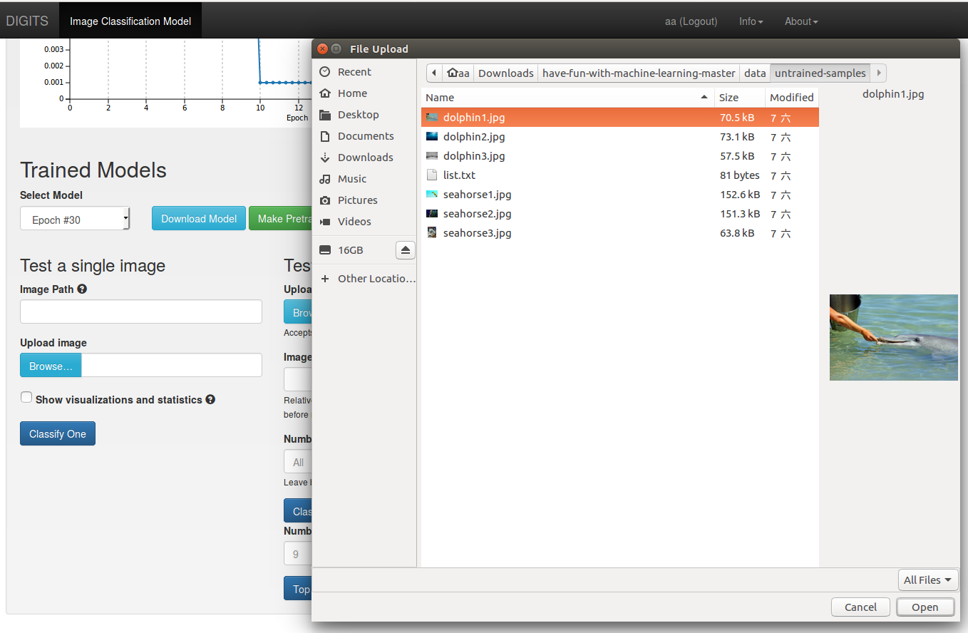
- Click classify one to test
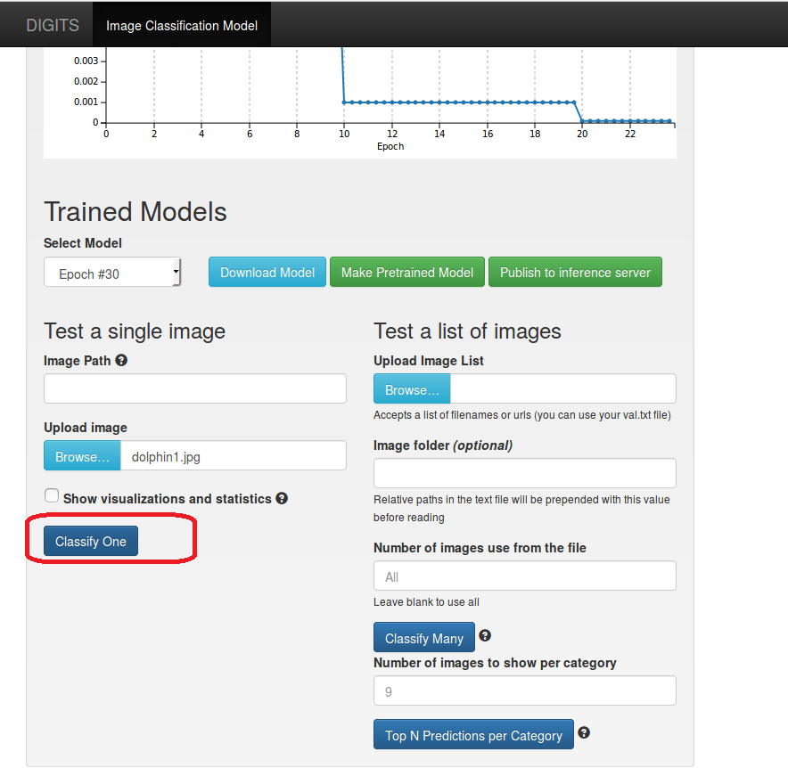
- Result comes out
