How to write DMI information under windows
Preparation:
Steps:

- Decompress DmiEditWin64.zip and open DMIEDITx64.EXE
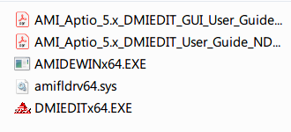
- Here is the toolbar and there usage
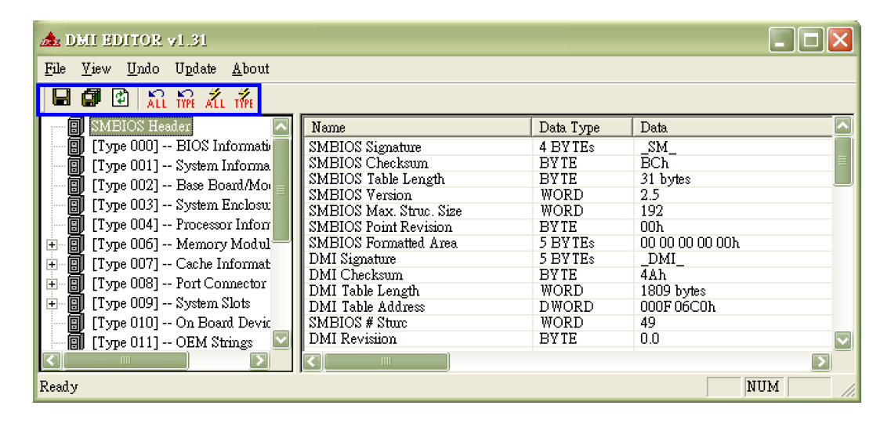
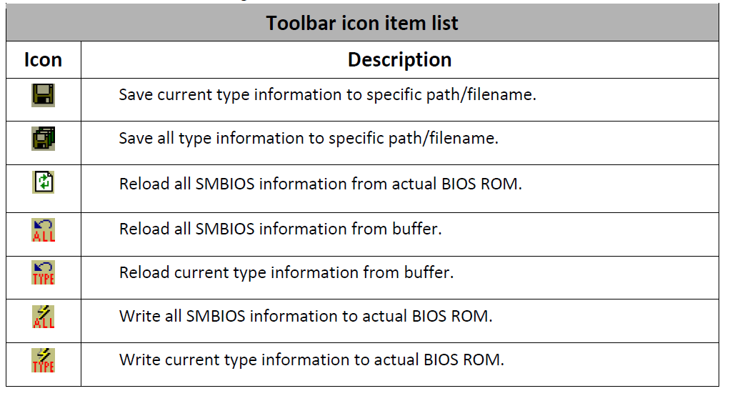
- Left side is DMI information catalog
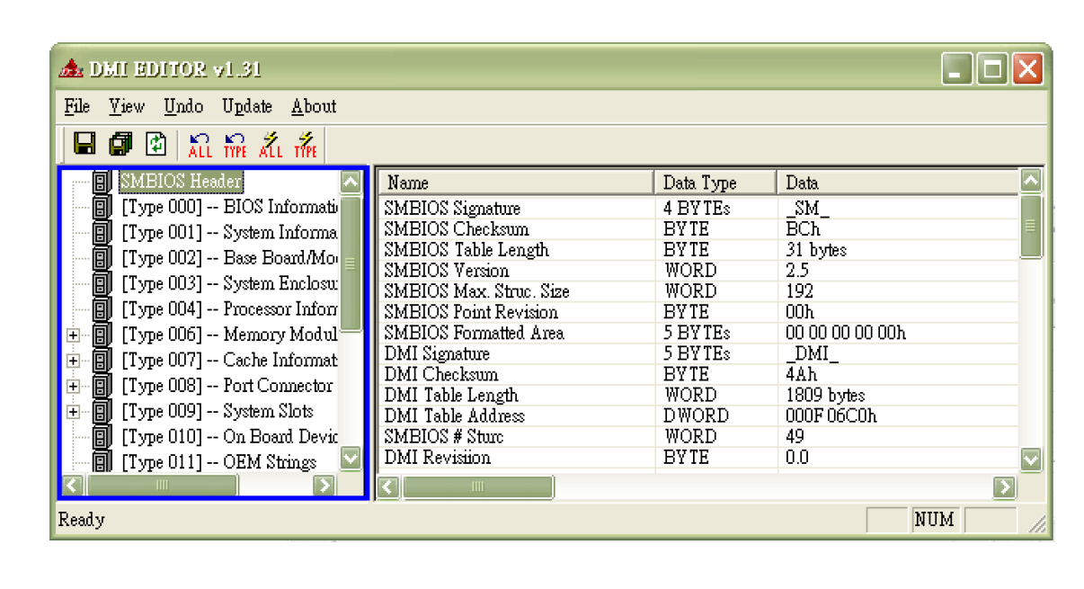
- The string with green is the information you can modify
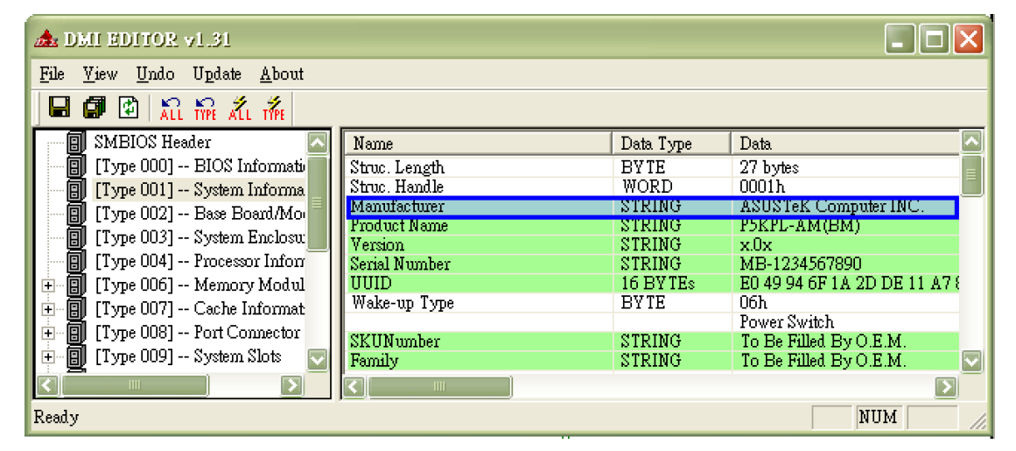
- Click and change DMI info
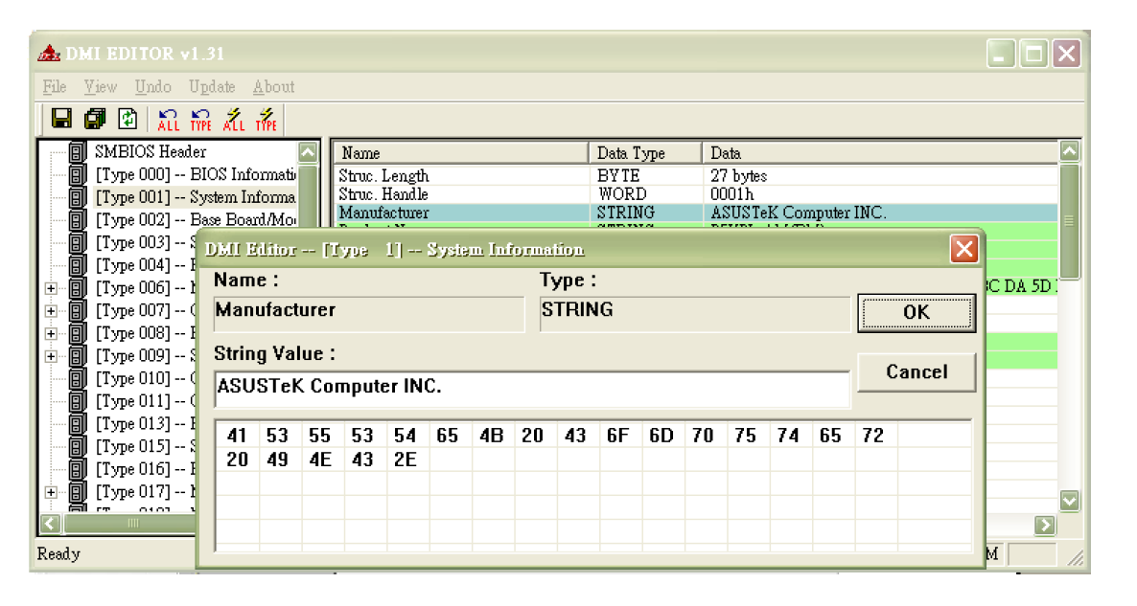
- Choose All to updated all the DMI info, and choose current type to update specific DMI info
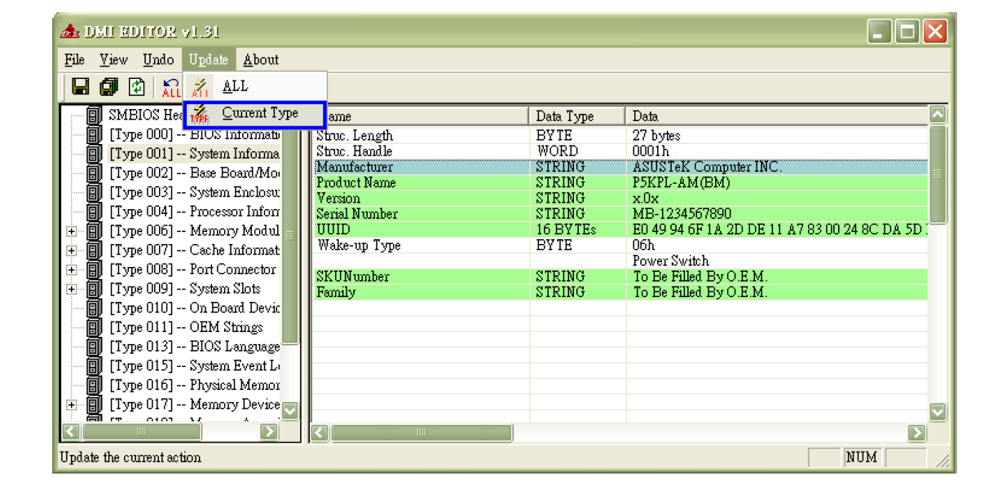
- Click yes to update DMI info
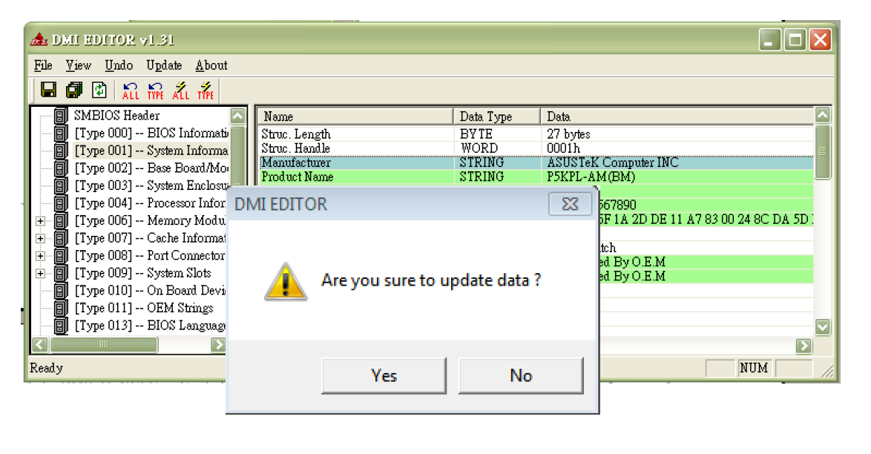
P.S Choose save to remain your DMI setting
