

ASRockRack Technical Document (Mar/2018)
Q: How to remote update BIOS/BMC and Export/Import BIOS setting under Ubuntu16.04

Preparation:
- For BIOS/BMC update
- For export/import BIOS setting

Step for BIOS/BMC update:
- Decompress FWUpgradeAgent.zip
- Put BMC & BIOS image in “FWUpgradeAgent” folder
- Open terminal in FWUpgradeAgent folder.
- Execute: sudo chmod 777 *
- Execute: ll (Check if all the files in “FWUpgradeAgent” is executable to every user.)
- Execute following command to update BIOS/BMC:
BIOS:
python ./FWUpgradeAgent.py -FW BIOS -File {image name} -IPs {IPMI IP} -Action 3
BMC:
python ./FWUpgradeAgent.py -FW BMC -File {image name} -IPs {IPMI IP}
- Below is the sample after flashing is done.
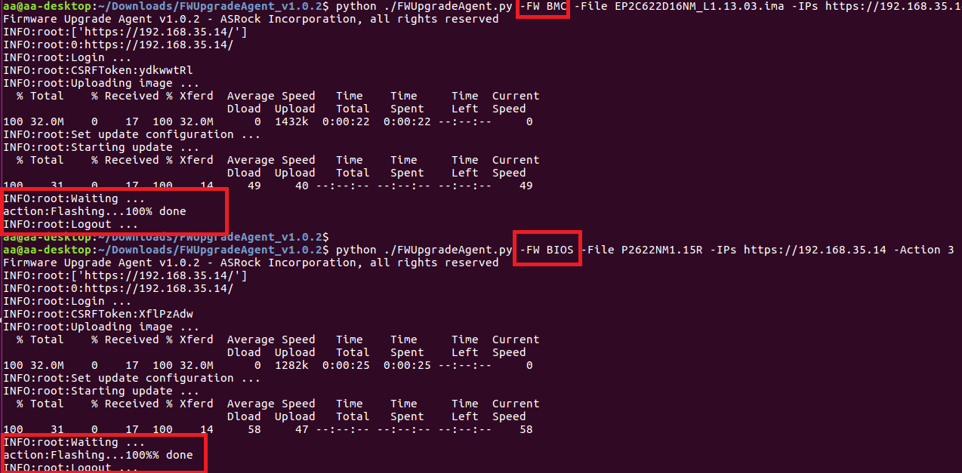
- Please check BIOS & BMC version after update complete.

Step for BIOS Export & Import:
- Decompress HttpBMCCfgEditor_v1.0.1.zip
- Open terminal in “HttpBMCCfgEditor_v1.0.1” folder
- Execute following command to export/import BIOS setting
Export:
python ./ HttpBMCCfgEditor.py -APIVer 2 -Class BIOS -IPs {IPMI IP} -U admin -P admin -Export new
Import:
python ./ HttpBMCCfgEditor.py -APIVer 2 -Class BIOS -IPs {IPMI IP} -U admin -P admin -Import new.json
- Below is the sample after export & import is done.
