SceEfi SOP
Preparation:
Step:
- Decompress SceEfi.zip and put SceEfi folder into your USB
- Insert the USB then boot up the system
- press F11 to enter boot menu and choose “Built-in EFI Shell”
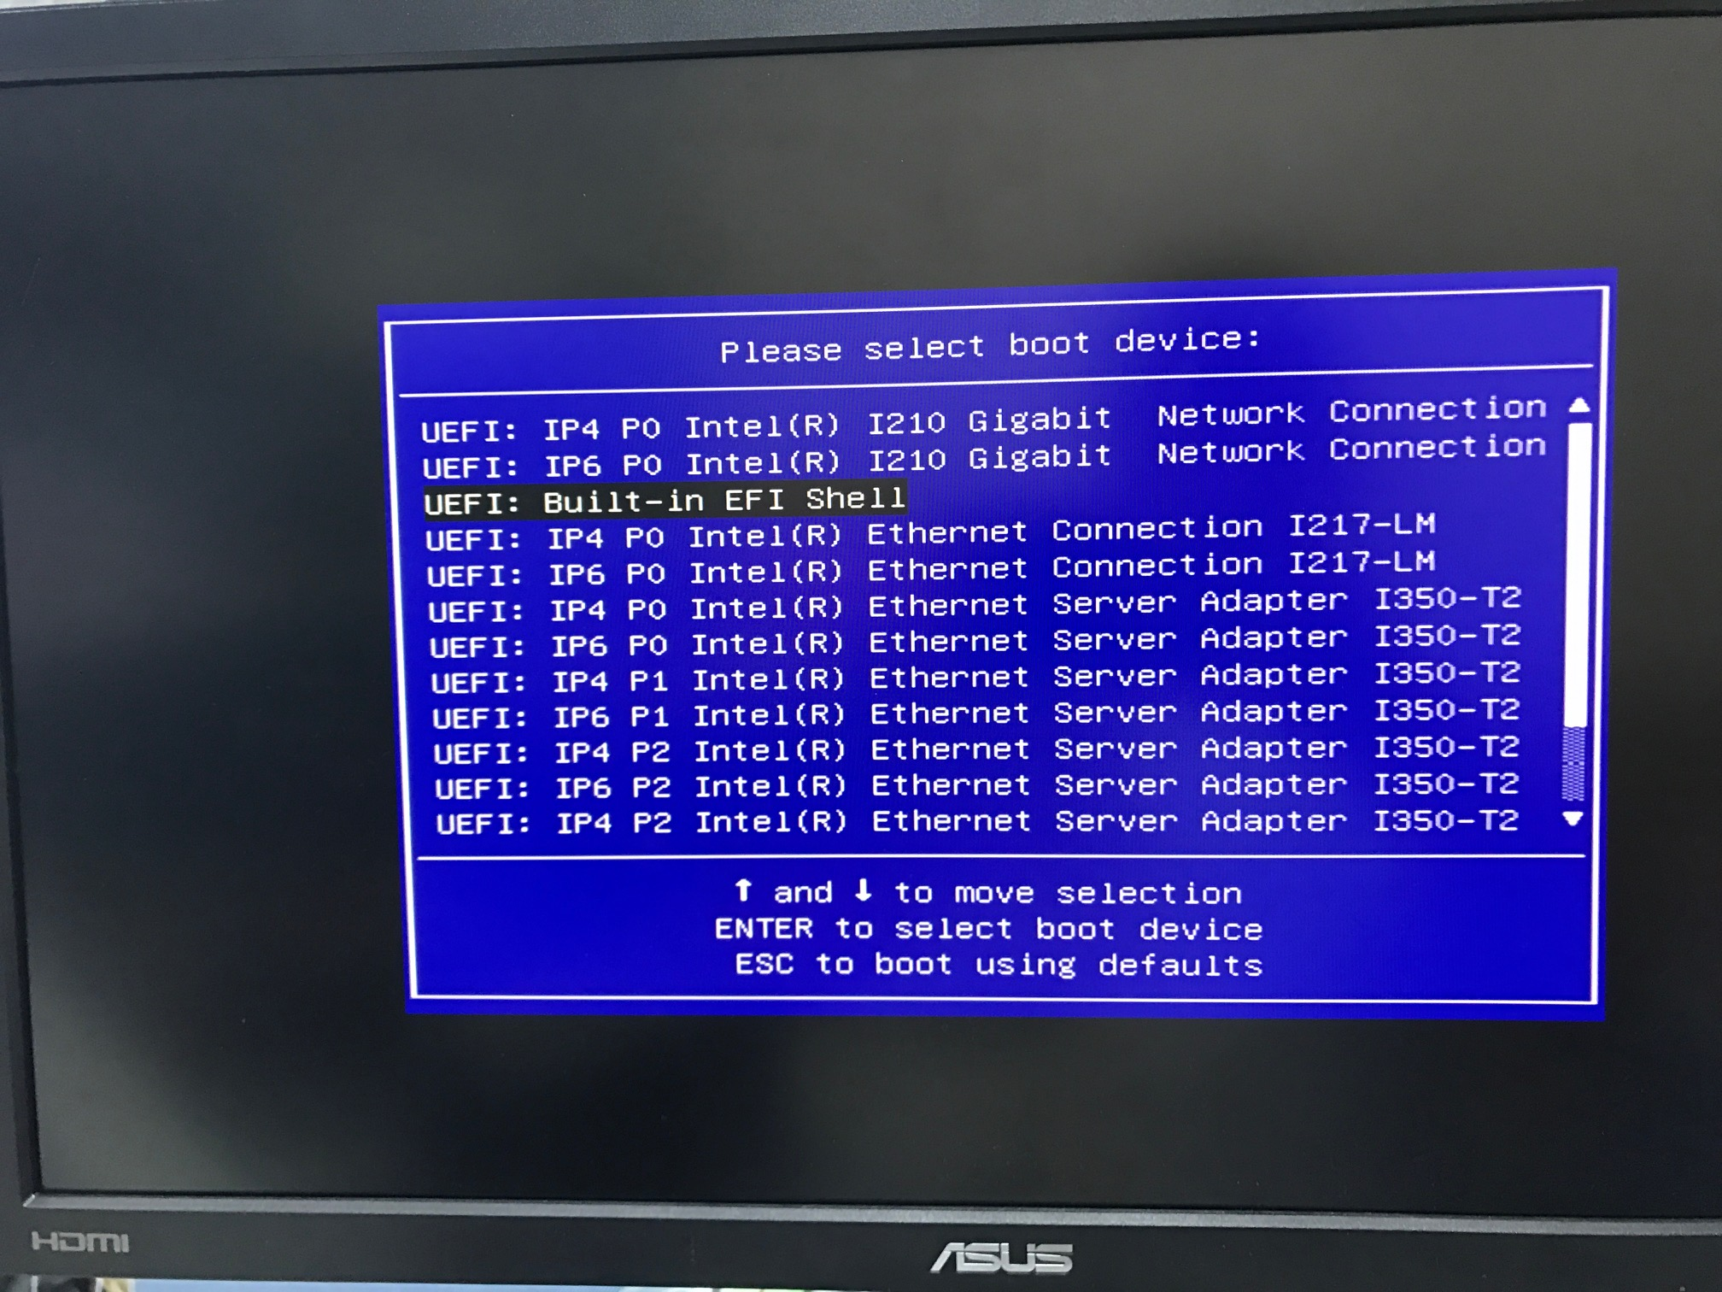
- Choose your usb directory (in this example , path of usb is fs0)
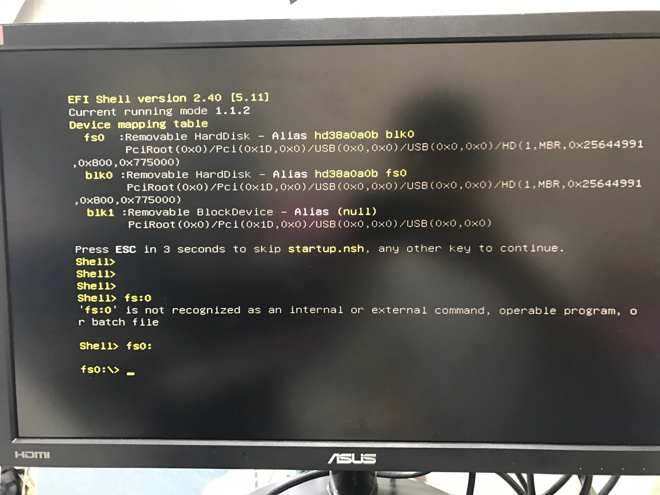
- Enter into the directory SceEfi
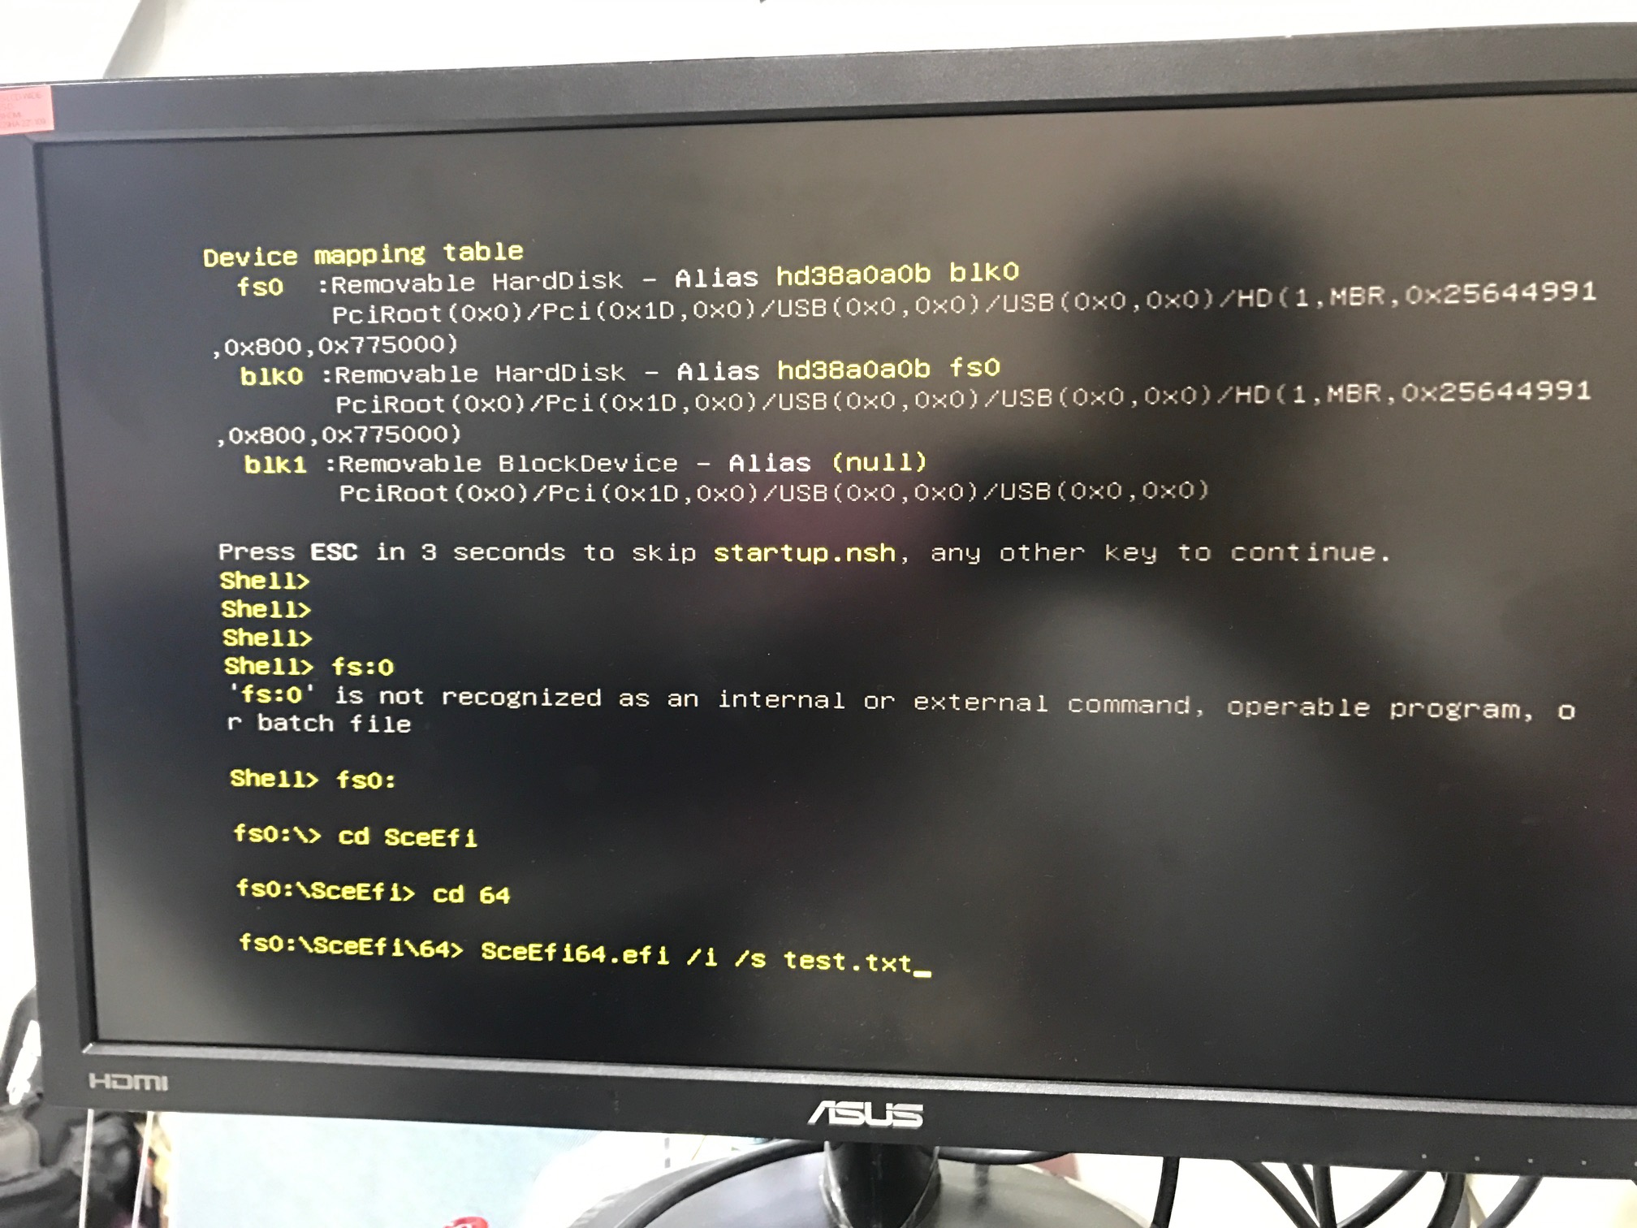

- Input SceEfi64.efi /i /s test.txt

- If the message “script file imported successfully” appear , it means OK (You can ignore the warning message)
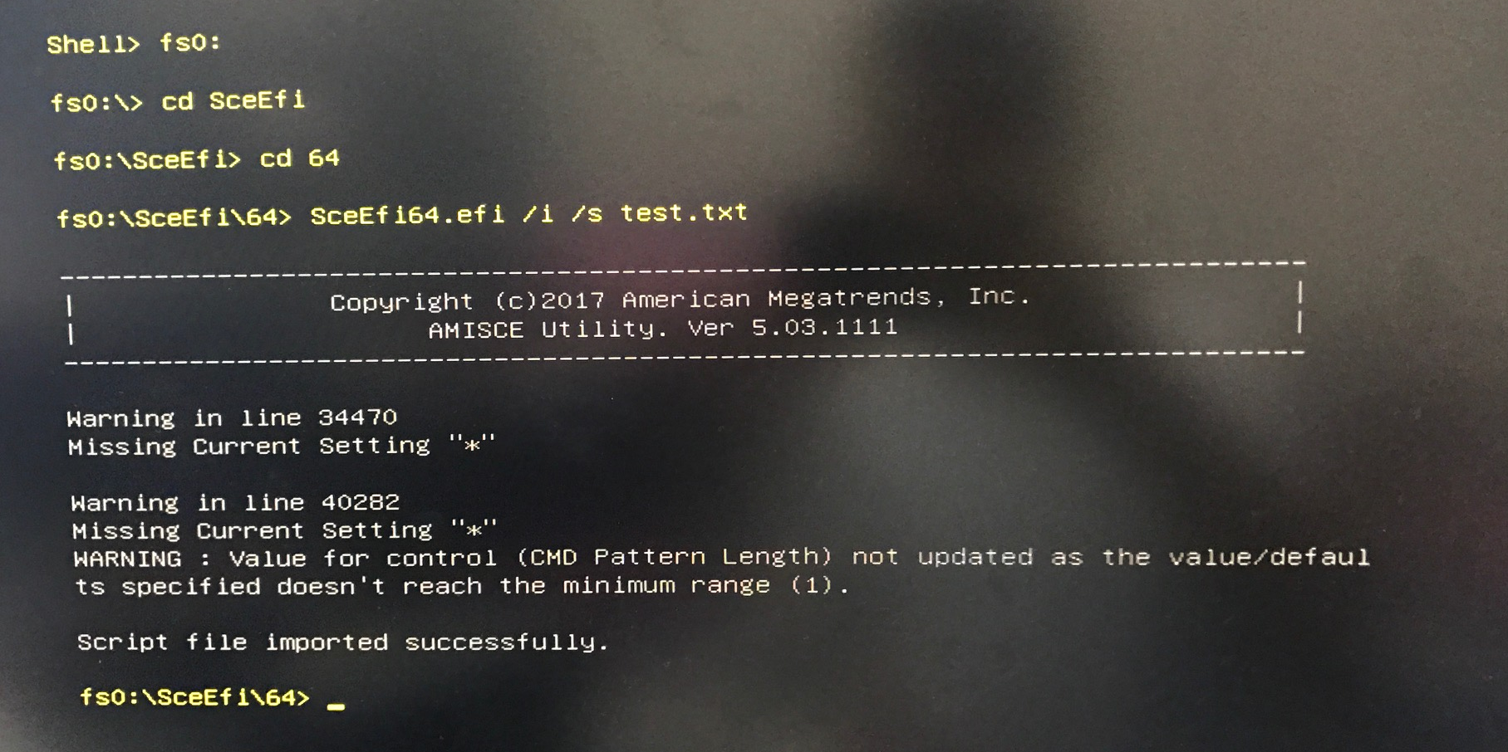
- Double check if those options are modified successfully.
BIOS➔Advanced➔CPU configuration➔CPU C-state support “Disable”
BIOS➔Advanced➔chipset configuration➔PCIE ASPM support “Disable”
BIOS➔Advanced➔chipset configuration➔PCH PCIE ASPM support “Disable”
BIOS➔Advanced➔chipset configuration➔PCH DMI ASPM support “Disable”

