**TPM2.0 TEST SOP**

OS : SERVER 2012 R2 -GPT MODE

MB : D1521D4I

P.S: OS must install with UEFI mode

1. Prepare a TPM2.0 module
2. Put TPM2.0 on TPM pin After ac off

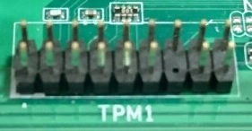

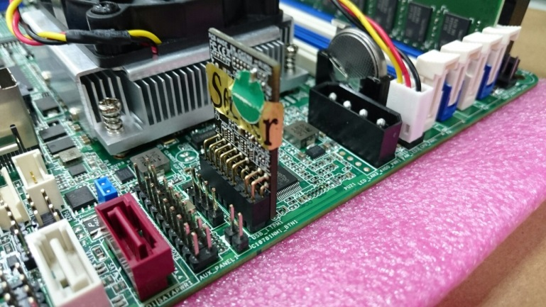

1. After Boot up >BIOS > Advanced > Trusted Computing > Check if it can recognize TPM20 Device > set TPM State to “Enabled” > press F10 to save and leave。

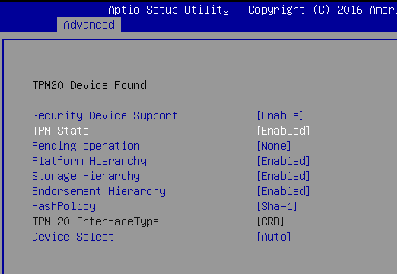

When log into OS。Check if it can see Trusted Platform Module 2.0 at Security Devices

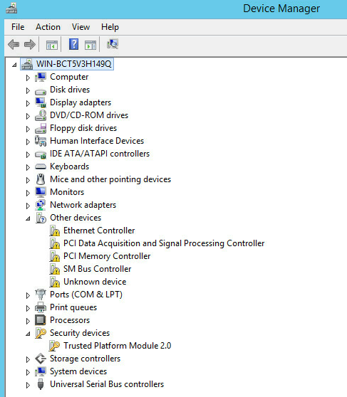

1. Open Server Manager



1. Find “Add roles and features” > then Press “Next” * 4

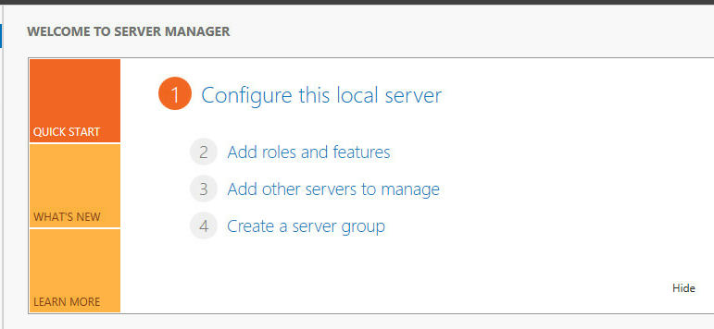

1. Click BitLocker Drive Encryption > Add Feature > Next (P.S Don’t press Install at this page)

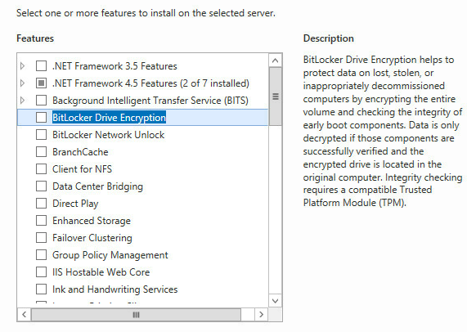

1. Click Restart the destination server automatically required > Yes > Install >  
   system will automatically reboot

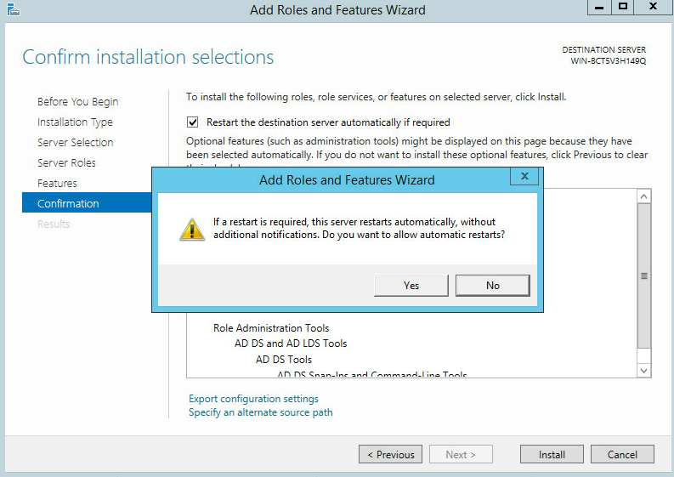

1. BitLocker will install automatically after reboot.

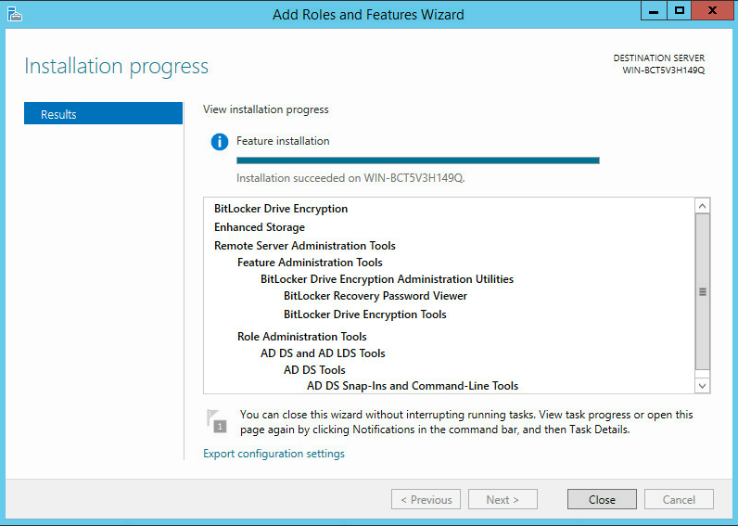

1. Find Control Panel > System and Security> BitLocker Drive Encryption

(Please reboot again, if you can’t find BitLocker Drive Encryption) > click TPM Administration (at Bottom left corner)> If TPM Status shows “The TPM is ready for use, with reduced functionality” > choose Clear TPM > Restart

*** If TPM Status shows ”The TPM is ready for use” , then please jump to step n. ***

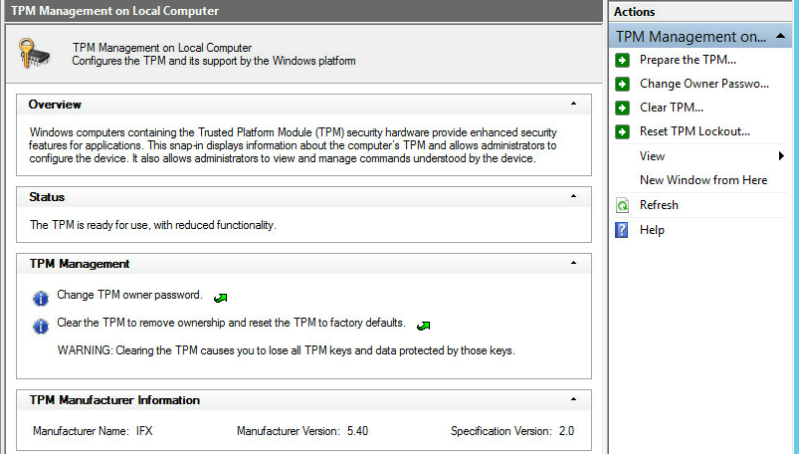

1. Press F12 after reboot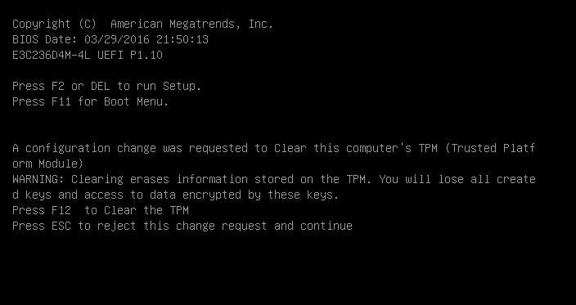

# After boot into OS, it will show TPM is ready > Close.

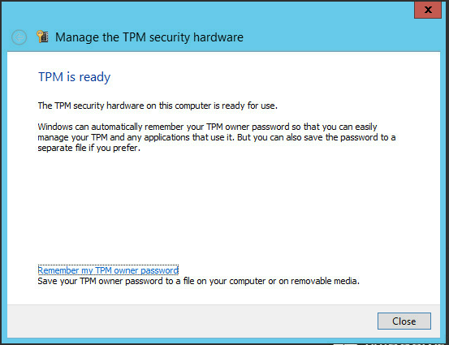

# Check if TPM Status shows ”The TPM is ready for use”

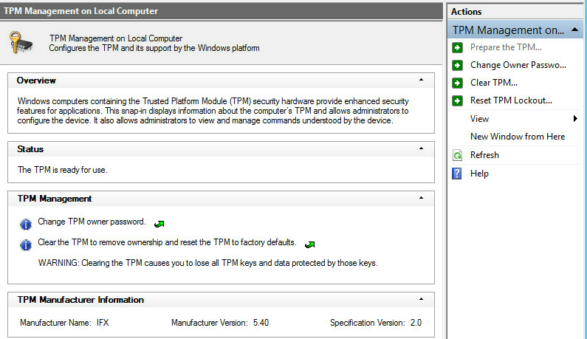

# Open BitLocker Drive Encryption，then choose C: <Turn on BitLocker>

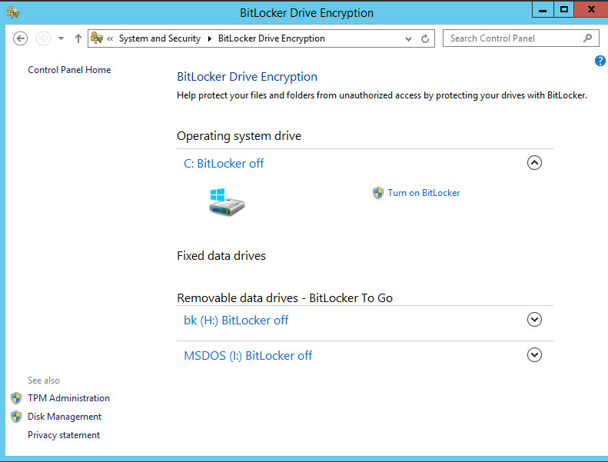

# Insert a USB Flash first > choose “Save to a file” > put your BitLocker decrypt code into USB。

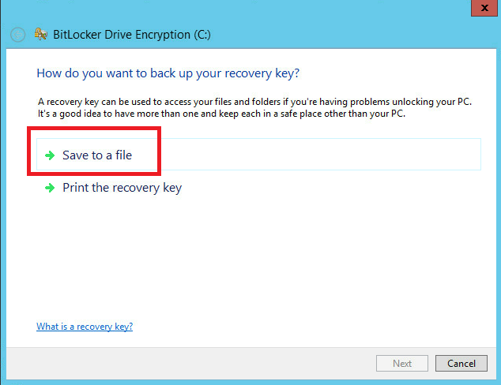

# When the message <Your recovery key has been saved> shows up, please Press<Next> to proceed.

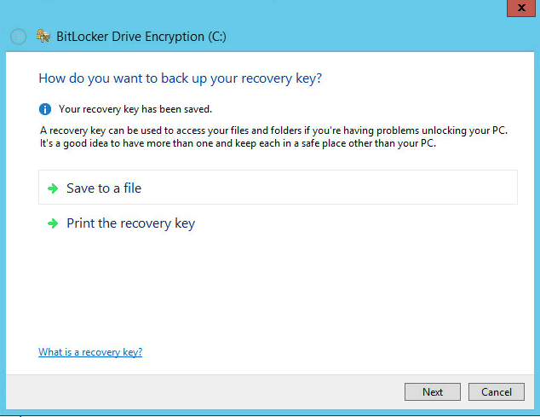

# Choose <Encrypt used disk space only> then choose <Next>

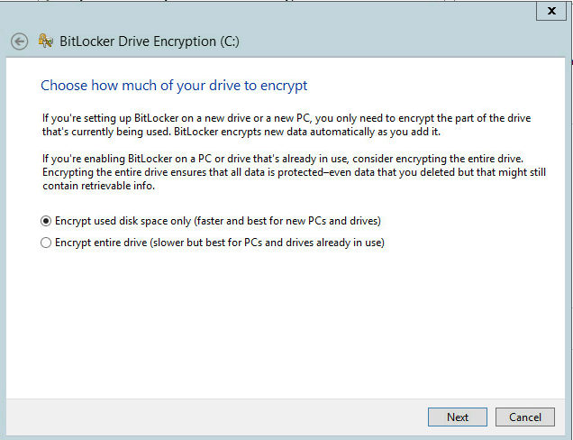

# Enable <Run BitLocker system check> then choose <Continue>

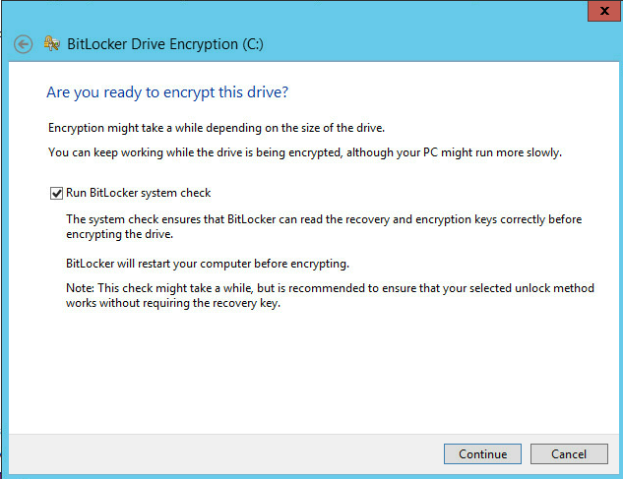

# Reboot the system.

# After you reboot and login to the OS，you can see BitLocker is working at bottom right corner.

# After the encrypt process done，please reboot the system. Then shut down the system after login to the OS

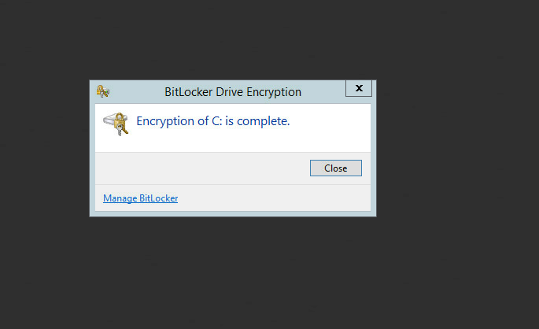

# Remove TPM module on the mother board then boot up, and check if there will appear recovery key message or not.

# Check if the system can login to the OS normally, after put TPM module back to the mother board.