- How to Flash BIOS FW in DOS
- How to Flash BMC FW in DOS

- Flash BIOS FW in DOS
Preparation | :
- A boot USB drive
(P.S. you can build a boot USB drive by rufus)
- Update BIOS batch folder

Step:

- Copy BIOS ROM to “AFUDOS2.39_ASR01” folder.
- Use a boot USB drive booting to DOS.
- Execute command “AFUDOS <ROM_NAME.rom> /p /b /n /asr /x” to flash BIOS firmware.
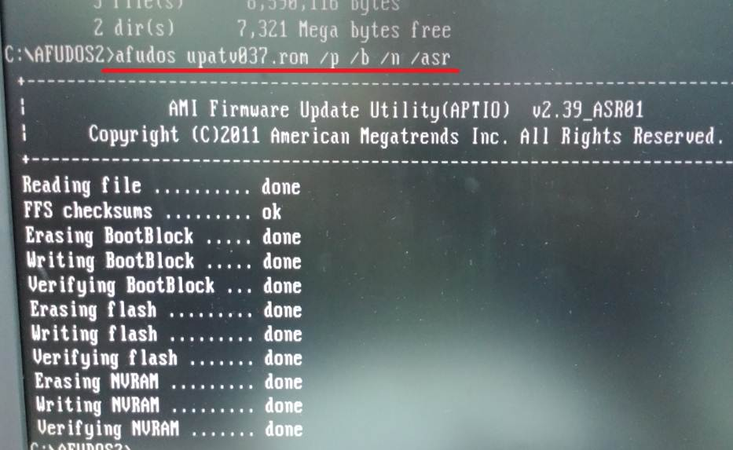

- Check BIOS version in BIOS.
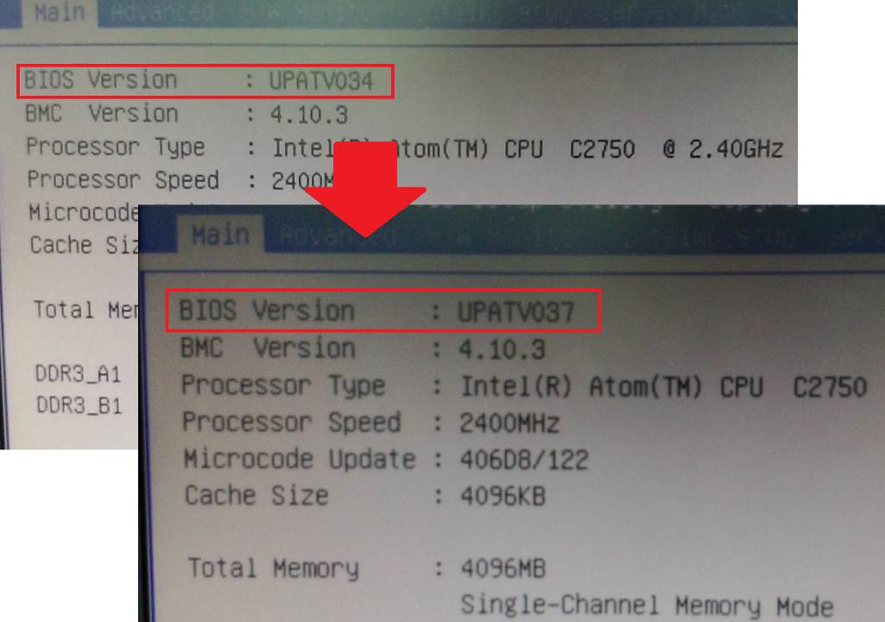
=====================================================
Flash BIOS firmware completed!

- Flash BMC FW in DOS
Preparation | :
- A boot USB drive
(P.S. you can build a boot USB drive by rufus)
- Update BMC Batch files folder

Step:

- Copy BMC ROM to “FlashBMC_DOS” folder and modify BMC ROM name to ROM.ima
- Use a boot USB drive booting to DOS.
- Execute command “SOCwMAC.exe” to flash BMC firmware.
Flash process will take about 5 minutes, please wait.
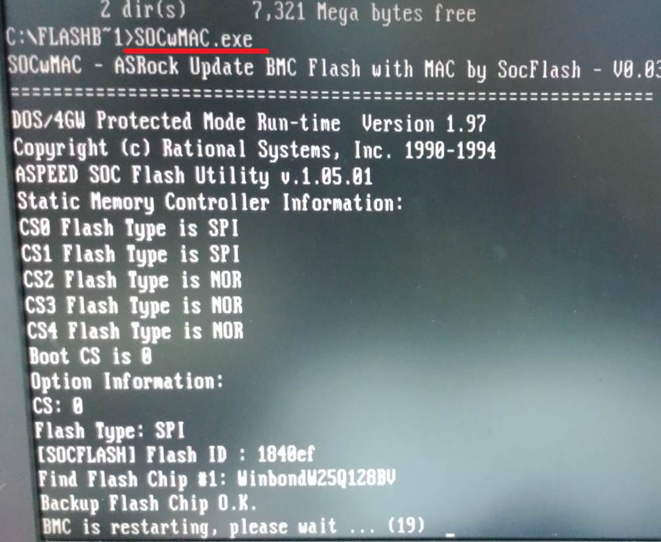

- Check BMC version in BIOS.
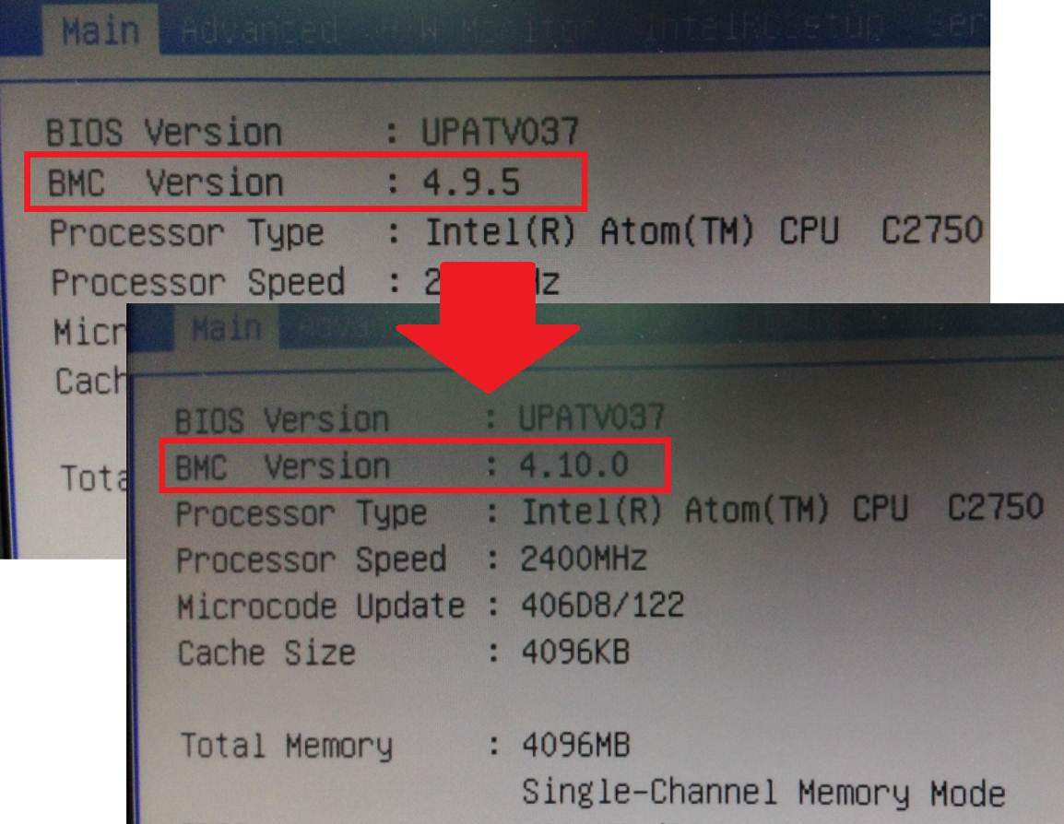
========================================================
Flash BMC firmware completed!

