Update BMC Steps
- Login IPMI web page then choose maintenance
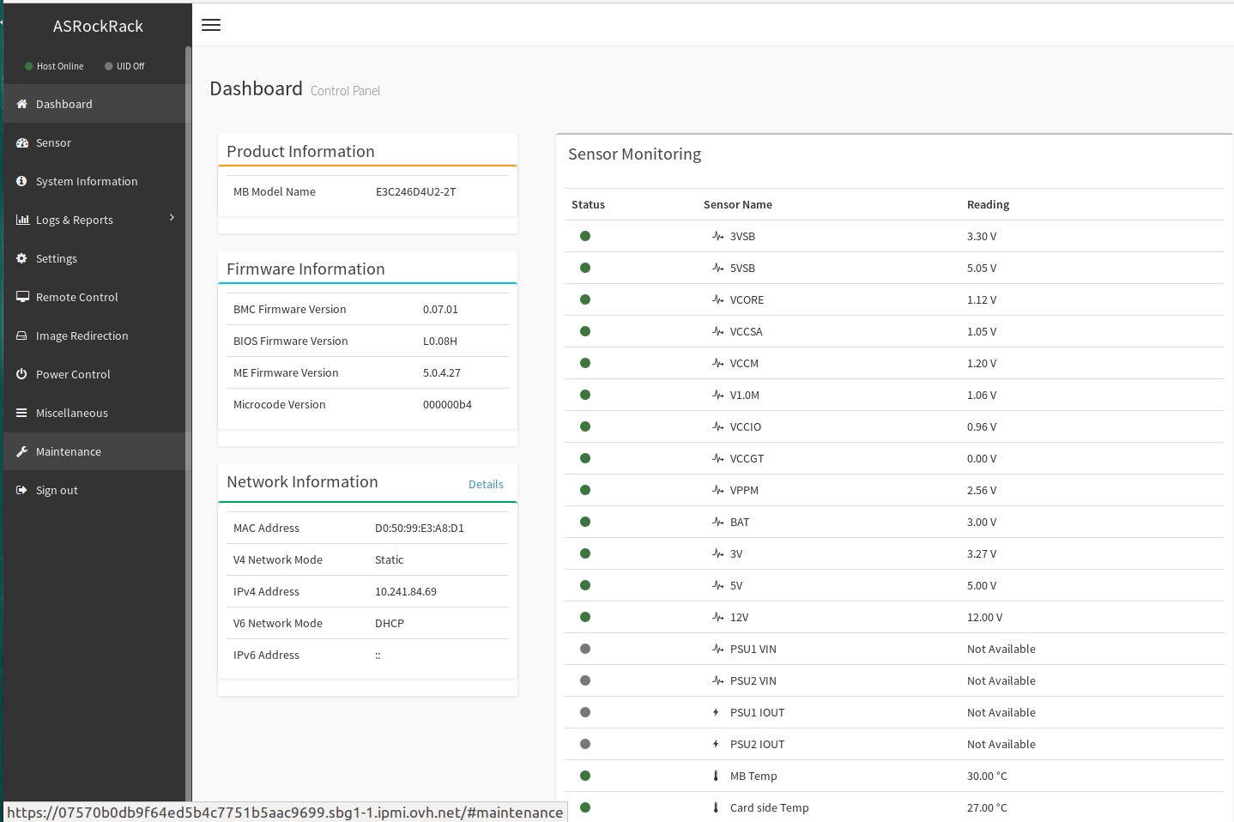
- Chose firmware update
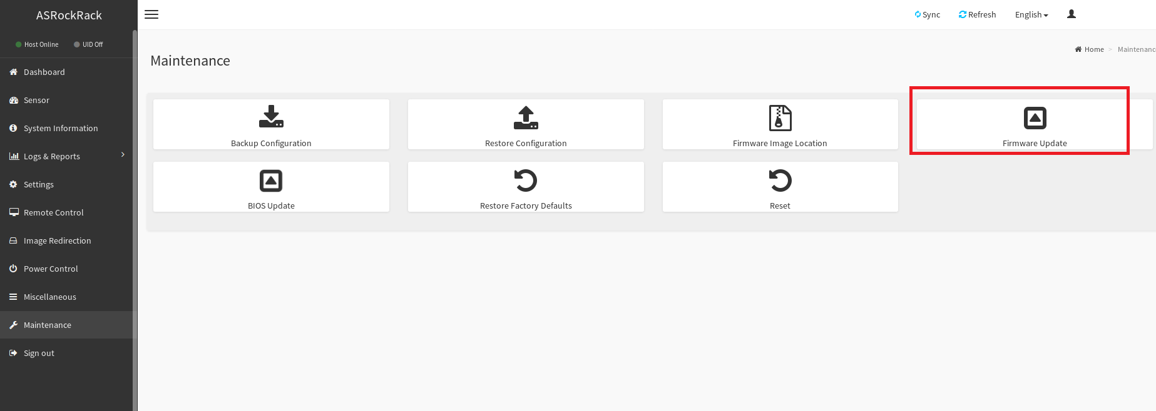
- Select your BMC image
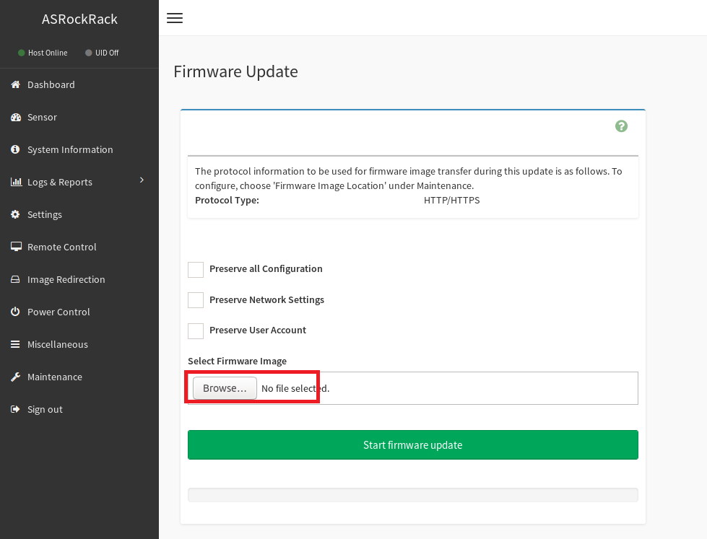
- Select yes to upload BMC image
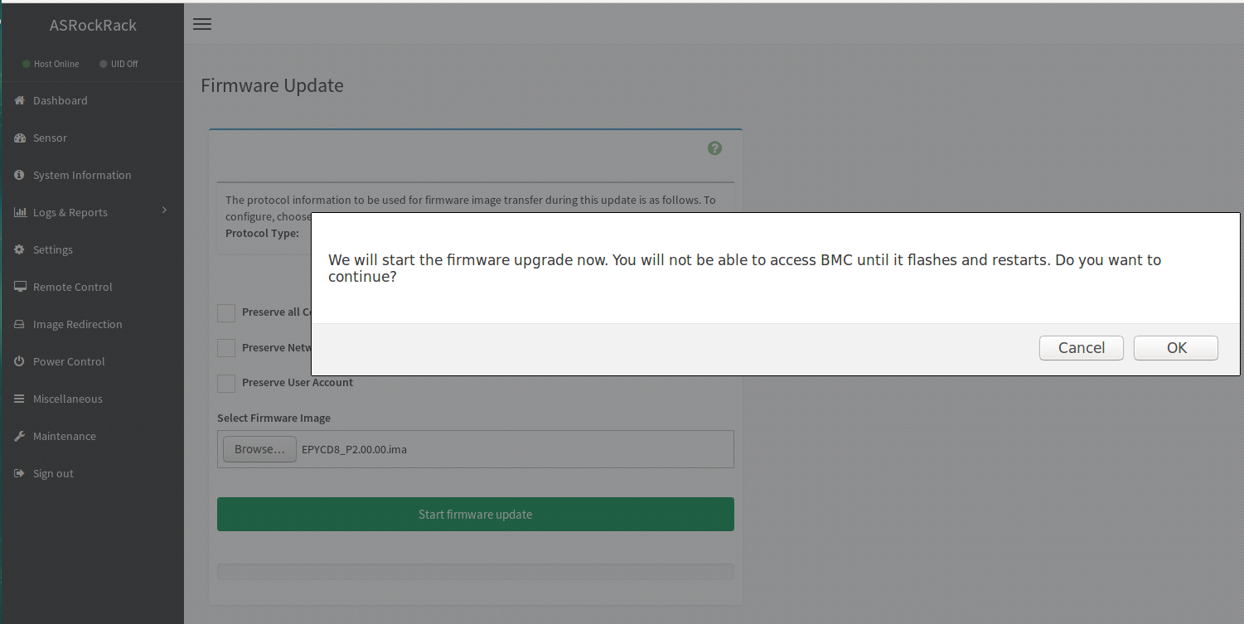
- After upload complete, chose proceed to update BMC
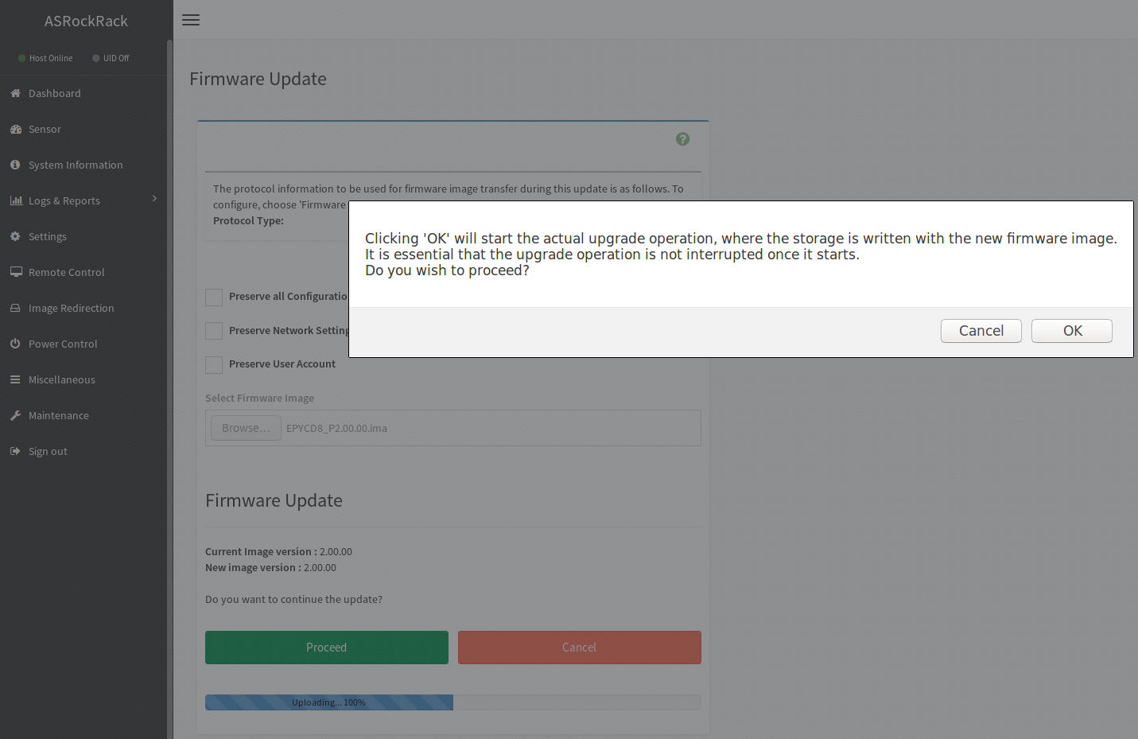

- After update complete wait 1~2 min for BMC restart
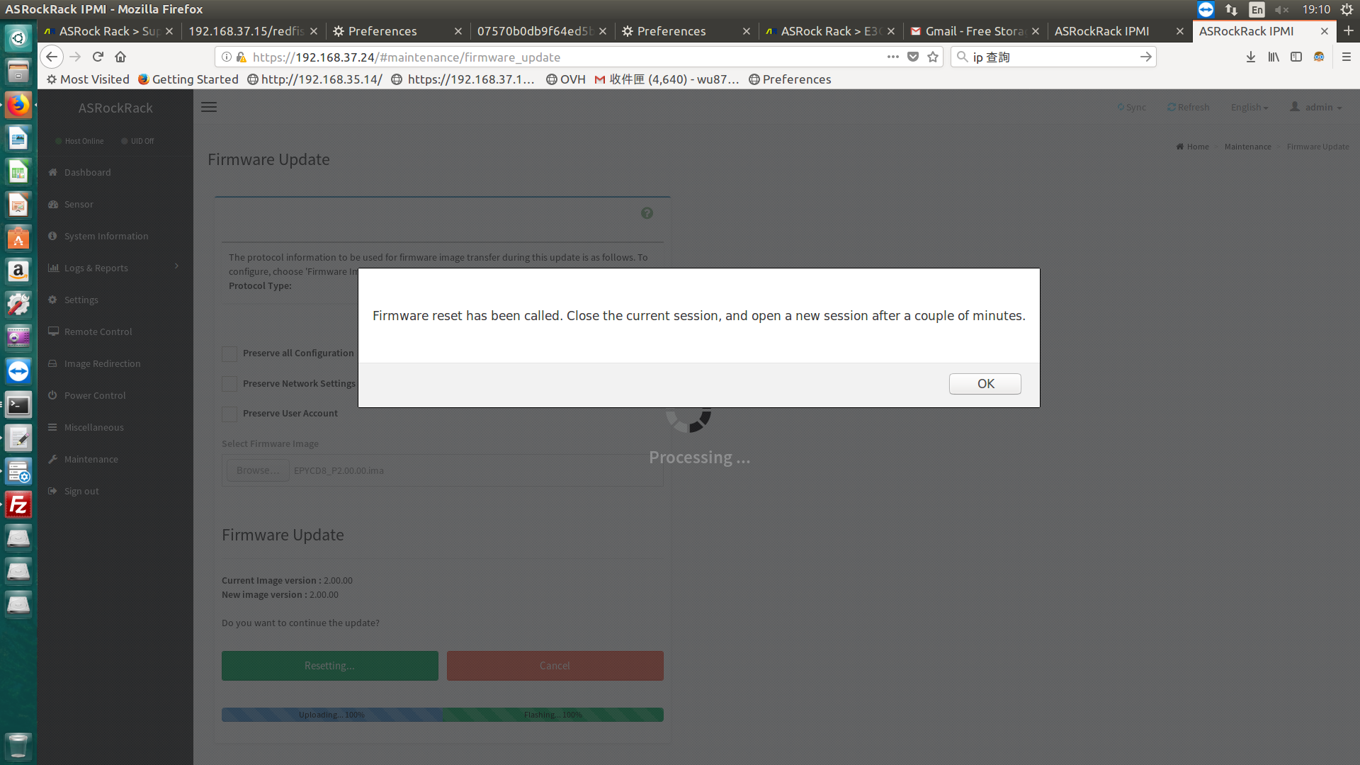
- Reboot and check the BMC version in BIOS main page

