To update the BMC firmware via IPMI, please follow the steps below.

- Enter the management system and click the Firmware Update from the top menu bar.
*Note: please make sure your browser is IE v11.0.9600.17239, FireFox v31.0, Chrome v37.0.2062.120 or above version.

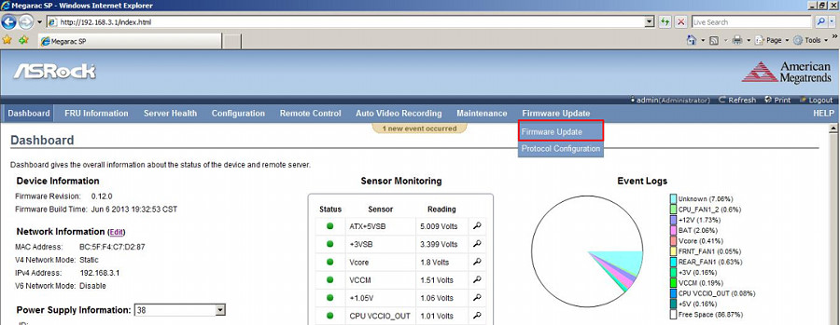

- Enter Preserve Config.
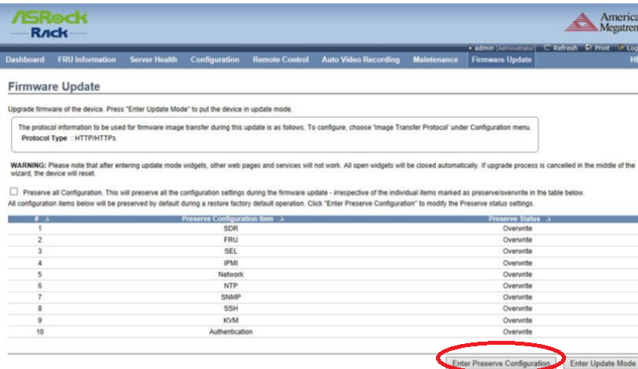

- Change IPMI and Network to “Preserve” and save.
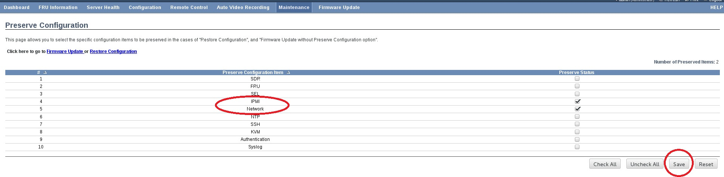

- Click Enter Update Mode > OK.
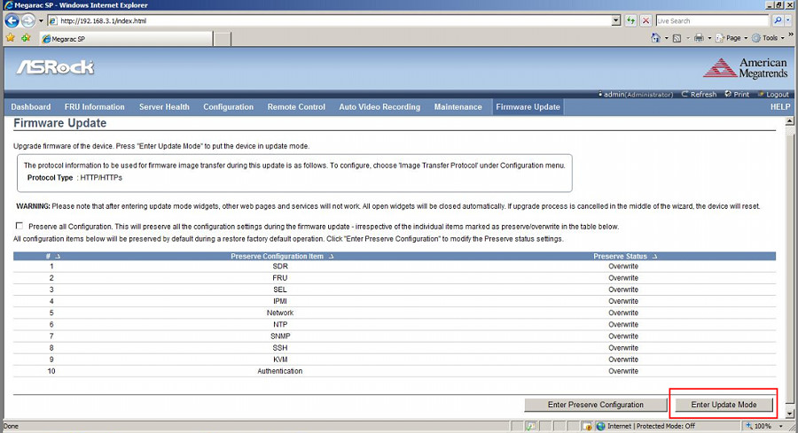

- Click Browse… to select the BMC firmware file from the directory. Click Open > Upload.
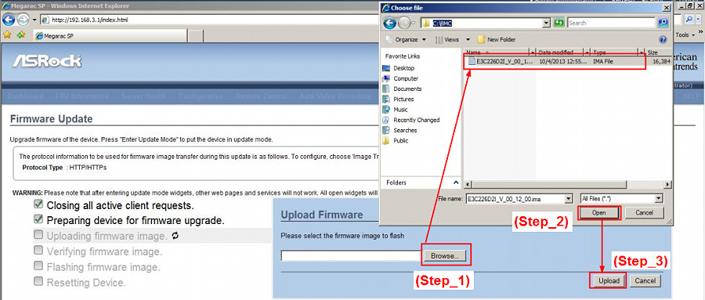

- Click Proceed > OK to start.
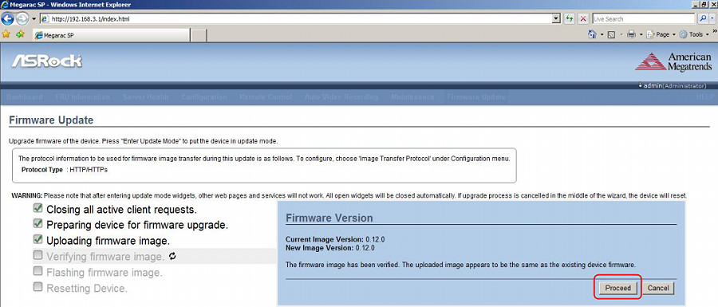

- When you see the screen below, firmware upgrade is completed.
