Update FRU SOP

Preparation:
- FRU tool
- Bootable USB

Step:
- Put FRU file into USB then boot into USB
- Execute FRUTool.exe will show example parameter.
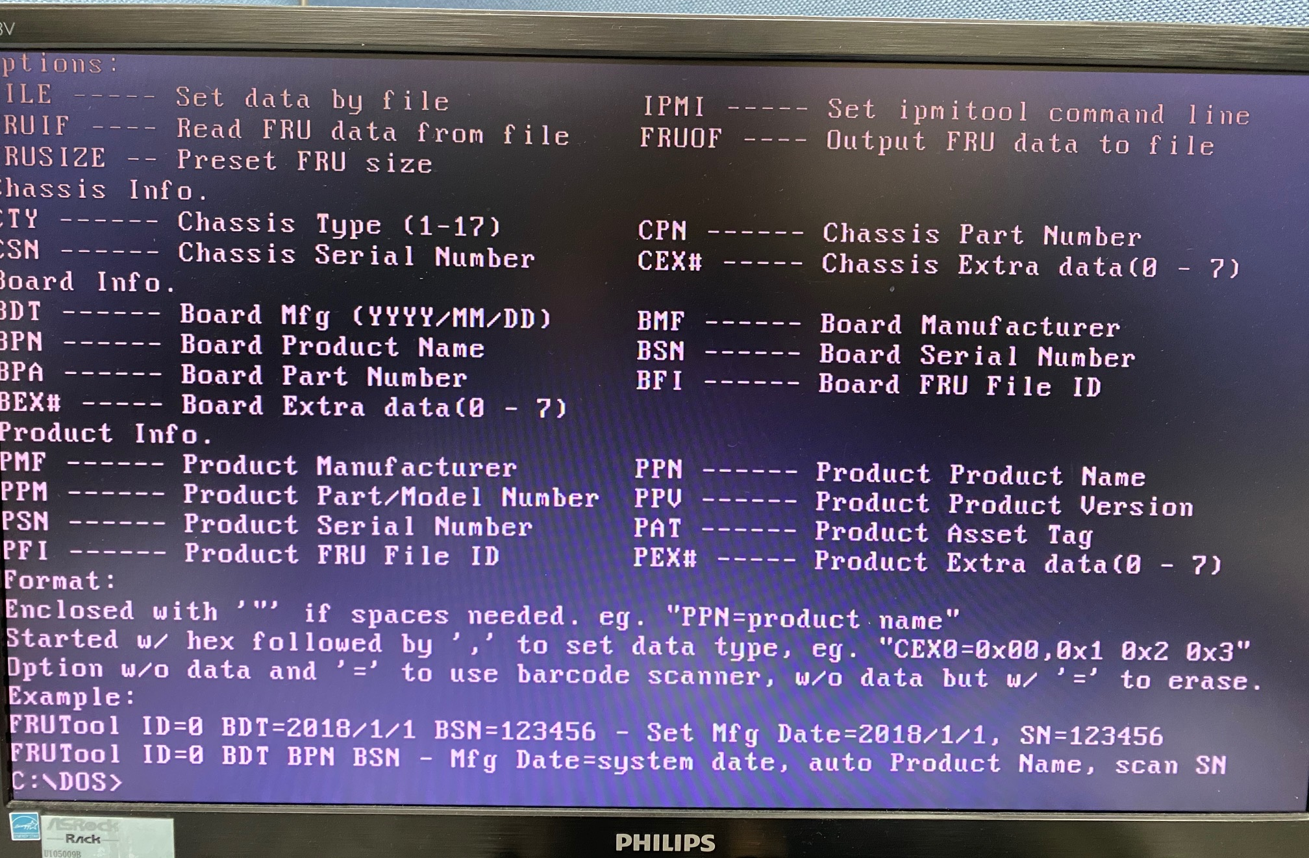
Ex: FRUTool.exe ID=0 BPN= 1U1G-C422/2T PMF=ASRR PSN=123456789

- Reboot and check if FRU info is correct in IPMI web page or not?
