- Link by stunnel
OS: windows
Stunnel Download link: http://www.stunnel.org/downloads.html

Generate SSL key (optional)
- To generate SSL key, use a linux OS, open terminal and execute:
openssl genrsa -out privkey.pem 2048
- openssl req -new -key privkey.pem -out cert_req.pem
- openssl x509 -req -days 365 -in cert_req.pem -signkey privkey.pem -out sign_cert.pem
- cat privkey.pem sign_cert.pem > server.pem
- Upload the newly created SSL certificate and private key in the BMC via webpage.
Path: IPMI ->Settings->SSL settings->upload SSL certificate
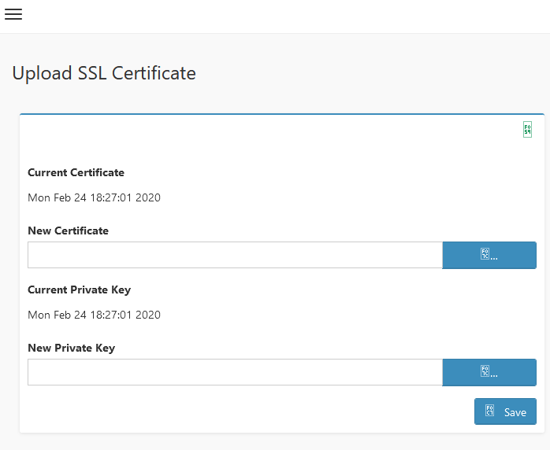

Install stunnel
- If install successful, stunnel icon should appear in windows task bar (down right)
- Right click on the Stunnel icon, and select Edit Configuration
- Add entry for VNC client as given below and save
[VNC]
client = yes
accept = 127.0.0.1:5678
connect = 10.0.124.22:5901
cert = C:\server.pem
- Reload configuration
- Launch VNC client with loopback IP address

- Link by putty.ssh
- Download putty
- Open command prompt and navigate to directory where putty.exe is placed.
- Enable SSH session with BMC by issuing following command in terminal.
putty.exe -ssh -L {Any Port}:{BMC IP}:{VNC Non Secure Port} {BMC username}@{BMC IP} -pw {BMC password}
Ex: putty.exe -ssh -L 1234:localhost:5900 admin@10.0.124.130 -pw admin

Terminal CMD
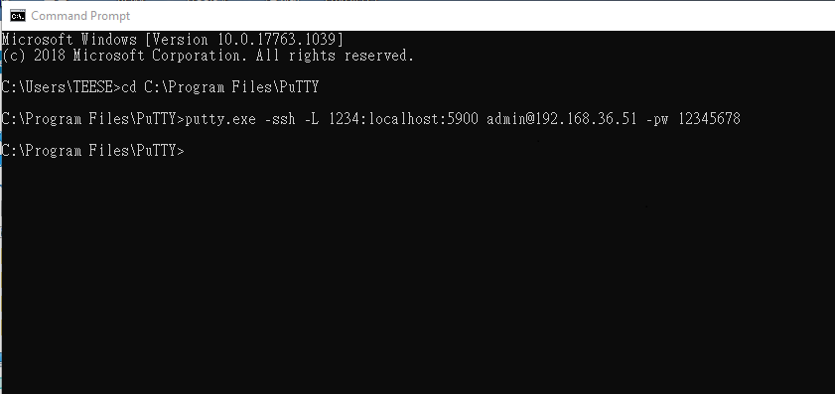
Putty
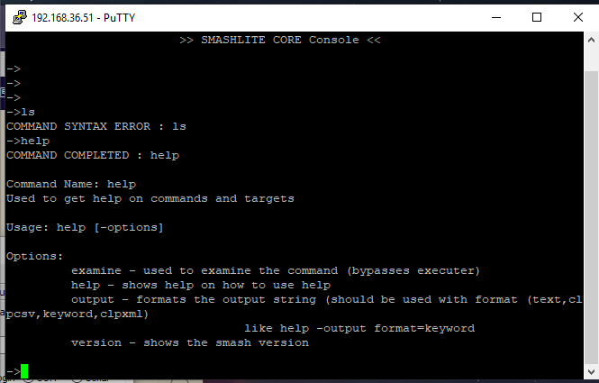
- Link by tightvnc
Download link:
https://www.tightvnc.com/
Steps:
- IPMI page=>setting=>media redirection
- Enable VNC non secure connection
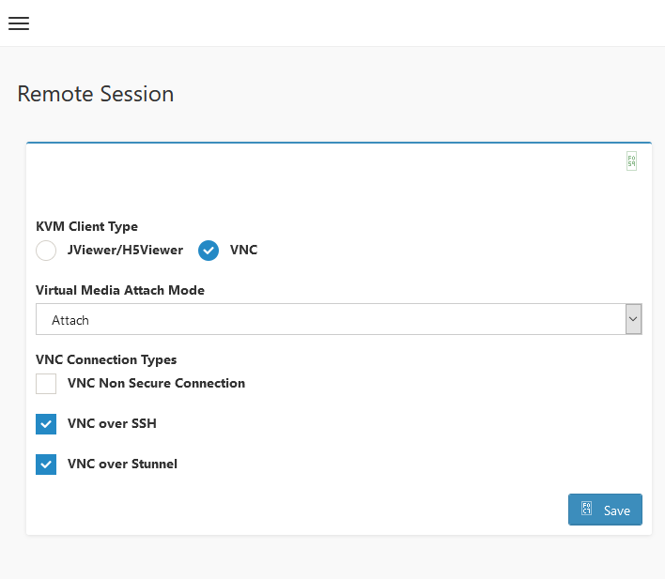
- Use tightvnc viwer to link your IPMI IP
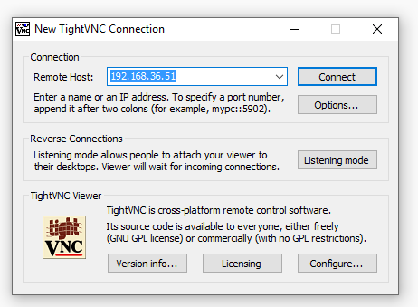
- Success
