Yafuflash update BMC SOP

Execute environment:
Windows OS

First you need to Prepare:
- 2. (Only needed when update local system’s BMC)

There are three ways to update BMC by Yafuflash:
Update one system’s BMC with Yafuflash:
- Put BMC image file and Yafuflash.exe in the same folder
- Use cmd line to execute Yafuflash -nw -ip <ip> -u admin -p admin -full <rom.ima> -vyes

Use Yafuflash and FlashBMC.bat to update more multiple system’s BMC:
- Put BMC image file and Yafuflash.exe in the same folder
- Put the system ip address which you want to update BMC into ip.txt
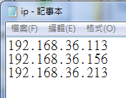
- Execute FlashBMC.bat，and then enter following information.
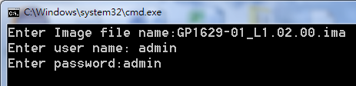
Update local system’s BMC with Yafuflash:
1. On the system which you want to update BMC, please use ipmiutil to execute following command first➔ipmiutil.exe cmd 00 20 c8 aa 00
2. Put BMC image file and Yafuflash.exe in the same folder
3. Use cmd line to execute Yafuflash -cd <rom.ima> -vyes
4. After BMC update complete, use ipmiutil to execute ➔ipmiutil.exe cmd 00 20 c8 aa 01

