Steps:
- Select first port of X550
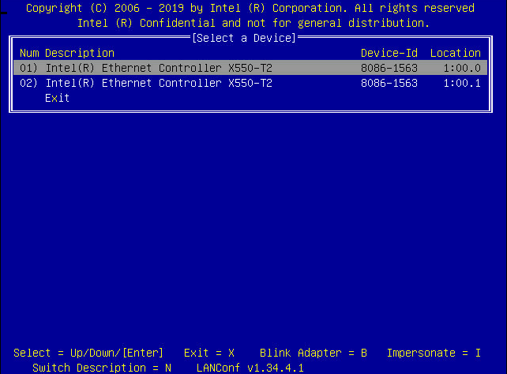
- Choose EEPROM/FLASH => RAW EEPROM
- Select the bit in red frame
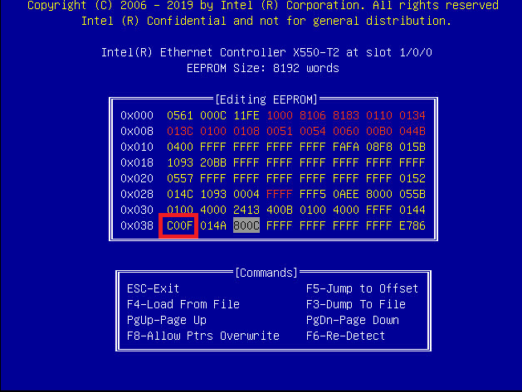
- Change C00F to C007 and save
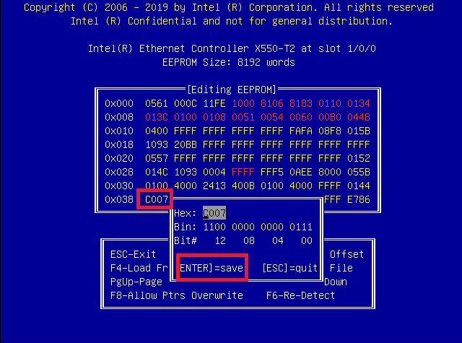
- Press esc to save and leave
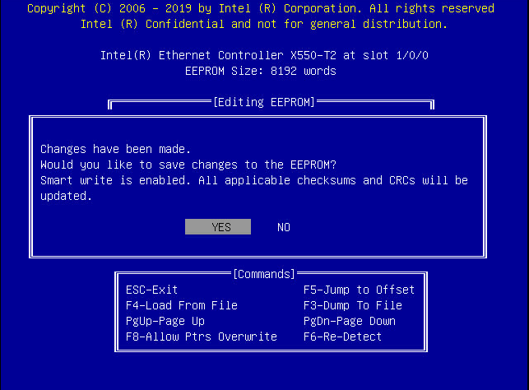
- System power off (AC power off for 30 sec)
- Reboot and test Lan status

