**Data control instruction**

**1. Applicable soft versions**

Data control is applicable for V8.11、V5.00、V5.01、V5.02 and higher soft versions. Software versions lower than the four versions above are still available for previous monitor 3.02.

**2. Installation**

Double click on icon, picture below will be shown:

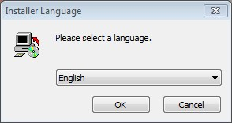

Click on next step and choose the installation path, default path is available. The software can be directly start up after installation (default direct start, not to start up can be chosen). Shortcut icon, through which the software can be quick start, will appear at the same time,

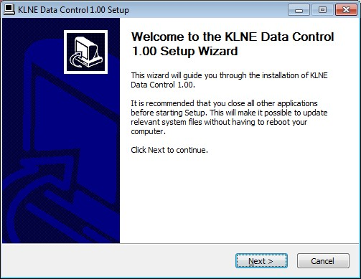

**3. Connect data line**

Connect RS232 USB line to the RS232 port on the inverter.

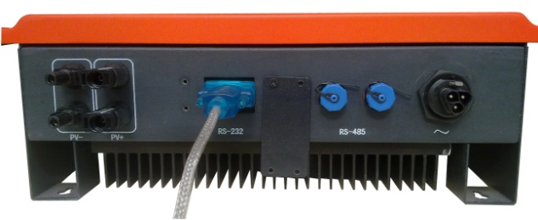

Find RS232 port COM1 through My computer=>right click=>attribute=>hardware=>equipment management.

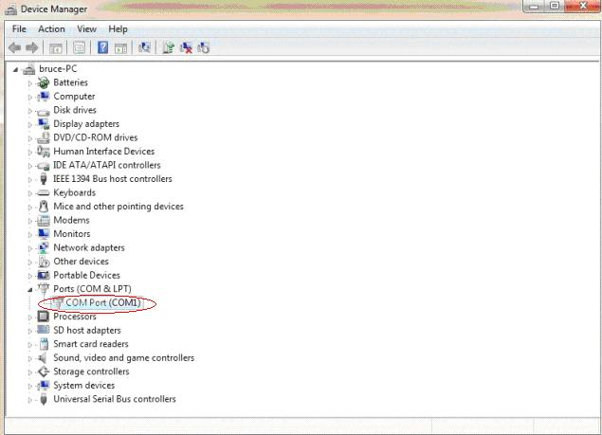

Connect another USB joint to the computer. (Recommend WINDOWS XP system)

**4. Software interface**

Double click on 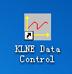 icon to open the software, interface will be shown as below. In order to make the user convenient to use other programs, data control does not support Zoom extents. On top of the interface are different function buttons, 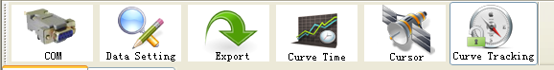, users can materialize all the quick operation through these buttons. The buttons inclueds most of the content on the option barr.

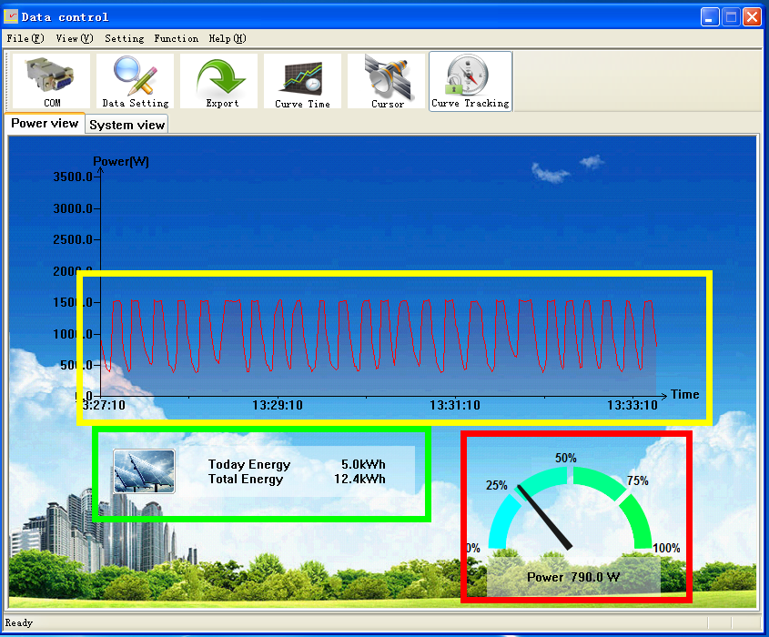

**5. Operation**

1. Set com communication port: check the recognized communication port after inserting the data line. It is COM1, click on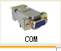, popping up dialog box. Input corresponding number in COM No. as above the recognized port is COM1, therefore input 1. Click on OK after inputting then computer can achieve communication with sunteams.

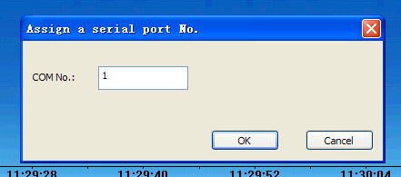

1. Click on , popping up dialog below, there is no need to input password , The system interface can be opened after clicking OK directly, As picture shows below. Users can only monitor instead of revising the internal parameter. The buttons in the red bracket are grey. Click on “cancel” to exit the monitoring interface.

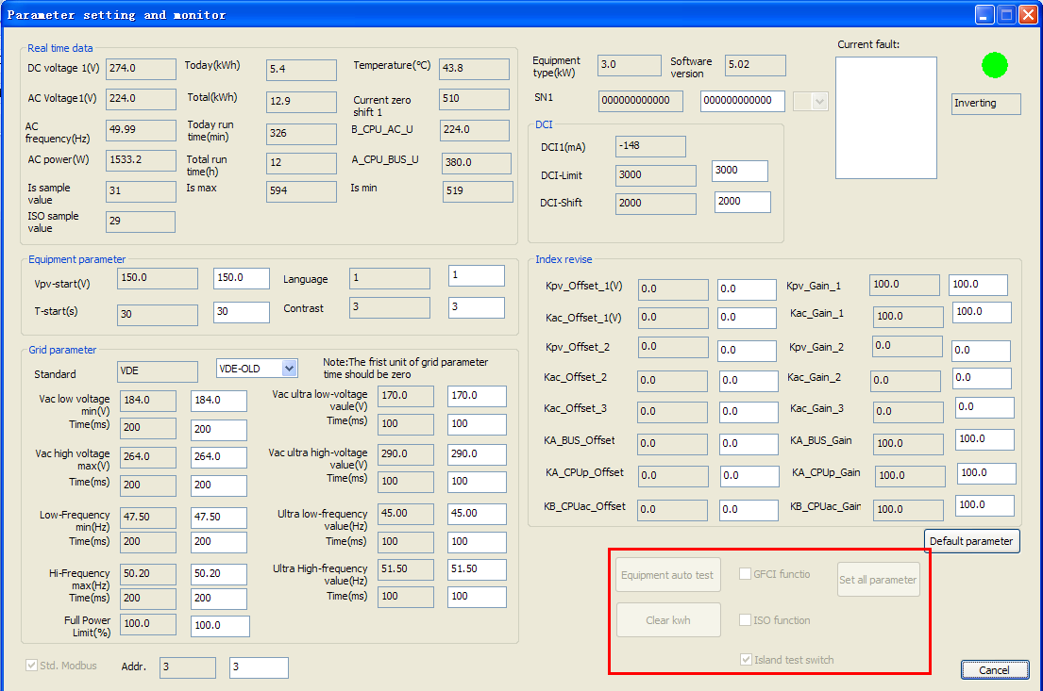

After inputting the password, the monitoring interface will be shown as below, the buttons in the bracket above are bright, therefore, the system operating parameter and serial number can be revised. If users need the password, they can apply to the after-sales Dept.

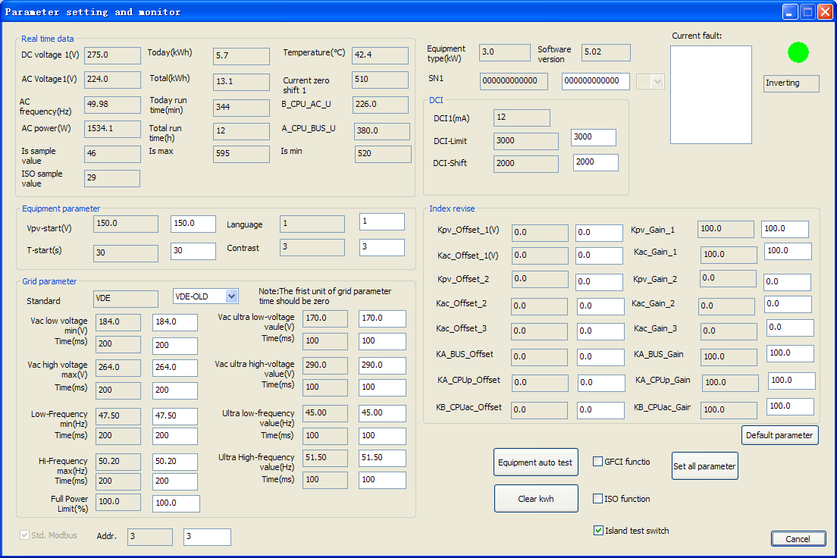

Data control will save the report forms automatically at the directory of software installation root. Users can click on to save a certain period data if needed, As picture shows below, users can choose the interval time to saving the data.

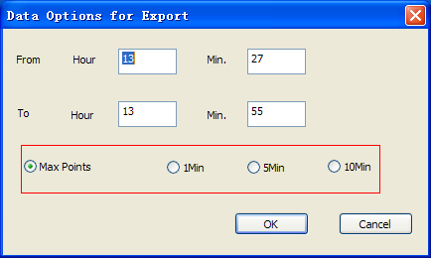

Dialog box below will be shown after clicking on “OK”, Users can choose the save position of the report forms and open the report form after conservation.

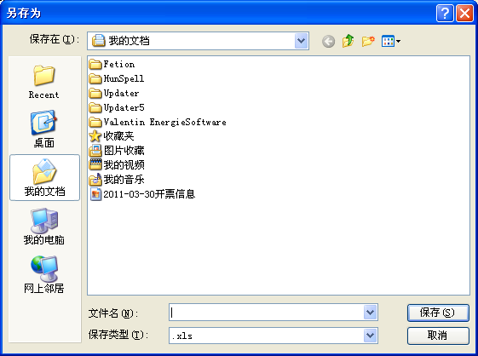

4) with this fuction, users can detailed monitor the power curve during a certain period. Picture below will be shown after clicking on it.

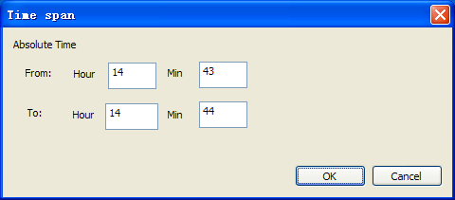

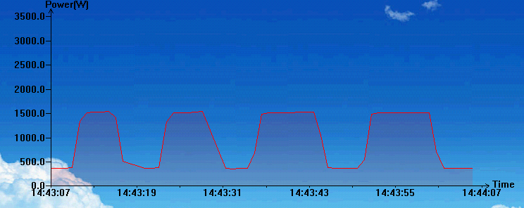

5) Users can click on  button to select power curve at a time point on the diagram. As the picture shows, the vertical bar can be dragged using the mouse.

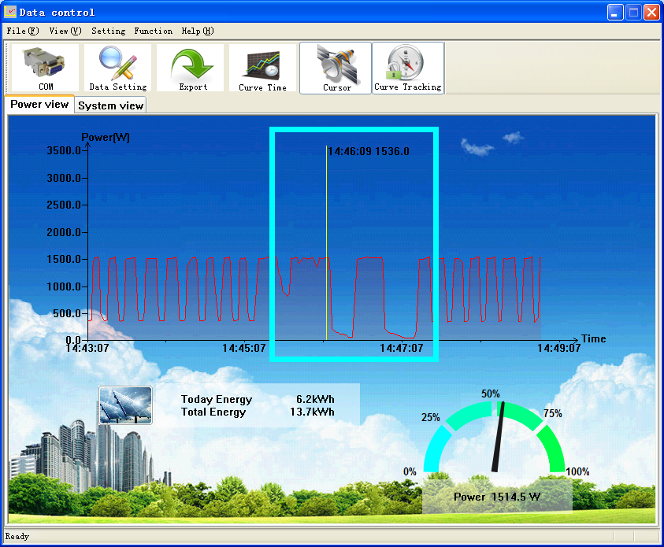

6) click on 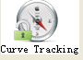 button can fix the coordinate , that means the curve will stop update when get to the most right side until click on this button again.

7) Click on “system view”, as picture shows below, shifting to system introduction interface in which the “principle” is icon display interface while “Text info” is words explain. Users with words explain interface can revise the words description in “myfile” document at root directory and reboot data control to complete modification.

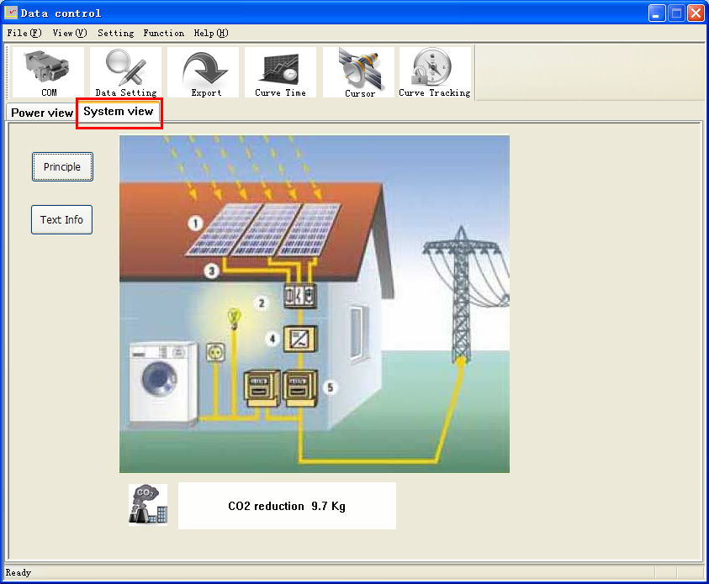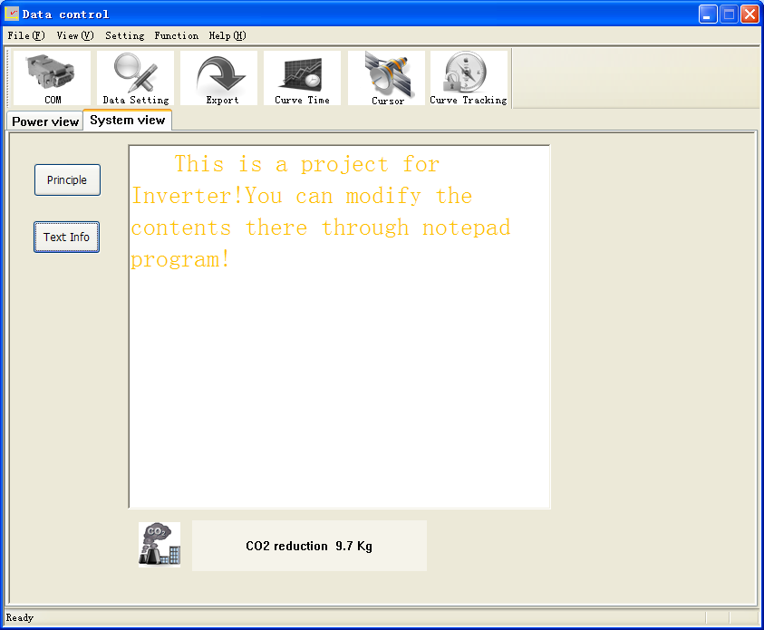

8）If data control communicates with sunteams, the internal working data of Sunteams will be automatically reserved to the computer, users can check it themselves. Right click on 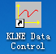, picture below will be shown.

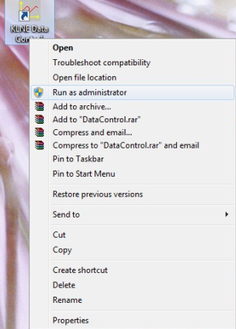

Click on “properties” ,picture below will be shown.

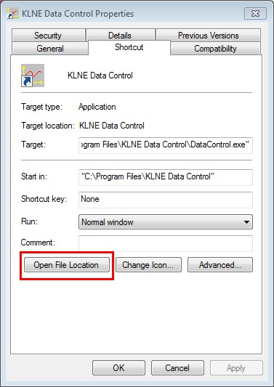

Enter into root directory of data control by clicking on “open file location”. Open “hisdata” D:\Program Files\Tencent\QQ\Users\847296907\Image\9N8IZ{)0(68M7}%%S~~~){O.jpg, stored system operation data can be seen.

9）The introduction above are the main functions of data control, there are some functions not used often. If needed, please contact after-sales Dept. We will be pleased to serve you.